London
Business
School

The
2006
Consulting Club
Case Book

Table of Contents

I. Introduction..............................................................................……….........................3

II. The Consulting Interview Process…………………………………………………..4
a. Introduction to the Process……………………………………………………………..4
b. What Firms are Testing for with Case and Fit Interviews……………………………. 6
c. The Interview Challenge………………………………………………………………11

III. How to Ace Case Interviews..........................................…..…......... .......................12
a. Overview of Case Interviews ...................……………………………….................... 12
b. Tackling a Case Interview – A Step-By-Step Illustration..............………………….. 14
- Business Case
- Estimation Case
- Brainteaser
c. Six Major Types of Business Case…………………………………………………….23

IV. Practice Business Cases........................................................................................… 33

Cases Written by London Business School MBA 2005:
Case 1: Terrific Tennis Plc (by Damien Bruce)………………………………………….35
Case 2: Titleist Golf Balls (by Neil Corrigall)…………………………………………...39
Case 3: XYZ Holiday Parks (by Douglas King)…………………………………………45
Case 4: Beer Industry (by Nicola Winn)…………………………………………………50
Case 5: Sunco, Financial Services (by Sanjiv Padmanabhan)…………………………...54
Case 6: Supermarket Case (by Mark Buckle)……………………………………………63
Case 7: London Millennium Dome (by Caspar Schlickum)……………………………..67
Case 8: Candy UK (by Steven Klooster)………..……………………………………….75
Case 9: The Vitamin Store (by Maria Novales-Flamarique)………………………….…82

Cases Written by London Business School MBA 2006 - new for the 2006 Case Book:
Case 10: AluCo (by Jim Bonner)………...………………………………………………89
Case 11: Drinking Water Purifier (by Shruti Goyal)…………………………………….94
Case 12: Scottish Bankers (by Rob Feeney)……………………………………………104
Case 13: Greek Television Channel (by Gustavo Brito)……………..………………...114
Case 14: Pharmaceutical Industry (by Niels Dam)……………………………………..126
Case 15: Happy Healthcare (by Shane Clifford)……………………………………….133
Case 16: Russian Tourism Industry (by Kevin Krogmann)……………………………144
Case 17: Irish Retail Bank (by Vishal Dixit)…………………………………………...156
Case 18: Performance Chemicals (by Matt Singer)…………………………………….164

V. Fit Interviewing...........................................................................…………………..168
a. Overview........................................................................................................………..168
b. The Importance of Fit ......................................................................................……...168
c. Criterion Based Questioning………………………………………………………....169
d. Two key ‘Why do you want to…..? Questions……………………………..………..171
e. Do You Have Any Questions for Me?……………………………………………….172
f. A Two-Way Process………………………………………………………….………173

VI. Conclusion .........................................................................................................…..175

I. Introduction
Welcome to the second edition of the London Business School Consulting Club Case Book, which has been updated with the addition of nine totally new practice business cases.
This book is intended as a resource for members of the Consulting Club and for any student looking to secure a Summer Internship or a Full-Time Position within consulting, or within any firm that uses business cases in their interviewing process, e.g., Johnson & Johnson.
This book is not designed to be the only available or necessary resource on the subject of consulting interviews. Students who only read this book and do not get involved in Consulting Club events or in practice mock crack-a-case interviews are doing themselves a disservice. Instead, this book should be used in tandem with other resources available through the Consulting Club and Careers Services, such as evening lectures, group crack-a-case training sessions, company sponsored events and mock interviews.
I hope that the combination of this Case Book and the other resources available will maximize the effectiveness of London Business School students during the consulting interview process. If anyone has any questions about the book or the process, please feel free to contact me.

Good luck!

Katie Medina
Associate Director, Consulting
London Business School

II. The Consulting Interview Process
a. Introduction to the Process
Whether applying for a full-time job or a summer internship with a consulting firm, you will have to go through a two (or occasionally three) stage interview process. The majority of firms’ interviews follow a similar pattern:

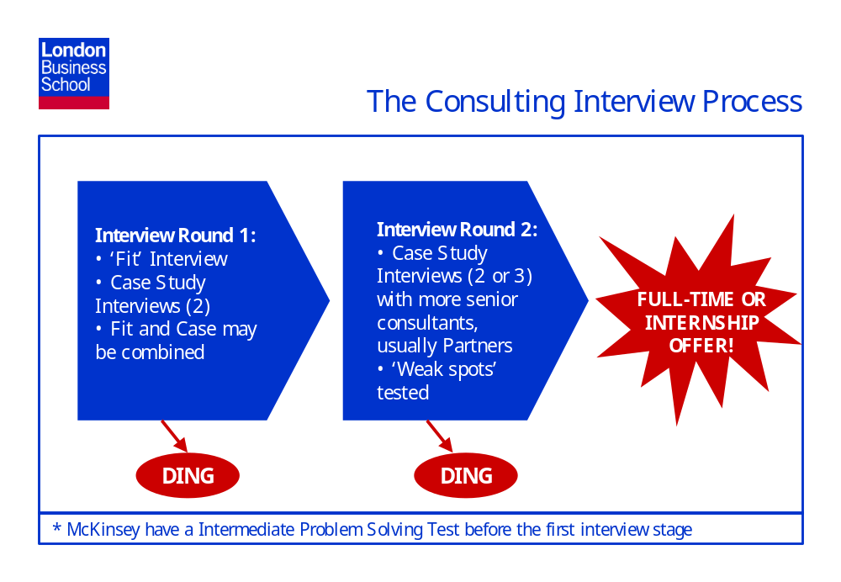
* McKinsey have an Intermediate Problem Solving Test before the first interview stage, and a group exercise, a role play and an Advanced Problem Solving Test at the final interview stage.

Round 1
The first round will generally consist of two or three 45 minute interviews with different consultants at the firm you are applying to join. Case and fit interviews may be separate or combined. First round interviews are usually held on the London Business School campus.

Round 2
Round 2 will be conducted along very similar lines to Round 1, but will generally be held at the office to which you are applying. In addition, the interviewers will probably be more senior than those who interviewed you in the first round – Partners as opposed to Associate Consultants or Managers. You will be given two or three business cases and in addition your ‘fit’ will be tested again. Interviewers in this round will be given feedback from your first round, and will be asked to test ‘weak spots’ – competencies that the interviewers in Round 1 were concerned that they hadn’t tested properly, or that you may have performed badly on. You will help yourself if you try to be very self-aware during your first round interviews and analyze the points on which you feel you might have let yourself down or under-represented your abilities. Spend some time practicing answers to questions on these topics so that you can prove, if they are tested during the second interview, that they are not valid weak spots.

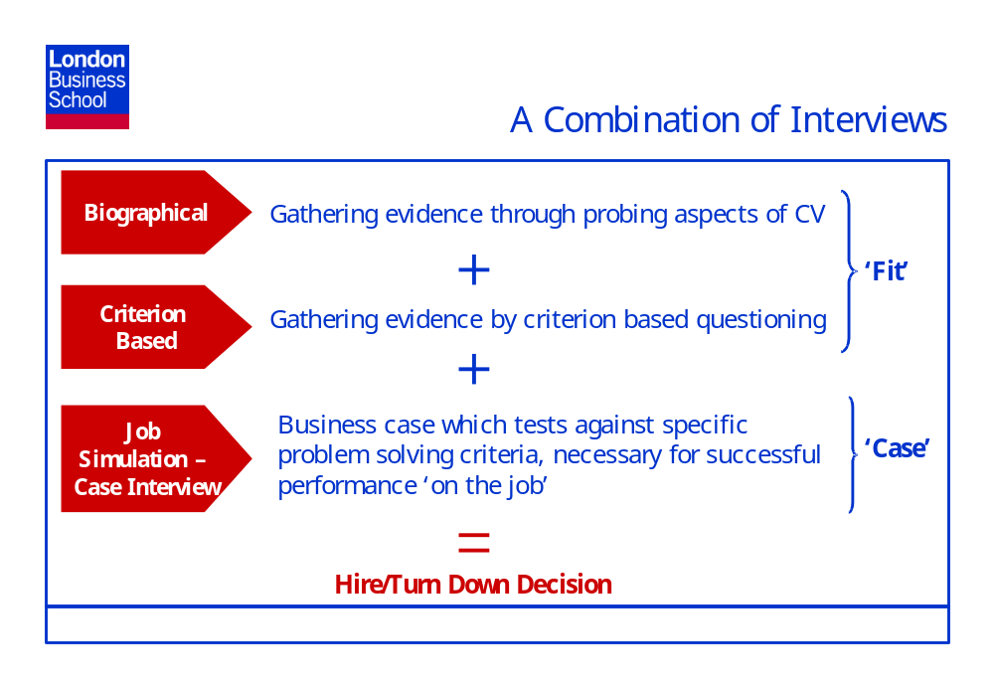
Understanding and preparing for both the case and the fit components of the consulting interview process greatly improves a candidates chances of obtaining a position in consulting and also reduces the stress associated with the interviewing process.
Case interviews are dealt with in detail in sections III and IV of this Case Book and Fit interviews are covered in detail in section V.

b. What Firms are Testing for with Case and Fit Interviews
Consulting firms are not looking for a specific background, industry or functional experience in the MBAs that they employ. Probably 80% of people joining consulting firms at the Associate (MBA) level are career changers. Most of the consulting firms who interview at London Business School will have comprehensive training programmes – comprised of both in-house courses and on the job training – and are therefore not looking for people they take from MBAs to have a full or even partial array of well developed consulting skills when they join their firm. However, what they are looking for is very high caliber ‘raw material’. Consulting firms will generally assess this raw material in four ‘buckets’ or ‘dimensions’, all of which are key to performing well in a job in the consulting industry. People need to demonstrate strong ability on three of the four dimensions (i.e., in consulting parlance, be ‘above the bar’ on these three dimensions) and be ‘outstanding’ or ‘truly distinctive’ on one of the four dimensions. Outstanding or truly distinctive is judged as ‘this candidate would be within the top 25% of consultants currently working in the firm on this dimension.’ If you are above the bar on all four dimensions, but not outstanding in one, you will not get the consulting job.
Consulting firms will use a combination of case and fit interviews to gauge a candidate’s abilities on these four key dimensions, laid out in the following slide:
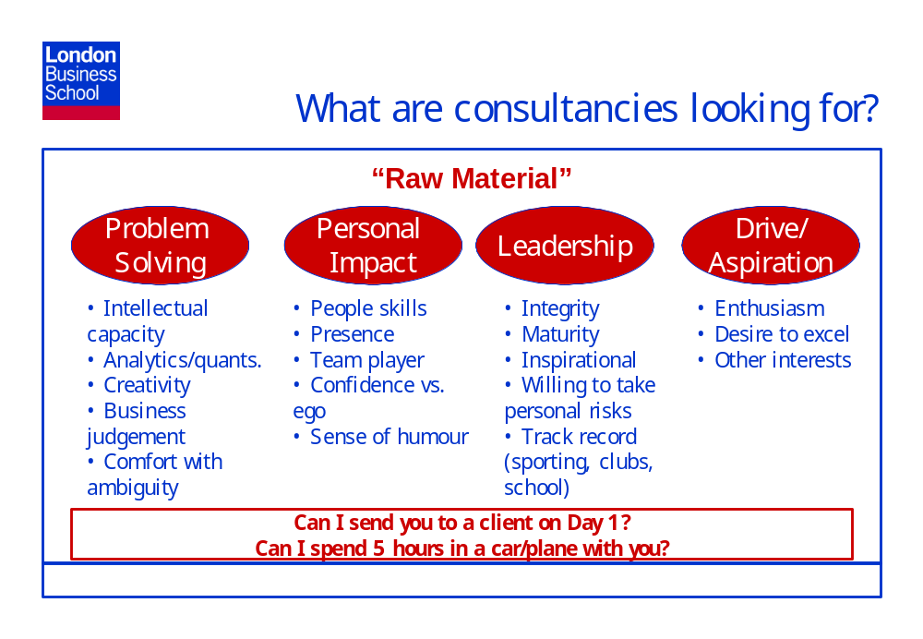

Generating Evidence on Problem Solving Skills with a Case Interview –
A consultant is, above all else, a problem solver – i.e., they are contracted by clients to solve their business problems. Strong problem solving is therefore key to securing a job in the consulting industry. Your problem solving ability will be judged almost exclusively by your performance on the case section of the interview process. Your ability to excel during case interviews will depend firstly on your ‘intrinsic abilities’ (i.e., intellectual capacity, quantitative ability, creativity, etc) and secondly, and very importantly, on the amount of effort you have put into learning what is expected of you in a case interview and the amount of practice you have had in solving cases. The interviewer will be looking to generate evidence on the following Problem Solving criteria from a candidate’s performance in a case interview:
Intellectual Capacity:
- Tested by giving the candidate a tough issue that requires complex reasoning
- Seeing whether the candidate picks up on hints given to them during the interview process
- Teaching the candidate a concept, then seeing if they apply it later on in the case
Comfort with Ambiguity:
- How willing in the candidate to attempt to solve the problem?
- Not – ‘I don’t know anything about this area/industry’ – that’s the whole point
Business Judgment:
- Does the candidate focus on where the real problem is – can they identify the ‘big buckets’ and ‘smell money’?
Logical and well-structured approach:
- Can a candidate identify the key issues and address these in a logical and structure way
- Does the candidate use frameworks only if they are appropriate; not shoehorning the case into the last framework they learned?
- Can they clearly summarize their conclusions so far at each stage of the case?
Creativity:
- Does the candidate come up with alternative ideas or creative suggestions that they may not have seen in other companies and that the interviewer may not have heard before?
Ability to Listen and Learn:
- Does the candidate answer each question in isolation, or do they think about everything discussed so far and its implications for this question?

Generating Evidence on Personal Impact with the Case and Fit Interviews –
Your Personal Impact will be judged during both the case and fit sections of the interview. Consulting is about working closely with clients, so an interviewer will be looking for you to demonstrate that you are intuitive around people – both from your track record and that you interact with him/her in an intuitive and empathetic way during the case and fit interviews. For example, in the case interview saying - “I’m not familiar with the UK credit card industry. Do you pay off the balance in full each month like we do in Germany?” - is far more intuitive that making the following bald assumption - “I’m going to assume that in the UK you pay the balance on your credit card each month.” During the fit section of the interview the interviewer will ask questions about your experience on the various dimensions they want to test, e.g., are you a team player…., how have other people you have interacted with in the past (work and MBA colleagues, team mates) viewed you…….., etc.
The interviewer will be looking to generate evidence on the following Personal Impact dimensions from a candidate’s performance in the case and fit interviews:
Confidence, composure and grace under pressure vs. ego:
- Is the candidate comfortable and in control?
- Do they remain confident even when they make mistakes?
- Do they keep forging ahead?
Teamwork:
- Do they use new information or feedback on wrong answers to push forward their thinking?
- Do they respond to the interviews feedback with – ‘That’s interesting, and it must mean that….’ – rather than getting defensive
- Have they demonstrated strong team working in their past jobs, extracurricular activities?
Sense of Humour:
- Are they enjoyable to interview?
- Can I see myself having a laugh with this person when we’re stuck in a hotel in the middle of Scotland together?
Presence:
- Will this person be taken seriously by the client?
- Are they someone that other people will listen to?
Generating Evidence on Leadership with the Case and Fit Interviews:
Your Leadership abilities will be judged during both the case and fit sections of the interview. However, the majority of the interviewers opinion of your leadership skills will probably be generated from exploring your track record as a leader in the fit section of the interview as it is hard to demonstrate real leadership abilities during a case interview.
The interviewer will be looking to generate evidence on the following Leadership dimensions:
Integrity:
- Candidate solves the problem posed/responds to the questions they are asked. They do not try to bend the rules
Maturity:
- Candidate is articulate, persuasive and credible
- The candidate could be put in front of a client on their first day in the job
Inspirational:
- Candidate will inspire others to follow him/her and to trust his/her judgement
Track record:
- Does the candidate have more than one good example of where they have occupied a leadership position and can they discuss these leadership roles convincingly and in depth?
Generating Evidence on Drive/Aspiration with the Case and Fit Interviews:
As mentioned previously, consultancies also use case interviews to demonstrate to the candidate the type of work that they do. Therefore the case study is not just a hurdle to be cleared (e.g., by learning ‘crack-a-case methodology’) to get the job. During the case the interviewer will be looking for you to demonstrate that you are enjoying solving the case, that you are enthusiastic and engaged by the business problem and that you are interested in finding out the solution. Most interviewers will give you a case that they have personally worked on or are currently working on, and they will be pleased and react very positively if you show an interest.
Drive/Aspiration will also be tested in the fit interview, by looking at your levels of achievement in your past work and extracurricular activities.
The interviewer will be looking to generate evidence on the following Drive/Aspiration dimensions from a candidate’s performance in the case and fit interviews:
Enthusiasm:
- Is the candidate enthusiastic about trying to solve the case and do they want to know what the solution was at the end of the interview?
- Will they thrive in a consulting environment?
Desire to excel/Results Orientation:
- Candidate pushes to solve the problem; does not give up
- Strives to excel in everything that they take on
Other interests:
- Has demonstrated success in activities outside the work arena

c. The Interview Challenge
The challenge that you face in interviewing is to convey your excellence on all of these
dimensions in a 45 minute time period. Your ability to achieve this goal is a function of three things: innate ability, understanding of what is required of you, and practice and self-awareness. There is little you can do about innate ability, though the very fact that you are a student at London Business School suggests that you have the ability to get a job in consulting. (If however you know that you are not strong on a number of the skills highlighted in the previous section as being critical to success in consulting, then you might want to consider other career options.)
With understanding of what is required of you and practice, you will find that many of the elements listed above come across naturally. If you are a quantitative and/or engaging person, you will come across as so in the interview without thinking about it (you still need to practice, however, since these natural predilections will easily be masked if you enter the interview unprepared or nervous). Practice will also help you identify the areas that don’t naturally come across for you in a short interview. Identify these areas quickly, both by looking at your past performance in interviews and by internalizing the feedback given to you from mock interviews at London Business School, and work actively to improve your ability to convey them to an interviewer.
In every interview, you must also maintain significant self-awareness of how you are being (or might be) perceived. Actively manage the image you are conveying. That may seem like a lot to think about while you’re also trying to solve a complex case, but it is very important.

III. How to Ace Case Interviews
- Overview of Case Interviews

Why consultancies use Case Interviews
Many recruiters, and in particular, consulting companies will test for a high degree of competence in the area of solving complex, business problems. A management consultant is above all else a problem solver and therefore this is the core skill that consultancies look for when interviewing candidates.
Consultancies use case interviews because cases give them the opportunity to see how a candidate thinks about business problems and tests a candidate’s ability to solve these business problems. The primary purpose of a case interview is therefore to test candidates’ problem solving skills in the widest sense, including their skills in structured, logical thinking, issue identification, analysis, creativity, insight, business judgement, numerical ability and taking a collaborative approach.
Case interviews also give the candidate some insight into the type of work that consultancies conduct. If you do not enjoy solving problems during a case interview, it may be an indication that, in fact, a career in consulting is not for you.

Types of Case Interview
An interviewer may use any or all of three types of cases during a case interview:

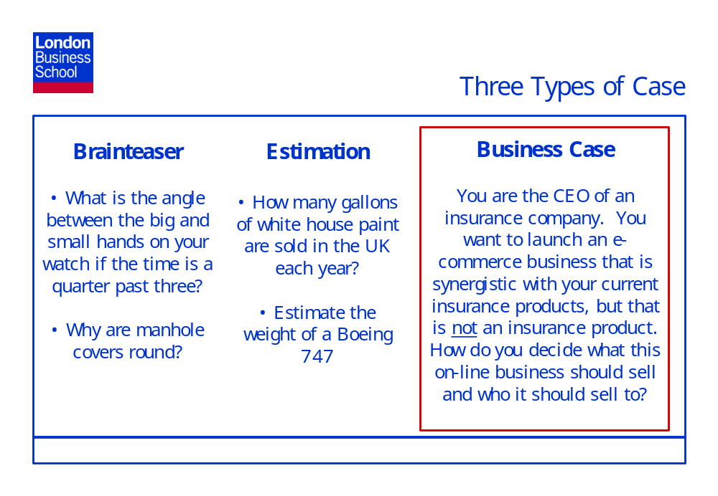
The majority of consulting interviews are Business Cases because these are the only case type that really tests the skills that a consultancy is looking for, and also that demonstrates the work that a consultant will be required to do once in the job. In a business case, the interviewer presents a business situation and asks the interviewee to ‘solve’ it through discussion. For example:
- Firm A’s profits have been declining for the past eighteen months. Why has this happened, and what would you recommend to help Firm A improve its performance?
- Firm B makes jewelry and is considering expansion into the fashion retailing business. Would you recommend that it do so?
- Firm C makes tin cans. It is planning to expand its manufacturing capacity and is debating whether to add to its existing plant or build a new plant. What would you recommend that it do?
An interviewer may ask an Estimation Case either in addition to or instead of a business case. While we would recommend that an estimation case should never be used solely or instead of a business case because it does not test for the required intrinsics in as robust a way as a business case, a lazy interviewer may use it to save themselves the trouble of preparing a proper business case. Examples of estimation cases are:
- Estimate the weight of a Boeing 747
- Estimate the number of BMW cars in Germany
- Estimate the number of gallons of white house paint sold in the UK every year
An interviewer may throw in a Brainteaser, but will virtually never use a brainteaser as the sole case in an interview. The problem with brainteasers is that they are binary – the candidate either ‘gets’ them or doesn’t. Examples of brainteasers are:
- Give me three reasons why manholes are round
- What is the angle between the big and small hands on your watch if the time is a quarter past three?

- Tackling a Case Interview – A Step-by-Step Illustration
Business Cases
‘How do you eat an elephant?’
‘One bite at a time.’
It’s the same with solving business cases. When you get a case posed in an interview, don’t just think, ‘Oh, God I have to solve this huge problem in one go.’ Solving a case successfully consists of running through the following four basic steps:
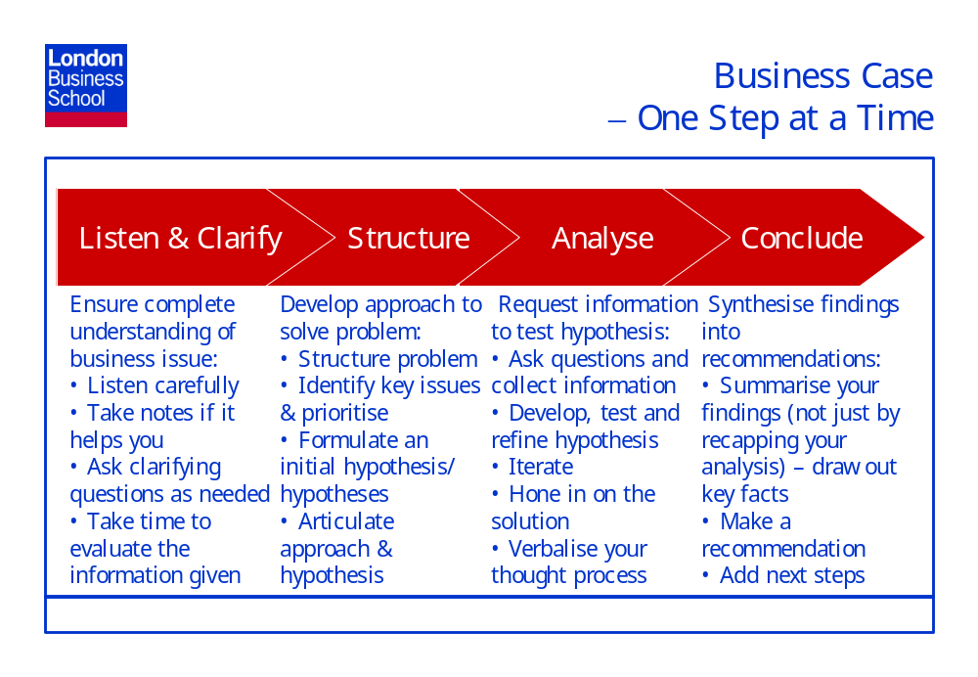
Step 1 – Listen and Clarify:
The interviewer will introduce the case to you by giving you a bit of background (e.g., type of industry, who your client is) by describing the specific business situation and then by giving you some initial information. The amount of initial information you get will depend on the individual interviewer and their interview/case style. Some interviewers will provide you with a lot of information initially. Some of this information will be important, other bits will prove to be irrelevant. Other interviewers may give you very little information up front, deliberately leaving the question vague to see how you cope with initial ambiguity.
However, when the interviewer poses the case to you, make sure that you listen very carefully. If it helps, take notes. (Make sure that you take a pen and paper with you into the interview.) The importance of listening cannot be emphasised enough. You will create a very bad impression if you need the interviewer to repeat the question or if, through not listening, you have missed the key facts and therefore go on to solve the wrong case or fail to focus on the important issues in the case. That having been said, it is completely legitimate to verbally paraphrase the situation and information back to the interviewer before you begin to tackle the problem to ensure that you have understood the key facts.
It is also a good idea to ask clarifying questions. The interviewer may have used terms that you are not familiar with – ask him/her to explain what those terms mean. For example, when talking about the insurance industry and interviewer may use the term, loss ratio. If you haven’t heard of this term, ask them to explain what it means. Clarifying questions show that you are taking a real interest and demonstrate that you are serious about fully understanding the business problem posed. If you don’t make sure that you understand what the interviewer is asking you to do upfront you are denying yourself the opportunity to perform well in the interview. In general, you should not need to ask more that one or two clarifying questions, and it is fine if you don’t have any.
Once you have received and clarified the information, take a bit of time to evaluate it. It is polite to ask the interviewer if he/ she wouldn’t mind if you take a minute to think about the problem (e.g., would you mind if I take a few seconds to collect my thoughts?). There is obviously no right or wrong amount of time to spend thinking about the problem, though generally, you should not spend more than a minute – and less than that if you can. A minute’s silence will feel like a long time to the interviewer. Bear in mind that a large part of the interview is about generating a rapport with your interviewer and the only way you can do this is through a quality, two-way dialogue. Too much silence and lack of eye contact (i.e., staring hard at the paper in your hand as if it will give you the answer) are all negative to creating rapport.
Step Two – Structure:
Your next step should be to ‘structure’ your answer – i.e., give yourself a coherent structure that you can use to guide your analysis. The structure that you use can be one that you have ‘made-up’ (but that is logical and fits the problem) or it could be a framework that you have been taught at business school, e.g., the three Cs or Porters 5 Forces. You may decide that a combination may be the most relevant. However, it is key to remember that the objective of the exercise is not to ‘fit a framework to the problem’. A framework is no more than a tool that you can use to help you organise your thoughts and analysis and ensure that you are exploring all the key issues. One of the criticisms that has been levelled by consulting companies at London Business School MBAs in the past is that people try to shoehorn an inappropriate framework onto a problem. If a framework fits, by all means use it. However, if you can’t think of a framework that fits the problem – or you have a framework in mind but you’re not sure that it fits – have the confidence to develop a structure of your own to guide your thoughts and analysis.
Once you have thought of a good structure, communicate that clearly to the interviewer, so that he/she understands how you are structuring your thoughts. Based on the structure/framework that you have developed, you should then be able to break the central issue into a number of pathways to addressing the problem. For example, in a business case where the interviewer is asking you to find out why Company A’s profits have been declining for the past two years, using the Profit = Revenue – Costs equation is a good structure to start with. Company A’s declining profits could be due to loss in revenues (price x volume) or increase in costs (fixed costs + variable costs). Given that your time is limited it is important to prioritise the issues that you investigate in the case. The interviewer may have given you a hint early on which might steer you towards a particular path first. For example, they may say that a new, aggressive competitor entered the market eighteen months ago, which is a steer that perhaps Company A has been losing market share and hence revenue.
Most consultancies take an ‘answer first’ or ‘hypothesis driven approach’ to solving actual business problems. This means that they will come up with a ‘straw man’ as to what the likely solution to the business problem might be and use this straw man to guide, and prioritise, their analysis. At the end of the case they may have either proved or disproved their initial hypothesis in coming up with the answer – and each is equally legitimate. If you disprove your initial hypothesis, it shows that your analysis was rigorous and succeeded in disproving the ‘obvious’ straw man. In disproving your initial hypothesis, your analysis should also have revealed what the true solution to the problem is. If you prove your initial hypothesis with your analysis, all well and good.
For Company A above, an initial hypothesis might be: ‘Given that Company A’s profits are declining and that you’ve mentioned an aggressive new entrant has come into the market, I would hypothesise that it is more likely to be a revenue rather than a cost issue, and so I’ll start my analysis by looking at revenues first.’
As you conduct your analysis throughout the case interview, remember to relate your findings back to you initial hypothesis: ‘this seems to support my initial hypothesis….’, ‘this seems to refute my initial hypothesis’, and if you are refuting your initial hypothesis indicate that actually, Z is more likely to be where the solution to this problem lies.’
Step 3 - Analyse:
The analysis phase should form the bulk of the case interview. In this phase you will ask your interviewer questions and collect the information you need to conduct your analysis, develop, test and refine your hypothesis and hone in on a solution based on the facts. Throughout the analysis phase you must verbalise your thought process to the interviewer so that they can see how you are thinking. Try to think of the interview as a dialogue between you and the interviewer. They want to like you – and in addition to judging your Problem Solving abilities through the business case, they will be judging you on Personal Impact, Drive and Aspiration and Leadership. Therefore you must demonstrate that you are: good with people (clients); convincing in your arguments; can take feedback/challenge without becoming defensive; that you are a good listener, etc, during your case interview. Try to ensure that the interviewer enjoys the interview. Bear in mind that they will probably be seeing twenty or thirty candidates over a two or three day period and interviews can blend into each other for the interviewer. However, if they really enjoy the interview they will remember you very positively.
There is also a skill to drawing information out of the interviewer and many interviewers will give candidates who they believe are asking questions in a structured, thoughtful way much more information that they would give to candidates who they believe are just reeling out an unstructured laundry list of questions in the hope that they will be able to piece some kind of analysis together from that laundry list. You must only ask questions that you can justify – and then demonstrate that you are using the answer to that question to further your analysis and push the case forward.
By asking questions and bringing to light new information, you will be able to determine whether your initial hypothesis was valid or not. If your analysis proves that your initial hypothesis was invalid, systematically follow your structure and progress to the issue with the next highest priority. Then, based on the new information you receive, develop a new hypothesis as soon as possible. For example:
‘Based on what I’ve learnt from my analysis so far, it appears that actually a reduction in market share and therefore revenue is not responsible for Company A’s declining profitability. It appears to be a cost issue. Though we haven’t lost any market share due to the increased competition in the market, our COGS have increased as we’ve tried to increase the quality of our product but maintain the same price to hold on to our market share. To solve the profitability issue, Company A probably needs to look at ways of maintaining the additional quality, whilst reducing COGS, or perhaps saving on costs in other areas if this proves difficult.’
Asking questions, collecting information and developing and testing hypothesis is an iterative process. As you receive answers to your queries, you should be able to hone in on the answer, and the interviewer may also guide you.
Once again, it is key to continually verbalise your thoughts and analysis to the interviewer. When doing calculations, explain all of the steps you are taking to the interviewer. This illustrates your thought process and maximises the ability of the interviewer to coach you. If you then get the wrong answer at the end of the calculation, the interviewer will be able to see where you went wrong and see whether it was a minor error which they can ignore, or if it was a major error which may indicate you do not have the quantitative skills to be a consultant. If you conduct your calculations in silence and just reveal the answer at the end, if this answer is then wrong, the interviewer will have no idea as to whether your mistake is major or minor and may just assume the worst.
As I’ve already said, asking questions is a fundamental part of the process, but you must ask these questions in the context of your structure and the issues you are exploring – rather than just firing off questions randomly or in no particular order.
As you work through the case, it is also a good idea to summarise where you are at various stages – what you have learnt, what this learning means in diagnosing the problem and which issue you are going to explore next.
Step 4 – Conclude:
Once you feel that you have exhausted all the issues and consequently, lines of analysis, finish the interview by summarising the situation and providing a recommendation or recommendations. Try not to just recap the analysis you have just conducted in your summary. Rather, summarise the key things that you learnt as you performed your analysis and how these added together to reach your recommendation. For example, going back to Company A whose profitability has been declining for the past eighteen months:
‘I recommend that Company A looks at ways to reduce their indirect costs to try to reverse the slide in profitability. Given that the industry is characterised by intense competition, it will be difficult to grow their market share or to increase prices. Reducing COGS without negatively affecting the quality of the product and losing customers would be difficult. Therefore they should look at other ways to save money, though for example, reducing factory overheads, saving money through supply chain efficiencies, reducing head office costs, and improving marketing spend and sales force efficiency.’
You may also want to add some next steps or additional considerations, as appropriate, to your conclusions and recommendations. This shows that you recognise the limited amount of time and information you had available in getting to your conclusion and that there may be issues you haven’t had the time or the information to address properly. Cases are short. Implying to the interviewer that you have covered every base in a complex business issue in 30 or 40 minutes, might indicate that you are short sighted or perhaps even arrogant. It is much better to make reasonable recommendations – but also to acknowledge that you haven’t been able to be completely exhaustive and highlight the areas you’d like to penetrate further (if you had more time).
Estimation Cases
An estimation case is usually in the form of something like – ‘How many gallons of white house paint are sold in the U.K. each year?’
Other examples of estimation cases are:
- How many tube trains are there on the underground?
- How many golf balls would fit in Canary Wharf tower?
- If a male and a female goat are put on a deserted island that has plenty of food and water on it, what would be the island’s goat population after ten years?
- How many wedding dresses are sold in the UK each year?
- How many divorces are there in the US each year?
- How many fire extinguishers are there in London Business School?
- How many coke cans would fit in Buckingham Palace?
- And so it goes on!
The point I’ve been trying to illustrate above, is that you can (and probably will!) be asked to estimate just about anything. This actually makes it very easy to practice estimation cases, because you can come up with a list of at least twenty estimation cases in under five minutes.
If you run into one of these cases, firstly make sure that you have clarified, and therefore fully understand, the question. With the house paint case, if you do not come from the U.K you may be unfamiliar with gallons. Ask the interviewer what a gallon is (approx 4.5 lts). In addition, you should remember that interviewer may deliberately not have given you all the information. Another sensible, perceptive question to ask in this case is whether the paint is internal or external. The paint is actually for external walls only – and I would mark an interviewee down if they failed to establish that at the start, though I would not fail them on the case on this point alone. Once you have established that you understand the question properly, break it down into logical steps and solve each step one at a time. An example solution to the house paint question is:

Step 1
• The population of the UK is about 60 million
• One quarter of the population live alone – 15 million homes
• Three quarters live in families of between two and six – I’ll assume an average of three people per household – 15 million homes
• Total number of homes in the UK is 30 million

Step 2
• Some of these are houses, some are flats
• Every single person I know lives in a flat. However, because I live in central London, I’ll assume that is not entirely typical. I’ll assume 80% of single people live in flats, 20% in houses. 12 million flats; 3 million houses
• Assuming the opposite for families is probably fair
• 15 million houses; 15 million flats

Step 3
• Because the UK is a cold country, most houses are not painted white. There are centres where white houses are popular: Devon and Cornwall, some coastal towns, ‘chocolate box’ villages. But, the population in these areas is sparse and mostly houses. I will therefore assume that only 2% of flats are painted white, and 10% of houses.
• 300,000 flats and 1,500,000 houses

Step 4
• My house is 1,500 square feet. I’ll assume that’s average. The height of a wall is about 10 foot, so, in the average house there is (150*10) + (10*10) = 1,600 sq foot of external wall per house (I’m ignoring windows)• The average flat, is about a third the size of the average house – 500 sq foot. (50*10) + (10*10) = 600 sq foot of external wall per flat

Step 5
• Total external ‘white’ wall space is (1,600*1,500,000) + (600*300,000) = 3,150 million + 180 million = 3,330,000,000 sq foot

Step 6
• But, an external wall will only be painted once every ten years
• So, the total external white wall space to be painted every year is 3,330 million/10 = 333,000,000 sq foot. I’ve done a lot of painting in my life and on the side of a gallon, it says that coverage is about 20 sq foot per gallon. But I’d give a wall two coats, therefore coverage is 10 sq foot per gallon

Answer
33,300,000 gallons of white house paint are sold in the UK every year.
You will notice that I am making estimations at each step of the way – hence the name estimation case. However, the estimations that I made are sensible, relevant and are based on sound reasons. While you do have some liberty to make guesstimates – and the interviewer will not expect you to know exactly how many people live in the UK - your guesstimate is an indication of your common sense. Guesstimating the population of the U.K. at 1 billion people is likely to make a very poor impression. If you have no idea about the magnitude of what you are guessing at, state that and see if the interviewer offers up some information. That said, do not panic, and do not spend an undue amount of time trying to get the answer to be perfect – a good approximation is fine. It is legitimate to use any information that the interviewer might have given you and to estimate other facts you need based on your own best judgment. Just make sure that state all your assumptions out loud - lead the interviewer through your solution
When solving the case bear in mind the ‘evidence’ we discussed in the last section that the interviewer will be trying to glean. In addition to solving the case in a sensible way, the interviewer will be looking for you to generate some rapport with them. Saying things like – ‘Every single person I know lives in a flat. However, because I live in central London, I’ll assume that is not entirely typical.’ – is chatty and gives a little of yourself away. It also serves to illustrate to the interviewer that you are not just pulling your numbers out of the air. If you just solve the problem by continually saying – ‘I estimate that…….’ – ‘I estimate that………’ – ‘I estimate that…….’, your approach is dry, repetitive and guaranteed to bore your interviewer rigid!
How detailed you make your answer depends on whether the estimation case is given to you as the only case in the interview or as an add-on to a business case. In the former example you will be expected to take 15 to 20 mins to solve it and therefore you should go into a lot of detail – probably similar to the example above. If it is thrown in as an add-on in the last few minutes of the interview, tailor the length and depth of your answer accordingly.
It will be useful to know some common numbers and formulas to get you through these types of questions. For example, if you are planning to interview in the U.K., make sure you have an idea what the population of the U.K. is. The same for France, Germany, the U.S., etc. Knowing volume formula of a sphere (like a tennis ball) is also useful in case you get asked an estimation question like – ‘How many tennis balls would fit in Buckingham Palace’. The formula is 4/3 * pie * r3. Similarly you should know the formulas for the radius and diameter of a circle. A building is a rectangular cube and the volume formula is height times length times width. If you show that you are using the relative volumes to determine how many balls would fit in the building, you will likely satisfy the interviewer on this basis alone.
Brainteaser
Brainteasers are not cases in which a technique can be learnt, mainly because a brainteaser can be about virtually anything and posed in any way. However, brainteasers are increasingly rarely used as interviewers seem to be realising that they do not give a good insight into a candidate’s ability to ‘do the job’. If you get a brainteaser, just try to stay calm and take some time to think about the problem. Also, and very importantly, don’t panic if you don’t manage to solve the brainteaser. They are binary – you either get the answer or not – and if you don’t it certainly does not mean that you won’t get the job. It will just be one of many data points that the interview will use to make a decision.

- Six Major Types of Business Case
Types of Business Case
In general, there are six main types of business case:
1) Profit improvement
2) Industry analysis
3) Market entry
4) Capacity expansion
5) Acquisition
6) Investment
However, it must be remembered that these six categories are not mutually exclusive or completely exhaustive. For example, a market entry case might require industry analysis, and an acquisition case may involve evaluating return on investment. Some cases may not fit neatly into any of the six major business case types, but may incorporate certain elements from one or more of them.
1) Profit Improvement
Profit improvement cases are probably the most common business cases that you will encounter in an interview. They are also arguably one of the easiest as the problem is easily structured through systematically examining each aspect of the profitability relationship: Profit = Revenue – Costs.
In this business case the interviewer will typically ask you analyze why a firm’s profits have decreased and what a firm could do to reverse this decline and bring itself back to profitability. For example – ‘Company A’s profits have declined by 30% over the last eighteen months. The CEO would like your help him/her understand why this profitability decline has happened and what he/she can do to return Company A to profitability.’
As mentioned above, Profits = Revenues - Costs = [(Price - Variable costs) x Quantity] - Fixed costs.
Using the expanded form of the equation (in italics) adds an additional degree of depth to your analysis (hopefully impressing the interviewer) and also ensures that you don’t forget the difference between fixed and variable costs during your analysis. Other valuable profitability formulas that you could incorporate in your analysis include:
- Revenues = (Price * Quantity)
- Costs = Fixed costs + Variable costs
- Breakeven quantity = FC/(Price - Variable cost)
You should ensure that you are familiar enough with each of these formulae to be able to use them in a case interview situation. A good way to tackle this kind of case is to use the profitability formula to structure your answer up front – laying this structure out for the interviewer - and then exploring each dimension in detail.
In addition to the formula, you should have a sound understanding of both revenue and cost related issues. Revenue related issues to consider during your analysis include:
  - Factors that impact price:
- Market power
- Price elasticity
- Product differentiation
- Opportunities for differential pricing of the same product, e.g., airline seats
- Methods of Pricing: cost plus; matching; market based (think about the pros and cons of each of these)
- Brand Implications, e.g., strength
b. Factors that impact volume:
- External factors:
  - Competition (share of market, positioning/image, customers, profitability, differentiation, future plans
  - Substitutes/complements
  - Market forces (declining market size, technology, regulation)
  - Customers (needs – latent vs demonstrated, price sensitivity, segmentation – product extension)
- Internal factors:
  - Distribution channels
  - Manufacturing capacity
  - Logistics/supply chain/inventory management
- Growth strategies:
  - Sell more existing products to existing customers
  - Sell existing products to new customers
  - Sell new products to existing customers
  - Sell new products to new customers; think of product extensions
  - Note: New products do not need to be completely new. A line extension, e.g., Diet Coke, is classed as a new product, so remember line extensions when thinking growth strategies
Cost related issues to consider during your analysis include:
- Fixed versus variable costs
- Short-run versus long-run costs
- Capacity utilization and its impact on total average cost per unit
- Benchmarking costs against industry competitors
- Relative percentage weighting of cost components:
  - Cost of Goods Sold: labor; raw materials; overheads
  - Operating Costs; sales and distribution; marketing; general and administrative; research and development
An analysis of costs will vary with the type of industry being considered and it is very important to demonstrate sound business sense by showing the interviewer that you understand, for the specific industry that you are examining in your case, where the big money buckets are, i.e., that you can ‘smell the money.’ For example, for a pharmaceutical firm research and development expenses will be the biggest cost buckets. For an airline, fixed costs (i.e., leasing of or depreciation on the planes, fuel costs, landing fees, maintenance costs) are huge. In the case of a firm with multiple products, how the company is allocating their costs between the products, and therefore their ability to properly understand which products are making a positive contribution and which are not, may be an important issue.
2. Industry Analysis
With an industry analysis case an interviewer will ask you to evaluate the structure and/or desirability of a particular industry. For example, ‘Your client is the CEO of Company B, a U.K manufacturer of rolling stock for the railways. He/she would like you to help him/her understand whether the rolling stock industry a good one to be in. Why or why not?’
Porters 5 Forces is a tool to analyse industry attractiveness, but if you are going to use this to structure your answer, ensure that you don’t say to the interviewer – ‘Oh, an industry analysis case, I’ll use Porters 5 Forces.’ Instead, say to the interviewer, ‘There are six areas I’d like to look at to determine whether the rolling stock industry is potentially a good one for our client to be in. I’d look at the overall industry structure and market conditions as a whole, then I’d like to look in more detail at customers, competitors, suppliers, threat of substitutes and finally what barriers there are to entry/exit.’ You can then analyse each of these in turn.
Issues to consider in industry analysis business cases include:
- What is the industry’s structure (competitive, oligopoly, monopoly)?
- What are the relevant market conditions (e.g. size, growth, profitability, segmentation, technological change, regulatory issues)?
- Competition: Who are the key players? How concentrated is the industry in terms of competitors? What are the strategic positions of the key competitors in the market? How is market share divided? How differentiated are competitors? What is price competition like? What are competitor’s relative cost positions? How vertically or horizontally integrated are competitors?
- Suppliers: What is the industry’s vertical chain of production? Who are the industry’s buyers and suppliers, and how powerful are they? What economies of scale/synergies are there? Are there any alternatives? What are the trends? How stable/continuous is supply?
- Barriers to Entry/Exit: How significant are barriers to entry and exit (e.g. economies of scale, learning curve, high fixed costs, and access to distribution channels)? How frequent is entry/exit? What is the likely competitive response? How steep is the learning curve? How important is brand equity? Is the industry regulated?
- What current and potential substitutes exist for the industry’s product/service?
- Overall: What factors drive success in the industry (e.g. technological leadership, consumer insight, brand equity)? That is, what are the benefit and cost drivers?
- Are there any trends that affect the benefit or cost drivers?
3) Market Entry
In a market entry case, the interviewer will ask you to decide whether a company should expand into a new geographic region, a new/related business, or a new customer segment. For example, ‘Company C manufactures and sells costume jewelry in the USA. They are considering expanding their operations to include fashion clothing, still within the USA. Would you recommend that they do so?’
The three C’s (customers, competitors and capabilities) is a valid framework to use to solve this case, but as with the industry attractiveness example, you should not just blurt out to the interviewer that you are going to use the 3Cs framework. Think what you can add to the three Cs to enhance its value. A general approach to market entry cases is to:
1. Size the market:
a. Define the market: product, geography, etc.
b. Evaluate industry structure
c. Assess market size, profitability, and growth by asking how much capacity is in the market; and,
d. Identify relevant trends (regulatory, technological, demographic, etc.)
e. Identify key success factors
f. Evaluate risks
2. Understand the competition:
a. Key players
b. Competitive situation – concentration and intensity
c. Share and positioning
d. Core competencies (strengths and weaknesses) and resources
e. Likely reaction to entry
f. Differentiation
g. Cost structure
3. Analyze customer needs:
a. Segmentation (size, profitability, share, growth)
b. Drivers of purchase behavior (product, price, promotion and place).
c. Power in the market
4. Identify Gaps in Customer Needs
5. Assess the company and analyze how well the company’s strengths match the new
market:
a. Core competencies (product/service portfolio, differentiation, management, workforce, key skills) and resources (can the firm establish a competitive advantage?) versus key success factors
b. Potential positioning and price positioning
c. Source of volume (steal share (from whom?) or expand category?);
d. Niche or mass strategy?
e. Cost structure (scale vs. scope economies)
f. Capital expenditure required
g. Potential returns
6. Evaluate Barriers to Entry
a. Customer-related: Product differentiation; Brand loyalty; Switching costs; Access to distribution channels.
b. Non-Customer-related: Proprietary technology; Economies of scale; Capital requirements; Experience curve; Regulation.
7. Evaluate Methods of Entry
a. Build, acquire, partner?
b. Quantify investment cost and risk
8. Analyze how firm has entered markets in the past, whether it has it been successful or
unsuccessful, and why?
4) Capacity Expansion
Capacity expansion cases usually revolve around how a firm can optimally increase its
output potential. For example, ‘Your client, the CEO of Company D has decided that he/she needs to expand Company D’s manufacturing capacity and is considering either building a new plant in Kuala Lumpur, Malaysia, or increasing the scale of its current plant in Singapore. Which would you recommend that it do?’
A good approach to tackling capacity expansion cases is:
1. Estimate the potential benefit of capacity expansion by quantifying market demand and potential revenue gains.
2. Evaluate the means of capacity expansion (existing plant or new plant?). Issues to
consider here include, availability of desirable location for a new plant, proximity to customers and suppliers, transportation costs, cost and availability of labour, technology, time required to complete expansion, capital costs of new vs existing plant.
3. Market considerations
- Impact on industry demand & pricing: will expansion create excess capacity in the market?
- Likely competitive response
4. Cost/Benefit analysis
5. Finally, investigate other options to ensure that you have fully analysed the problem. Other options could include outsourcing, leasing or acquisition of an existing plant.
5) Acquisition
In acquisition cases, an interviewer will typically ask you to evaluate whether a company should purchase another firm. For example, ‘Company E, a manufacturer of engines for sports cars, is considering an acquisition of Company F, which makes sports cars. Would you recommend that it do so?’
The easiest thing to remember, when approaching acquisition cases, is will 1+1=3?, i.e., will the acquisition add value over and above the value of the two component companies?
1. Ensure that you understand the acquiring company’s line of business, its core
competencies, its cost structure, and the underlying structure of the industry in which it
competes.
2. Assess the rationale for acquisition (e.g., Why is the company considering the
acquisition? What potential synergies exist?)
a) Acquire resources: increase capacity; increase distribution; broaden product line; improve technology; human capital; brand name; customers (network effect)
b) Decrease Costs: economies of scale; conomies of scope (brand, distribution, advertising, sales force, management talent, etc.); climb the learning curve more quickly
c) Other strategic rationales
3. Assess the likely response of competitors if the acquisition occurs
4. Consider organizational issues
- Will potential synergies be realized?
- Might the firm make any changes in advance of the acquisition to be better positioned post-acquisition?
- Is the firm in a position to perform the integration?
5. Determine whether the potential revenue increase/cost decrease exceeds the price of
acquisition (NPV analysis)
6. Consider alternatives to the acquisition; other targets; organic growth
7. If the acquisition is vertical (as opposed to lateral (new business) or horizontal (increasing the firms current scale) consider the following:
- What are the benefits of using the market that is keeping the entities separate?
- What are the coordination costs associated with using the market?
- How might the firm enhance the benefits of using the market or reduce the
coordination costs associated with using the market? That is, how might the firm
improve its situation without integration?
- What would be the source of gain from ownership?
- What organizational issues might be introduced (agency costs) as a result of
ownership?
While you may not have enough information to answer many of the questions above,
indicating that you understand the importance of these questions is useful. So do bring up a few. They are all questions that you would find critical to answer in coaching a firm through an acquisition to demonstrate that you understand what this type of analysis is likely to focus on.
6) Investment
Investment cases usually take the form of examining the potential purchase of a new
business or installation of new infrastructure. For example, ‘Company G is considering whether or not to purchase and install a new inventory management system. Would you recommend that it do so?’
A general approach to investment cases is:
1. Ensure that you understand the firm and its line of business, and the fundamentals of the industry it competes in
2. Determine why the firm is considering the investment
3. Do financial analysis (NPV analysis)
- What are the up-front costs of the investment?
- What are the projected cash inflows and outflows of the investment and how will they occur over time?
- What are the opportunity costs of the investment upfront and ongoing?
- What is the firm’s cost of capital?
- What is the investments upside/downside potential (sensitivity analysis)?
4. Other Considerations
- Effect on competition -- if the investment is made or not made, what will the competition do?
- Does the investment have option value (e.g. follow-on opportunities)?
- Timing: should the investment be made now?
- Other strategic considerations
5. Alternatives to making the investment.

IV. Practice Business Cases
The eighteen practice case interviews that follow were written by London Business School MBA students, all of whom worked within consulting either before their MBA or during their Summer Internship. They also all attended either the October 2004 or October 2005 Crack-a-Case Masterclass, run by the ex-Head of Global Recruiting at McKinsey & Company, and designed to teach student attendees how to be excellent case interviewers.
All the cases were written as a result of their consulting experience, and reflect a case that they personally conducted during their time as a consultant. Each case is structured, as much as was possible, as it would be given to you during an interview. Because the cases are written by different people, they are phrased differently and are of differing levels of complexity. Some are heavily quantitative, others are very light on quantitative questions. This reflects the huge variety of cases that you will encounter while interviewing with consulting companies. In actual consulting interviews, each interviewer writes their own case, from their own consulting experience, and the cases are not reviewed by a central ‘quality checker’ to ensure that they are comparable in terms of ease, quantitative content, etc. You may be lucky and get all ‘easy cases’. You may be unlucky and get ‘hard cases’. Most likely, you will get a mixture of cases that you can solve relatively easily and cases that challenge you to a far greater degree. In addition, what is easy to one candidate may be hard to another depending on their particular strengths. Unfortunately the consulting interview process involves a large amount of luck in addition to the skill and preparation, and in acknowledgement of this, the cases in this book accurately reflect a broad picture of the types of cases you will encounter.
As the cases in this book are designed to give you a solid foundation in solving business cases during consulting interviews, this section is not meant to be read straight through. Instead, you should dedicate a significant amount of time to studying each case individually. A good way to use these cases would be for students to give them to one another during case practice.
We have retained the initial nine practice case interviews from the first edition of this Case Book, which were written by MBA 2005 students, and added nine brand new cases, written by MBA 2006 students. For quality reasons there are not enough cases in this book for you to rely on it as the limit of your practice. As mentioned in the introduction to this Case Book, please just use this as one source and ensure that you supplement it with attending Consulting Club presentations and getting involved in the mock case interviews organised jointly by the Consulting Club and Careers Services.
(Cases 1 to 9 were written by MBA 2005 students; cases 10 to 18 are new cases for this edition of the Case Book written by MBA 2006 students.)

Case 1 - Terrific Tennis plc
Introduction
Before asking you specific questions on the case, I’m going to give you some general background. We will be covering a number of issues today, so don’t be alarmed if I change track abruptly.
Our client is Terrific Tennis plc, the UK’s leading owner/operator of fitness centers. Like most fitness centers, these usually include a gym, pool, spa, sauna, tennis courts, and a crèche for children. The centers are located mostly in suburban areas and provide parking for members.
Our client has been extremely successful in the UK, and is considering an expansion into Continental Europe (and in particular, Germany).
Question 1: What six pieces of information would you want to understand when considering this expansion?
This question is deliberately ambiguous and is designed to test the candidate’s ability to structure an answer. Obviously the candidate should not use a model in a formulaic way, but most often this question is approached via a “3C’s” or “Porter’s Five Forces” analysis. It is recommended that the interviewer give the candidate 30 seconds or so to come up with a few points, and then ask the candidate to start with what they have.
The following points might be made in response to this question:

 | Good answer | Additional Points for an outstanding answer
Customers | - Market size and growth  - Market segmentation – activity level of Germans, preferences | - Cultural factors – will Germans leave their children at a crèche? Will they drive to a gym?
Competitors | - How many competitors are there?  - How intense is the competitive rivalry?  - How do they position themselves? | - Legal/Regulatory issues  - Maturity level of the market  - What is the history of new entrants into the market
Company | - Can the business model be replicated in Germany?  - Can we achieve any economies of scale? | - Can the company afford to expand?  - Is there real estate available for suburban centres?

Question 2: You’ve come up with some useful pieces of information there. How would you go about finding out those pieces of information?
This question is relatively simplistic. Common answers include:
- Purchase marketing analyses/research reports
- Internet search on competitors
- Call industrial estate agent re real estate costs
- Etc
However, the best answer is to simply call someone within the consulting firm who has experience in either the German market, or the fitness centre industry. Accessing internal expertise from other consultants is how most consultants prefer to operate, and in a large firm there is usually someone who has done a similar study, or who at a minimum knows a lot about the market you are seeking to enter.
This question is designed to make the candidate realize this point, and hence this should be stressed to the candidate. If the candidate has the opportunity to make this point in a real interview, they will come across as “one of the team”, ie someone the interviewer can see themselves working with.
This is a very important element of an interview.
Question 3: OK, let’s assumes that the team has investigated the costs of the expansion, and determined that a pure tennis court facility would be the best way to enter the German market. A tennis court facility could be opened and operated for one year at a total cost of GBP 147,000. Using the following information I will give you, can you help us determine the minimum annual charge our client should pass on to members to cover the running costs of the court?
- Number of courts: 10
- Hours of use: 8am – 6pm
- Days of use per week: 7
- Playing use (hours per member per week): 1
- Assume that the courts are always in use during their opening hours
This question is designed to test basic quantitative skills. Some candidates will try to do a profit analysis and ask for revenue data – if they do, the interviewer should ask them to set revenues equal to the cost base to redirect them.
The candidate must realize that they need to make an assumption about doubles play percentage. If they don’t realize that more than one person needs to be on the court at any one time, then they have missed a fundamental assumption and have failed the question. It is recommended that interviewers tell candidates to assume 50% singles and 50% doubles court utilization (if asked).
The calculated solution is as follows:

Number of players per court per hour | 3 | 50% 2 players and 50% 4 players
Number of hours played per week per court | 70 | 7 days x 10 hours per day
Number of members per court per week | 210 | 3 players/pc/pd x 70 hours/pw/pc
Number of members | 2100 | 210 members/pc/pw x 10 courts
Cost per member per annum | £70

Optional question: £70? Are you sure that is an annual subscription charge and not a weekly subscription charge?
This is a trick question designed to ensure the candidate understands what it is that they have calculated. By dividing the GBP 147,000 annual costs by the number of members (who can only play one hour per week), it is indeed an annual subscription charge. This question also tests a candidate’s ability to take a stand on their answer.
Question 4: Assume that after further investigation, the team determines that there is a competitor in the German market who holds a 65% market share in the fitness centre market (i.e. full fitness centers, not just tennis courts) and has a cost base of £40 per month per member. The team has determined that our client, Terrific Tennis, could not get their cost base lower than £60 per month per member.
Given the existence of a dominant market player with a significantly lower cost base, would you recommend entering the German market?
The best answer to this question is “it depends”. What is required is further investigation into what the competitor is offering, and whether we can differentiate from that offering. For example, if the competitor operates in the lower end of the fitness market, we could launch a premium fitness centre offering and position ourselves in an entirely different segment – making the cost base differential of marginal relevance. The candidate must display an understanding of this point to pass this question.
An outstanding candidate would consider alternative outcomes from the investigation. For example, the candidate might say that if the investigation reveals that the competitor operates across all segments, ie low end to high end, and maintains a lower cost base, then an appropriate recommendation would be to not enter the market (we would be vulnerable to a price war we could not win).
Question 5: You’ve been asked to update the CEO of our client with the findings of the team we’ve discussed today. What three points would you emphasise to the CEO?
The candidate should tailor their answer along the lines of an elevator pitch. They key points that should be made are:
- If we were to open a pure tennis court facility in Germany, we would need to charge at least £70 annual subscription to make it profitable
- We should only consider entering the German market after determining whether we can differentiate our offering from the dominant 65% share market player
- A number of broader issues should be considered (candidate should select some issues from their answer to question 1)

Case 2 - Titleist Golf Balls

Note: This is a purely fictional case largely quantitative in nature. It’s a good introductory case, and something that you may see in a first round of interviews.
Introduction
The Titleist Golf Ball Company is a global manufacturer and supplier of golf balls. It is present in almost every market in the world. One country where they are not yet available is the African country of Malawi. Currently they have no representation in the country and have no information on the size of the market.
By way of background, Malawi is a small country between Tanzania, Zambia and Mozambique. It has a population of 11 million and a GDP/cap of $158. There is no detailed, reliable information on population demographics available.
The CEO wants to know, should they enter the market and if so, how?
Question 1
How would you go about analysing this?
The candidate should lay out a clear structure and get into some level of detail in each section. The main sections to be covered are:
- Size of market, particularly a way to estimate the number of balls sold in the market, eg:
    - Number of players X games played per year X balls lost per game
    - Sales per producer X market share per producer
    - Number of retail stores X balls sold per store
    - Number of golf courses X games per year X balls lost per game
    - Benchmarking players or size against comparable countries
    - Note: Estimating a luxury product’s size from country demographics is rather impractical as this is a very poor country and information systems are ‘sketchy’ at best.
- Revenue and costs
  - Pricing by segment
  - Cost structure (fixed / variable components)
- Competitors currently supplying the market
- Retail structure / value chain – comes into understanding how to enter the market
- Options to enter the market
If the candidate starts to ask for data immediately, force them to layout how they would structure the problem.
Question 2
Lets look into the part of your structure where you looked at the size of the market. The information we have been able to collect so far is:
Number of members registered with the Royal Malawi Golf Association: 48,723
Number of golf courses in Malawi: 206
Candidates should round these numbers during the calculations
At this point the candidate would need extra data to do the market size estimate. If they get stuck on this or the calculations after about 5 minutes, skip to the next question and give them a market size of 10m balls.
Whichever method they choose, give them the following information:
Consumer approach
- They should hopefully pick up that there are tourists, casual players etc. If so tell them there are 150,000 unregistered/casual players
- They should ask for frequency of playing and balls lost per game, so give
  - Registered members : 1 game/week, 1 ball lost per game
  - Unregistered members: 12 games/year, 5 balls lost per game
- The question most people don’t ask is, are all lost balls replaced with a new ball. If they ask, state that they should assume this for now.
Calculations
Registered– 50,000 players x 1 game/player/week x 50 weeks/year x 1 ball / game = 2.5m balls / year (note: 70% of people get this wrong and say its 250,000)
Unregistered – 150,000 players x 12 games/player/year x 5 balls / game = 9.0m balls / year
Total market size = 2.5m registered + 9.0m unregistered = 11.5m balls/year
Golf course approach
- Golf courses utilised 4 months per year at 100% utilisation and at 50% for 4 months per year and is closed for 4 months per year
- Average game takes 4 hours. There are 18 holes per course split into two sections (front 9 and back 9). A player can start play on either the front 9 at hole #1 or back 9 at hole #10.
- Most golf games are played as a pair of players at the maximum capacity, there are 2 teams playing a hole (ie 4 players per hole)
- A golf course is open 10 hours per day
- Average player loses 2 balls per game
- All players must finish 18 holes in a day
Calculations
Think of how many players can play on a course per day. Since all players must play all holes, we only need to analyse say the Front 9. It takes 2 hours for the first players to finish the front nine. At that time, there are 2 teams per hole, 2*9=18 teams on the course. Every hour for the next 8 hours, 9 teams finish the front nine, ie 9*8=72 teams finish per day. So 72 teams * 2 players / team = 144 players / course / day

2
8
10
0
18
Front nine
Time
Player teams on course
2
8
0
9
Front nine
Time
Player teams leaving course
10
Balls lost per year = Balls lost /day * days per year
Plying days per year = 30 days/month * 4 months *100% + 30 days/month * 4 months * 50% = 180 days/year
Total market size = 150 players/course/day * 2 balls / player/game * 200 courses * 180
days / year = 10.8m balls/year
Question 3
Now that you know about the market size, lets talk a bit about the market. The market is currently supplied by 3 suppliers. There are two local entrepreneurs who import balls from China and an American supplier, Callaway who imports from the US. Each player has a 1/3 market share. How would you think about the strategic issues of this market structure?
This should test some strategic thinking on what are the issues that affect this market. Candidates should cover things like:
- How next steps in the value chain may affect the system
  - Who does the distribution, where are the sales points etc?
  - How are their businesses structured?
  - In this case final sales are via pro-shops at the golf courses and they use salespeople to build relationships
- How does product offering affect the system
  - In this case, Callaway is premium quality, priced at $0.75/ball, the others are medium quality priced $0.60/ball. We are comparable/slightly better than Callaway
- What does pricing look like in the system
  - What are competitors pricing like (see earlier)
  - Are consumers price sensitive (in this case, the cost of golf clubs, course fees, tuition etc is far greater than the cost of a ball, so generally they are very price insensitive to ball costs)
- Do the competitors appear to make money in the country
Question 4
We spoke to our accounting department and they came up with some costings for entering this country. ‘Hand over sheet with costings’. Based on this information and marketing’s estimate of an entry price of $0.78/ball, does it make economic sense for us to enter the market?

Additional information from accounting department
Revenue per ball $0.78 / ball
Direct materials cost $0.22 / ball
Labour cost $0.15 / ball
Other variable costs $0.16 / ball
Country office costs
Rent $5,000 per month
Sales person cost to company $2,400 per person per month
Country manager cost to company $4,000 per person per month
Other assumptions
1 salesperson can service approximately 40 golf courses (South Africa benchmark)

This should be pretty quick to crunch the numbers. Candidates may ask for things like rate of return the business needs, or target market shares etc, but give them nothing. See if they can come up with insights like….. it will take X many balls to breakeven, which means a Y% market share. Economically, this is a marginal market, with $0 fixed investment. You need to cover your marginal fixed and variable costs to make the market viable, so using breakeven is a good way to start to think about whether to enter the market.
Many candidates end up doing things like working out the profit for the whole market and saying its worth us entering. Clearly there are logic flaws if they do this. Give them a few minutes, then guide them to breakeven volumes and market share.
Calculations
Variable margin = 0.78-(0.22+0.16+0.15) = 0.25/ball
Salesmen needed = 206 / 40 = 5 people
Fixed costs = 12*(5000 + 4000 + 2400*5) = $252,000 / year
So breakeven = 250,000 / 0.25 = 1 million balls
i.e. about 10% market share based on our previous assumptions
Question 5
Based on your previous analysis, we need an X% market share to get into this market. As seen in our costing report, our traditional way to enter the market is to use salespeople to get visibility in stores. What other creative ways can you think of to get into this market?
This should show some business judgement on. Most ideas are OK as long as they make sense. Candidates should bring up ideas like
- Use of 3rd parties who have a distribution system and thereby making the system purely variable, rather than putting our own people in and creating fixed costs
- Converting the 2 local entrepreneurs to supplying the market with our ball vs the Chinese imports (provided we they can prove they will make more money)
- Trying to cut fixed costs out of the system by changing pay packages, using less salesmen etc.
Question 6
What is the most critical assumption you have made so far?
Most things are fine if they can justify them. Bonus points for anyone who identifies
- Not all balls that are lost are replaced by new ones. This is an implicit assumption in most people’s analysis. If only 1 in 5 balls are replaced, this changes the picture massively. Where do all those lost balls go? There has to be a 2nd hand market somewhere.
- Unregistered players may not replace lost balls with new balls. Tourists may well have a sufficient stock of their favourite ball bought in their native country. Casual players may prefer 2nd hand balls to new balls. Since this segment’s demand is 80% of the market, it skews the picture.
Question 7
The CEO walks in. You have 1 minute to put your case forward to him.
This is the classic elevator speech. Candidates should be clear and concise and action orientated with their recommendations. Hopefully, they should remember that the question the CEO asked was “should they enter the market and if so, how?”

Case 3 - XYZ Holiday Parks

Introduction
In this case we are going to make an assessment of an acquisition opportunity. The questions will help guide you through the case. This case is long and, in 30mins, the interviewer may be more interested in covering certain questions in depth than asking all questions.

Context
A client is considering the acquisition of a XYZ Holiday Parks, which runs 4 static caravan (US: “trailer”) parks (A, B, C, D). These holiday parks are in coastal locations in Cornwall and Devon and each has a range of facilities including indoor or outdoor swimming pools, tennis courts, mini golf, amusement arcades, bars and restaurants. Caravans are owned by the company and let to holidaymakers – typically British families looking for a cheap holiday – between March and October.
The parks are medium scale with an average of 400 pitches. The sites are well maintained and boast good customer satisfaction levels which has led to 50% of visitors being repeat customers. Caravans come in a range of sizes, sleeping between 4 & 8 people. Caravans cost on average £15,000 but go up to £40,000 and have an average life of 15years.

Question 1: What are the key drivers of profit in this business?

A gentle introduction to the case. The candidate should identify:

Sources of revenue
  - Rental income
  - On-site revenues (bars, etc.)
- Key cost items
  - Maintenance / Site running costs
  - Marketing
  - Corporate overhead costs
  - Selling costs (agency fees)
  - Depreciation
Question 2a: What would you estimate the revenue of this business to be?

This is testing confidence and ability to manipulate numbers and make sensible assumptions. The candidate should recall information from the introduction and make sensible assumptions for required data points.
Need to recall:
- Size of parks – 400 caravans per park
- Length of season – March to October = 35 weeks

Estimates:

Approximate rental per van – (suggest) £300 per van per week, [but sensible assumptions are equally valid – from £200 - £600 would be acceptable]
- Ancillary revenues – (suggest est.) £50 per person per week.
- Average of 6 people per van
- Utilisation rates. Suggest 80% estimates in the range 60% - 90% sensible.
Calculation:
Revenue = 4 Parks * 400 vans * 35 weeks * (£300 + 6*£50) * 80%
= £30.24mil
Question 2b: Given EBITDA @ 30% what profit (EBIT) is this company making?
Further required to recall that vans cost £15k and last 15years.
- OK to assume, but candidate should mention:
  - no material (historic) inflation
  - straight line depreciation
- EBITDA = 30% * £30mil = £9mil
- Depreciation on vans = £15,000 / 15years = £1,000 per van per year
- Depreciation = £1.6mil p.a.
- EBIT = £9mil - £1.6mil = £8.4mil
What item is missing in this analysis?
- Depreciation on other fixed assets, e.g. the swimming pools!
Question 2c: So what range of values would you put on this business?
- EBITDA multiple of 4 is appropriate, but sensible ranges would be acceptable
Question 3: What considerations would you want to make to be comfortable with the acquisition?
This is an opportunity for the candidate to show ability to structure and populate an appropriate framework to assess the competitive landscape and industry dynamics. Porter’s 5 Forces is a good framework to apply, but others would be fine, e.g. 3C’s.
Some of the specific details below could be provided by the interviewer if looking for further insights, but the more an interviewee provides, the better:
- Suppliers
  - Caravan manufacturers
  - Developers / builders of facilities on sites
  - Travel Agents (selling the holidays)
- Customers
  - British consumers – it is reasonable (although not necessarily true) to guess that customers are low income families, which are in falling numbers as the population gets richer
  - Growing tendency to take more short breaks, which is benefiting domestic holiday destinations
- Substitutes
  - Alternative holiday options / accommodation
    - Hotels / B&Bs
    - Overseas holidays / package deals (growing with short haul flights, e.g. EasyJet)
- Barriers to entry and exit
  - This market is well protected from new competition since it is very difficult to get planning permission to develop new caravan parks
- Competition
  - Interesting point to cover is what distinguishes this company from competitors, i.e. what sells the company to customers
    - Entertainment
    - Locations
  - There are in the region of 4,000 camping and caravanning sites in the UK, ranging from a field (for tents) with a tap to large scale holiday parks
Question 4: Analysis shows that the revenue increases follow capital investment in the parks. What does this tell you and how would you choose to run the business?
Here you are again being tested on ability to structure problems and ensure that the structure used is MECE (mutually exclusive, comprehensively exhaustive)
- Question suggests that investment leads to one of:
  - More customers
  - Higher rental rates
  - Higher ancillary revenues
- Analyse which is it:
  - If it is greater customer levels:
    - Ensure that customers are not coming for other reasons – e.g. marketing of new facilities – you could increase marketing which would drive up volumes without investment
    - If driver is genuinely the new facilities – does the marginal increase give a positive payoff? Can this be replicated at other sites?
    - Remember that capacity constraints in high season probably mean that the payoff comes from increases in low season demand – are new facilities appropriate to low season?
  - If it is higher rental rates:
    - Rental rates are controlled by management. What is stopping the management raising rates and can they be increased without the capital investment?
  - If it is higher ancillary revenues:
    - What is the marginal increase in revenue and does it justify the capital expense.
    - Is it repeatable at other parks?
    - Are you cannibalising other revenue streams?
Question 5: Most competitors choose an alternative business model whereby the caravans are sold to customers who may use the caravans themselves or sublet to holidaymakers. If you acquired the company you might choose to switch to this business model. How would it affect your business and what would be the benefits and risks?
There are a number of considerations here. This is an opportunity to show creative thought and general business awareness.
- Income streams of alternative model:
  - Sale of caravans on which the firm could charge a commission
  - Ground rental charge to owners
  - Commission charged for letting and managing caravans on behalf of owners
- Benefits:
  - Capital injection and removal of caravans from the balance sheet
  - Potentially higher utilisation rates
- Risks:
  - Full time owners are less likely to spend money in bars and restaurants than holiday makers
  - Significant exposure to cyclicality of market – investing in caravans is like investing in a second home.

Case 4 - Beer Industry
Written in Plain - Information from the interviewer

Written in Italics - Suggested content of answers by interviewee

Introduction
Your client is a well-known beer company. Recently they have become aware that their profits have been declining while those of their main competitors have been increasing.
Where would you start to solve this problem?
I’d like to start by asking some clarifying questions.
Does the company manufacture and sell beer? Yes
Is the beer sold in pubs/restaurants and in bottles/cans (supermarkets, grocery stores, etc.)? – Yes, but mainly in pubs and restaurants

Part I

I’ll start by considering Costs and Revenues since Profit = Revenue – Cost
On the cost side, dividing costs into fixed and variable items, the main cost items would be:

Fixed costs  Capital equipment  Salaries  Maintenance  Contributions to pension schemes  Depreciation on assets  Sales and Marketing | Variable Costs:  Distribution  Raw materials  Overheads

Moving onto the revenue side I would consider:
Revenues:
Sales of products
Investments
License fees
The client’s costs seem to be in line with its competitors. Where would you look next?
Ok, I’d consider the revenues. Since the main revenue comes from sales of final product, I would start here. Have sales been declining?
Yes, sales have declined 10% in the last year – how would you go about figuring out why?
Revenue is comprised of No of units sold (volume) x Price.
Have the prices been reducing?
No, prices have remained fairly stable.

What about the volume sold – has this been declining?
Yes, this appears to be the problem – the volume of beer sold has declined by around 10% over the last year.

Part II
Can you estimate the overall size of the market for beer in the UK?
I’ll start by assuming that the market includes beer consumed both in restaurants and bars and at home (purchased in the grocery store)
The UK Population is about 60million
I’ll now estimate proportion of people of the population who drinks beer at some time – within the potential market, which is everyone over 18 years old
Assuming Population is evenly distributed across all age groups up to 80 years old, roughly 75-80% of the population could be a beer drinker = > 50million people
But there are some people who never drink beer and some people who rarely drink beer.
Divide the potential beer drinkers into male and female, assume 50:50 split:

Females
25 million females – assume almost half of them (almost) never drink beer (prefer wine or other alcohol). 15 million drink beer at some point. Divide into high and low users
10 million low users – 1 pint per week (average)
5 million high users – 2 pints per week (average)

Total annual consumption (Females) = 20 million pints per week, 1 billion pints per year.

Males
25 million males – assume 20% never drink beer. The remainder drink beer at some point.
10 million High users – 6 pints per week
10 million Low users – 2 pints per week
Total annual consumption (Males) = 160 million pints per week, 8 billion pints per year
Assume cost of pint = ₤2
Value of beer sold in a year in UK = ₤18 billion

Part III
Our client currently holds 20% market share and is the 3rd largest in the UK market. (Lead 27%, 2nd 22%). How would you begin to find out why the sales of our client are declining?
I’d want to carry out a study to find out about three different areas:

Customers –
Who are the target customers?
What is the target demographic?
What is the target outlets for the sales of the client’s product? Has this changed?
Competition -
Has the competition taken any action which might affect our sales? E.g. price promotion? Marketing? Release of new product lines?

Company -
Are we behind the times?
Has the client been standing still while the competition is moving forward – e.g. launch of new product ranges like low carb. beer or low alcohol beer?
Do we have good products but the sales and marketing part of the business has not been active enough?
Could we be targeting sales and marketing more carefully?
What about our distribution channels – are they in line with our target consumer?

Part IV
Assuming that the major contributing factors to the decline in sales is a combination of competitor action – with price promotions and marketing campaigns - and a view that the client’s product is no longer “cool” but an “old-man’s drink”, how would you go about growing the client’s sales again? (looking for creativity)
- Analyse customer segments to understand what consumers value in each segment. Select a target audience and then relaunch brand with their preferences in mind – consider selecting a suitable celebrity to use in advertising campaigns
- Consider premium branding for more expensive products
- Price promotions – need to remain competitive – but this may impact profits if costs are high. Need to review costs in process – utilisation, distribution, etc
- Distribution outlets – currently sell mainly in pubs and restaurants – consider targeting supermarkets more – this could be a better way to reach our target customers
- Assess product mix – too many brands? Consider simplifying product range then marketing
- Acquire a small company with a strong brand and leverage that
- Consider expanding distribution outside of UK to achieve increase in volume – but beware of increased costs

Case 5 - Sunco, Financial Services
Industry: Financial services
Region: India
Source: Based on a simplified version of a real consulting engagement
(Some case interviewers give very little information in the beginning of the case and want you to probe for information. Some others however give a lot of information to see how you handle such enormous quantities of data. This case belongs to the latter category.)
The year is 2000. The case we are about to discuss today is based on the financial services industry in India. Before I tell you about our client, I am going to give you some information about the industry structure.
The industry has 2 sub-segments: Commercial Banks and NBFCs, which stands for Non Banking Finance Companies (the idea is to throw some complex sounding acronyms to see how the candidate handles it). Both these segments are highly regulated by the banking regulator but the key differences between the two segments are as follows:
- Commercial banks are typically national players whereas NBFCs are regional players the reason being that the former is a scale business
- NBFCs are not allowed by the banking regulator to offer an important product called checking accounts (or current accounts as it is called in certain countries) to their customers. Before I explain what that this product is tell me if you know the difference between an asset and a liability product for a bank is (candidates who are not familiar with the banking industry should not be afraid to ask the difference - this is a test to see if the candidate asks questions or just assumes things sometimes incorrectly). An asset for a bank is the loans it gives out and a liability for a bank is its borrowings. The checking account that I referred to is a liability product and the unique feature of this product is that it pays 0% as interest. This means that commercial banks can borrow from the consumer using this product at a very low cost. However, it is also a highly transaction intensive product which means that commercial banks incur a huge cost in serving its customers for this product. After a cost benefit analysis, it has been found that this is still a very profitable product for commercial banks.
Our client’s name is Sunco and it is India’s 2nd largest NBFC. Sunco is a very dominant player in Southern India and practically non-existent in other parts. It has been recently invited by the banking regulator to convert itself into a commercial bank. While on the one hand the CEO of Sunco is pleased by this gesture of the regulator, who has never extended such an invitation to anyone in the past, at the same time he is concerned at what it means for Sunco to convert into a commercial bank. He has given you a 30 minute appointment to brief him on how he should think through this opportunity.
CLARIFY:
In this case the ‘Clarify’ phase is very important as there is a lot of information given out by the interviewer and he/she will want to see if the interviewee has been able to understand and assimilate all that. After summarizing the above information in a minute (the candidate should practice that on his/her own – I haven’t provided a summary), some questions that the candidate can ask during the clarify stage could be:
Why has the banking regulator invited our client?
In a general sense, to promote competition in the commercial banking industry. The reason our client was specifically invited is because it has been AAA rated for its borrowings consistently for the last 5 years.
Have other NBFCs been invited as well?
Yes the top 3 NBFCs, all of who have AAA rating for their borrowings have been invited.
STRUCTURE:
After clarifying the issue at hand, the interviewee should first try and formulate a ‘structure’ for the discussion. While many structures can be used to solve this case, one good structure that could be used is to evaluate the ‘Option’ of go and no-go for becoming a commercial bank.
However, that’s a very high level structure and within each option, the candidate should evaluate the pros and cons using other lenses listed below in the ANALYSE section (what I have listed is a comprehensive set of lenses that can be used in this case but realistically not all can be discussed in a 30 minute interview)
Ideally the candidate should also come out with creative ideas of options other than just a go or no-go discussed later in the case. (I have found this to be a good framework to use in most ‘options’ based cases which involve, divestment, acquisitions, market entry etc).
ANALYSE
    - Market structure & competition:
(The candidate should find out about how many players are there in the Commercial banking segment, how consolidated is the market (market shares), what has been the past growth rates and expected future growth rates etc.)
If the candidate asks some of these relevant questions, the interviewer will provide some/all of the charts shown below. The main purpose of the charts is to see how the candidate reacts to data being thrown at him/her. The following graphs could be shown and the candidate asked to summarise his/her understanding:

SLIDE1
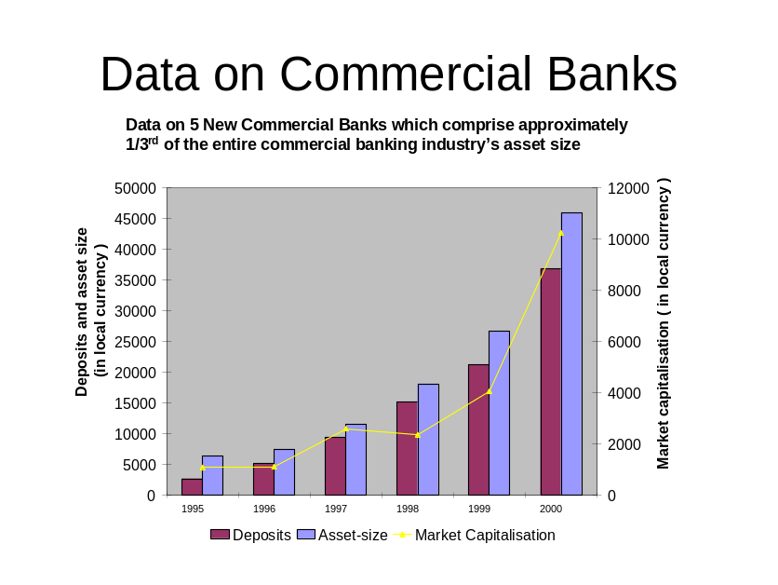

SLIDE 2
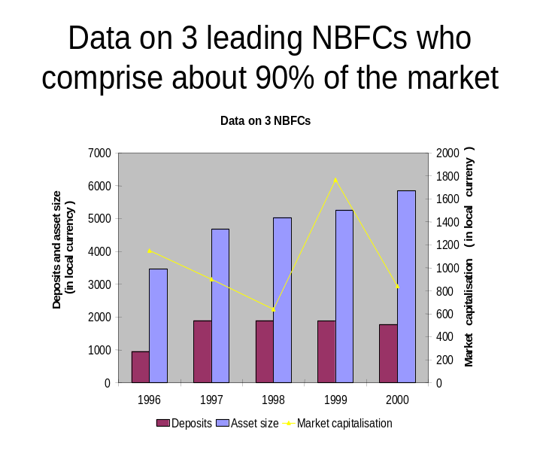

SLIDE 3

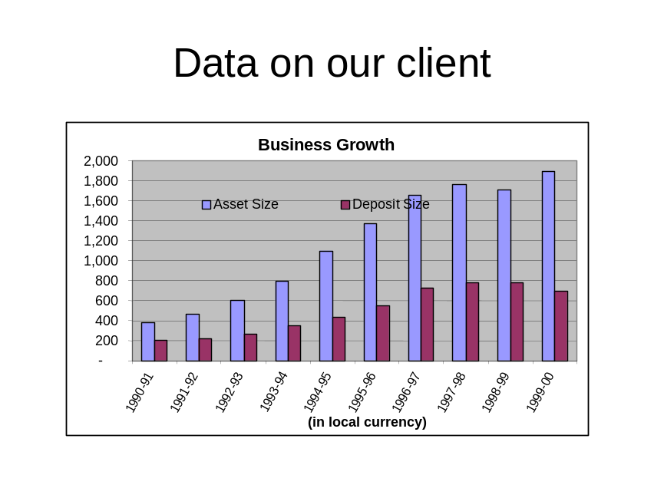

After seeing the above graphs, the candidate should ask one or several of the following questions or bring out his/her observations:
The first slide only shows 5 Commercial Banks, are there many more?
The Commercial Banking industry has 17 players, of which 12 are government owned and 5 are private sector. We don’t have data on the 12 government owned banks but know that they are not doing very well. Slide 1 shows data on the 5 privately owned banks which have been doing very well over the last 5 years as you can see.
For both commercial banks and NBFCs, the assets seem to be much more than the liabilities. So where does the balance come from?
That’s a very good observation. The reason for this is that the 5 private sector banks and the NBFCs are not able to borrow as much as they’d like to. The government banks on the other hand borrow much more than they can lend and therefore lend the extra money they can borrow to the 5 private sector banks and the NBFCs.
I notice that this problem is problem is particularly acute for Sunco as its liabilities seem to be reducing over the last 1-2 years whereas its assets are growing.
That’s a good observation once again. Sunco would definitely like to borrow more than it presently can. In fact, by becoming a commercial bank, Sunco believes that it can bridge the gap between its assets and liabilities entirely through its own borrowings and stop depending on government banks.
- Investment requirements
I now want to move to a discussion on the investment considerations. What are the typical investment requirements if Sunco were to become a commercial bank?
Based on your understanding of whatever I have told you so far about the differences between NBFCs and commercial banks, what do you think will be the main investments?
Well, I think the main investments would be in terms of:
- Infrastructure - since you mentioned earlier that commercial banks are national players, Sunco would need to invest heavily into real estate for building its branch network nationally
- IT systems and back offices: Since becoming a commercial bank would mean offering more transaction intensive products, Sunco may need to invest substantial sums into IT and back offices
- People: Since the current employees would not have the required skill sets in terms of credit skills, customer relationship management skills and transaction processing skills, Sunco would need to both hire new people and re-train its existing people
Good. I am going to give you some numbers based on what you just told me in terms of investments and we are going to try and work out the profitability of Sunco first as an NBFC and then as a commercial bank.
From the slide 3 above, you will notice that the assets of Sunco is presently at 1900 units of local currency and the liabilities of Sunco is at 700 units of currency. Assume that the assets are lent at an average interest rate of 12%, liabilities are borrowed at an average rate of 6% and the balance amount is borrowed from the government banks at 9%. Assuming that Sunco’s fixed costs presently is 30 units of currency per year, work out the profits of Sunco as an NBFC.
(The workings are as follows and the profit is 48 units)

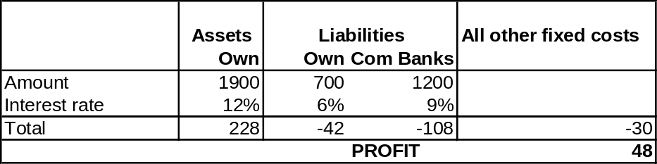

Now let’s try and work out the profitability for Sunco as a commercial bank. Assume that if Sunco converts into a commercial bank, the following three things will happen (read out slowly to see if the candidate listens carefully):
- The assets will double instantaneously at the same lending rate as earlier
- Sunco will not have to borrow anything at all from government banks and will be able to meet its entire fund requirements from its own borrowings at the same interest rate as earlier
- There will be additional fixed costs of maintaining the infrastructure per year
Assuming that Sunco would like to make the same amount of profits as before, how much can it invest additionally in fixed costs every year (this is a test of the candidate’s listening skills as invariably most candidates miss out on the specific question asked and work out the ‘total’ investments required and not the ‘additional’ investments)?

(The computations are as follows and the additional investment is 150 units of currency)

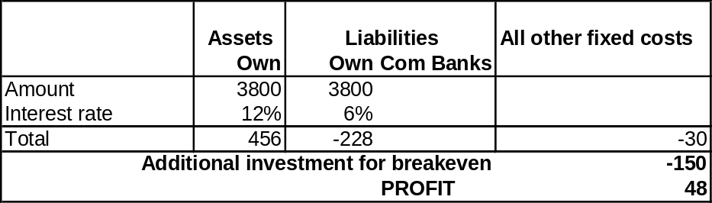

(The candidate may want to know 2 things at this stage – one whether the client or we have done a study to find out how much additionally it will actually cost to set up the infrastructure and second whether financing is available for this. These two aspects are irrelevant from the case point of view but show the candidate’s willingness to think on all aspects to a problem)
- Customers:
Will there be a big difference in the customer profile if Sunco were to convert itself into a commercial bank?
While the profile of the retail customers would be quite similar, the profile of the corporate customers will change quite dramatically because Sunco presently serves corporate customers only in one industry.
- Entry barriers
We already discussed this briefly in the beginning, but is there a cost that has to be paid for this licence and is the regulator going to invite some more players in the future to convert to commercial banks?
There is no cost for the licence and as far as we know the regulator will not extend this invitation to anyone else for a long time to come.
- Internal capabilities that can be leveraged
What are the internal capabilities of Sunco that can be leveraged as a commercial bank?
Sunco feels that two of its capabilities can be carried forward: Its strong brand name and the credit assessment skills of its credit officers (the interviewer should ask what this term means if not clear – credit assessment is basically assessing if the money being lent by Sunco will be repaid by the borrower). Do you think this is a replicable skill set?
Well as for the brand name, you mentioned that Sunco is practically absent in other parts of the country. This means that it will have to build a brand from scratch in these parts. As far as credit assessment skills go, it depends on whether the credit officers have skills across multiple industries and regions.
On the latter based on our discussion, we know that Sunco’s credit assessment skills are largely because of relationships that credit officers have with the limited number of borrowers in the industry in which Sunco lends to in Southern India.
Well that means that these officers may not have replicable skill sets that will enable them to deal with borrowers from other industries and regions.
- Regulatory constraints
In terms of regulatory issues, are there any areas for concern in becoming a commercial bank?
Sunco’s COO mentioned yesterday that commercial banks are very closely regulated and that Sunco’s people will take a while to getting used to the regulator ‘breathing down their neck’. Also as a commercial bank Sunco will have to pledge some of its capital for meeting various stringent regulatory guidelines – these are complicated issues but you could assume that there is an added cost on account of this.
And what does it mean for Sunco to say no to the regulator at this point?
By saying no to the regulator’s invitation, Sunco risks being in the bad books of the regulator for a long time to come.
- Cultural issues
Will the people of Sunco be able to cope up with the huge expansion of becoming a national player?
That is a good question. The culture in the Northern and Southern parts of India are quite different and the people at Sunco may take a while to adjust to running businesses in Northern India and this may lead to an unprecedented turnover of employees in the short term.

SUMMARISE
At this point the Chairman of Sunco enters the room and tells you, “I am aware that you are doing some very important work for us to evaluate our options of converting into a commercial bank. I have a flight to catch in 2 minutes – could you quickly summarise your findings so that I can think about this during my flight?”
(The interviewee should crisply try and cover all the points discussed above including the numbers part of the case)
Finally just before leaving, the Chairman throws a last question at you – “I was wondering if there is any other option for me to consider other than simply saying yes or no to the regulator….”
(At this point the candidate should evaluate other options which demonstrate practical business judgment such as:
- A merger with another bank (probably one which is strong in Northern India or in products which Sunco is not strong in
- A phased growth in first becoming a regional commercial bank in Southern India
- Buying a few years’ time from the regulator for converting).

Case 6 - Supermarket
Comments in normal type are to be read out to candidate

Comments in italic are for interviewer

Overview
You have been hired by a large UK supermarket chain. They are about to refurbish one of their stores, giving them an opportunity to change the sorts of things they sell in that particular store. To give you some context, if a supermarket wants to make large-scale changes in the layout and types of goods they sell, it often involves shutting the store as they need to get builders in, move equipment around, etc. so they do not make these changes very often. However they will have to shut this store for a week anyway so they can do things like re-paint it and put new tills, so they have an opportunity to re-think what they sell in the store. What the client want to know is: What changes, if any, they should make to the sorts of goods they sell in the store.
Rather than diving straight it, lets think in broad terms about what makes certain supermarkets more profitable than others. Say you were examining two stores in the same chain, of approximately the same size and one was making a lot more money than the other. Why could that be?
Look for homing in on profitability and what drives it (e.g. break it down into revenue and costs, then start thinking about different types of costs and what drives them, and what drives revenue. Then think about what could drive differences between stores).

Test any sweeping statements: e.g. ‘location is important’. Ask ‘Why?’
Pointers: Revenue side
If they are in the same chain, prices are likely to be the same (more or less), so revenue will mainly be driven by volume difference. Volume is a function of how many people come in and how much they spend. People tend to spend roughly the same on groceries irrespective of region (with some exceptions such as very affluent areas), so main driver is how many people shop there. This is a function of:
- number of people who live within x miles of the store (basic but people often overlook this)
- accessibility of store (how easy is it to get there)
- competition
(there are others)
- demographics is also relevant in that it affects how much they spend to some extent

Pointers: Costs
Remember: we are comparing two stores in the same chain, so many costs are the same. That includes cost of goods sold (chains buy centrally), marketing (done by whole chain), distribution. Focus on things that might be different
- Building costs: Lease vs owned. Property prices vary a lot.
- Staff costs: Some variance, but a lot of the staff are on minimum wage anyway.
- Operational costs: e.g. theft, throwing away things that go out of date. Most people will not think of this, but it can make a big difference.
OK. We’ve identified that one of the major drivers of store performance is the number of people who shop there. What I would like you to do now is to have a go at estimating how many people might be regular customers of a typical supermarket, located in the suburbs.
Specifics are not that important. If they are unsure, suggest using their neighbourhood store. There are several different ways of solving this. Most people will either
- try and work out the number of people in a given area, then work out how many of them might be regular customers
- work out how many people are in the store at a given moment, then estimate average shopping time and use that estimate how many shopping visits are made during a week, then estimate total regular customers.
The second one is a bit easier as it avoids trying to estimate population density.
If they get stuck on the population density bit, suggest thinking of population/area of London.
Pit-falls:
Households versus individuals
There are bound to be at least some competitors
‘Regular customers’ – not total number of visits by anyone. Typically people shop once a week. However not everyone is a regular customer of a store. Some minority will have no regular store or will not have regular shopping patterns at all.
Trade-off between over-simplification and getting bogged down in details.
(Upon some sort of final answer being produced)
Good. You’ve come up with xxxx regular customers, based on the assumptions and logic you have outlined. Could you tell me firstly whether that seems OK – is it too low, too high, or about right. Secondly tell me that the most important assumptions you made were in terms of their impact on the answer.
Looking for some common sense / business judgement. Anywhere from 2000-20000 can be justified – if it below or above that, challenge. On sensitivities, look for ability to home in on 2-3 things that could vary by a lot (e.g. number of people in a household doesn’t really change that much)
OK. We have talked about the sorts of things that can make one supermarket more profitable than another and seen one example where there can be a lot of variance – namely the number of regular customers, which as you have shown is subject to a number of different factors. Now lets return to the original problem. Let me give you some more information
The store in question is a mid-size store. By that I mean somewhere in between a small convenience store and a massive out of town store. It is located in the suburbs of a large city. It belongs to a national, premium chain, which sells high quality groceries at relatively high prices (an example in the UK, if you are familiar with it, would be Waitrose). The suburb it is located in is, on average, fairly poor.
Sales and profits in this store are good – as good as any other store in the chain. Why do you think it might be doing so well?

Should re-use some of earlier work about what makes one store do well versus others. As both sales and profits are very high, solution is likely to be on revenue side not cost side. Revenue is simply price * volume. As previously, if the store is outperforming others in the chain, it is likely to be volume not price (which is roughly constant across a given chain). So the store is attracting a lot of people. This appears counter-intuitive as the store’s range does not match local demographics. More obvious options
- it is the only store around
- people are coming from outside the local area
- suburb is ‘on average, fairly poor’. Be careful of managing by averages. There could be pockets of high income households.
(Additional info: given out in response to relevant points/question or volunteered if they run out of steam)
- Only local competition is giant Asda Wal Mart 2 miles down the road, which sells an enormous range of generally low quality goods at low prices.
- From customer surveys, you know most of the people who shop there live in the local area
- Area is on average poor, but with pockets of rich people
Given all this, it looks like there is a nice niche market, selling mainly to the pockets of rich people to whom Asda Wal Mart is not an attractive option. Strong candidate will want to compare that to competitor situation in other stores which are performing less strongly to test this hypothesis.
So, given all that we have discussed, what do you think they should do?

Sum-up situation. Come up with some sort of solution. Not changing anything is perfectly valid option – ‘if it isn’t broke, don’t fix it’. Can tinker and increase high end groceries at expense of cheap stuff, but be careful – just because people have higher income does not mean they only want premium goods – have to maintain a credible range.

More creatively, look to do something to make more money out of the high income people who have no other grocery store to shop in. Think about expanding beyond groceries. What sorts of things would these people want to buy? High quality homeware? Health products?

Case 7 - London Millennium Dome
Introduction
This case follows a format that may be different from others you have practised in that we are going to work through a problem together. I am going to ask you questions to guide you through the analysis and I am going to look to you to draw conclusions and solve the client’s problem.
If you are ready, I am going to read you a short description of the situation and begin asking you questions. Ready?
Context
The business we are talking about is the London Millennium Dome. The Dome is a large recreational and leisure experience facility in Greenwich in London. The facility consists basically of a large tent. Inside the tent there are 17 “Zones” each of which has a different theme, and each of which is sponsored by a different company. Sponsors have full creative control over their exhibits, and some zones are extremely popular while others are less popular.
The Dome is suffering from significant financial problems as well as a large amount of negative publicity. It is now March 2000, and you have been appointed by the UK government to come up with a solution for how to turn this thing around. To make matters worse, the facility has a “life” of one year, and will be closed in 10 months.
I want you to come up with the plan.
Can we start by you telling me what the key elements of your plan will be?
Good answers will cover the following:
- Because the London Millennium dome is suffering significant financial problems, I’d like to structure my answer by using the profit equation:
Profit = Revenues – Costs
Going into this equation in more detail,
Revenues = price * volume, and in this case price and volume are not just the price of tickets *number of tickets sold, but also other revenue sources, e.g., car parking, money from food and drink, so I’d want to explore all these other sources of revenue.
Costs = fixed + variable costs, and in this case, I’d imagine that fixed costs were actually very high, as the dome is a static structure with minimum level of maintenance, heating, lighting, minimum staffing levels, perhaps rent, etc.
- I’d also want to look into whether there are any operational/product problems. Is there anything wrong with the product / the experience?
- Lastly because I know that the Dome suffered a lot of negative publicity, I’d like to look at the “spin” – and how we manage the negative publicity
If the candidate mentions something very micro (i.e. not big picture), challenge them about why s/he thinks this is important.
If candidate goes into minutiae of case, ask to summarise what the three key headings will be, based on what they’ve said.
The above should form a framework for the conclusions and be a guide for the candidate to come back to at the end. They should get into each of these areas at some stage to have a thorough plan.
That’s a very comprehensive structure and you’ve got all the main points. Now lets talk more about the financial situation. Have a look at the following data and tell me what your thoughts are.
Show candidate Exhibit 2 and 3, with operating costs. Usually generates questions and discussion, there are some themes that emerge:
- Operating costs have gone down generally (note the dates are this month on the left – many candidates miss this and think costs have increased and start analysing this increase)
- Increase in personnel costs – could be good (if spent on better people / training etc, bad if its just increased turnover etc). Certainly Queue times suggest that we need to make sure we have great people to manage people’s frustrations (e.g. performers in queues etc. An answer that suggests cutting this should be challenged.
- Head office costs – down. Probably not much more to be cut out of this.
- Marketing – also very low, and we have little or no budget left.
- Overall probably not much room to reduce costs further, in fact should actually be increasing costs in some key areas, e.g., marketing.
- The most important one here though is maintenance as this is a symptom of the major problem the park has. Basically:
  - Maintenance is low given that we have to pay for all maintenance. The evidence for this is that the number of maintenance requests is going up for most zones, while the cost of providing maintenance has gone down. For an experience oriented business like this, everything needs to work, and maintenance costs and demands needs to reflect this.
  - Secondly, if we use queues as a proxy for popularity (which does not necessarily have to be the case of course – but it is a good proxy) can query whether maintenance is being spent effectively because many attractions that have no queues have significant maintenance requests. May also be that as these are always broken, there is no demand – rather than that it is an unpopular attraction.
  - Sometimes a candidate will assume that a request for maintenance also means that it was fulfilled which is not the case. A request is merely the logging of a request to have something repaired. Should therefore challenge candidate if they claim that maintenance is now cheaper per visit. We don’t actually know how many maintenance visits took place, only how many were required.
Overall, this is meant as a prompt for discussion, with the overall conclusion being that we want to increase maintenance and potentially marketing expenditure. Once this general conclusion is identified, move onto next question.
By how much do you believe we should increase these costs?
Given that there is no way of working this out from bottom up, need to consider the revenue side. A good candidate will identify this. If not, they should be prompted to consider funding sources.
What do you believe the key revenue sources for a business like this are?
Candidate should mention the following:
- Number of people
- Ticket price
- Spending on other park services (food etc)
- Car parking
- Merchandising
- Fees collected from displays and other operators who share the facility (by way of rent etc)
- Bonus points if they come up with anything else, but the above is pretty exhaustive.
OK, I can tell you that the revenues for the park are predominantly driven by ticket sales. What information do you need to calculate this months revenues?
A good candidate will probably ask for this information
- What is the ticket price?
  - Adult ticket is ₤24.30, Child ticket is ₤11.60
- What is the capacity of the venue
  - Around 22,000 visitors per day, but we are not operating at capacity for the venue
- What are our current visitor numbers?
  - EITHER – do this as an estimation question based on population in UK, how many people will try to go to the dome in the year, number of repeat visits, length of time the dome is open (12 months in total) etc – try to get to around 15,000 per day OR
  - Last month we had an average of 15,231 per day
- What proportion were children?
  - Ask you that question: Usually try to get the candidate to around 50 / 50 as this is a facility that people go to with their children in general, so assume high proportion of kids.
- How many days a month is the Dome open?
  - 7 days a week
Final figure should be that at this time we are making around
15,000 x (0.5 x ₤25) + (0.5 x ₤12) x 30 days
equals ₤8.3 million, call it around ₤8 million
Given that operating costs are around 9 million and we have concluded that we want to increase this to cover increased maintenance and potentially marketing, we need to increase our revenue to breakeven (Candidate should recognise that this is about cashflow breakeven, not about big profits). If they start talking about profit margins, challenge this – ask why need to make a profit. So, we need more cash.
If candidate is stuck, the interviewer will ask for what initiatives could be used to increase ticket sales
- More money from the government (this is NOT possible)
- Change price (again this is not possible)
- Increase in number of franchisees in the dome
- Increase visitor numbers
  - Marketing etc
  - Distribution
OK, let’s focus on distribution for the moment. What is your reaction to this data (give candidate data in exhibit 1)
Should realise that zero revenue is currently received from sales at the venue itself. Point out to candidate that typically 30% of people make an impulse decision to go to a facility like this based on weather etc.
How would you change the distribution channels?
Obvious answer is to start selling tickets at the door which could generate significant additional revenue. Also will have a cost impact as we own this distribution channel.
Ok, as you are completing this analysis, the Prime Minister rings you on your mobile. He is about to give a press conference, and needs a one minute summary of what you are going to do and what the effect will be. He wants the hard facts. Tell him.
Candidate should go back to original three points. A well structured answer will be as follows:
- Firstly, going to increase revenue by establishing at-venue ticket sales and distribution. Could increase revenues by up to 30%
- Secondly, going to use this increased cash to fund maintenance and develop a system for queue management. Focus on improving product to improve satisfaction.
- Some comments on the management of communications etc.
There are loads of little things that can be done and mentioned in the case, but a good answer will cover the above factors.
EXHIBIT 1

Internet sales 30%
Pre-sale offices in London 60%
Other non-venue based locations 10%
Total 100%
EXHIBIT 2 (₤ ‘000)

This month Last month
Service Personnel 7,109 ` 6,231
Head office costs 1,128 5,798
Maintenance 422 519
Marketing 574 546
TOTAL 9,233 13,094

EXHIBIT 3
Operating Data

 | Number of requests maintenance |  | Average queue times (minutes)
 | This month | Last month | Peak Queue | Off peak queue
Zone 1 | 6 | 12 | 21 | 3
Zone 2 | 10 | 5 | 25 | 2
Zone 3 | 20 | 15 | 92 | 17
Zone 4 | 34 | 11 | 12 | 11
Zone 5 | 20 | 7 | 76 | 23
Zone 6 | 18 | 9 | 88 | 21
Zone 7 | 71 | 54 | 34 | 12
Zone 8 | 1 | 3 | 44 | 10
Zone 9 | 29 | 12 | 57 | 14
Zone 10 | 22 | 15 | 232 | 121
Zone 11 | 10 | 14 | 76 | 16
Zone 12 | 32 | 18 | 21 | 4
Zone 13 | 1 | 0 | 140 | 92
Zone 14 | 0 | 1 | 32 | 4
Zone 15 | 20 | 12 | 42 | 3
Zone 16 | 37 | 31 | 18 | 7
Zone 17 | 45 | 20 | 12 | 1

Case 8 – Candy UK
Background & Introduction (1 min)
Companies “All Liquorice” (AL) and “Black Delight” (BD) are both in the candy industry in the UK. The candy industry produces chocolate, liquorice and chewing gum. There are 4 players in the market. Besides AL and BD there is Chewin, the leader and most profitable company, and Devotion. The market is competitive and strong consolidation has taken place over the last years. Now the board of All Liquorice wants to acquire Black Delight.
Note: Before you begin, think about the relevance of your comments. For example, don’t overemphasise R&D costs that can be cut out after acquisition. In the candy industry, R&D might not be of much importance. Think about the relevance of your questions. Lets say the interviewer hasn’t asked the first question, why would you already want to know what products or brand names each player has in its portfolio or how many people are in sales function. Use your time wisely and constantly ask yourself ‘so what if I know this piece of information, is that piece of information going to bring me closer to a conclusion?
Phase 1: Reasons and issues for an acquisition (7-9 min)
Q1: Why do you think would they want to acquire Black Delight? Note: Speak in general terms, do not go into specifics of the case just yet.
The candidate should come up with a structure, preferably written down, and show business acumen (link silly candy case with recent newspaper acquisition news) and creativity (come up with more than the first 3 obvious reasons). The candidate is not required to come up with the entire list of reasons, but an acceptable 1st year MBA candidate touches on synergies, market share, product portfolio and preferable defensive reasons.
Valid reasons
- Strategic (market position, product portfolio, growth opportunities)
- Synergies/ Value creation (cross selling, brand, economies of scale, production, transportation, purchasing, overheads)
- Financial (taxes, access to funding (although debatable according to finance theorists)
- Defensive; acquisition by other firm creates unconquerable competitor
- Undervalued (bad management, unfavourable market spirit)
Non-valid reasons
- Bigger airplane for management
Note: make sure you talk in specific terms not power MBA talk. With that I mean, if one mentions increasing market share as a main reason for an acquisition (which could very well be the case) understand why a bigger market share is attractive, what are the underlying dynamics? Don’t mention market share because you heard it in your strategy class. Many candidates confuse market share with size. Size allows you to spread out your fixed costs, whereas market share allows you to influence market prices.
Q2: What issues might arise during and after acquisition that could diminish value?
The candidate should point out that one has to keep in mind that there several reasons why an acquisition or merger is more than just adding up synergies from day 1. The candidate has to show the capability to quickly change perspectives and look at the issue from another angle. A minimum requirement for every candidate is to mention cultural issues and briefly elaborate on them.
- Value destruction (cultural, time to successful implementation, redundancies, management & talent leaving)
- Fees for lawyers, consultants, investment bankers
- Leakage of information and resulting speculation on market

Phase 2: Valuation
Q3: Assuming you are part of the AL team, how would you value Black Delight and how much would you bid?
The candidate must provide a structured approach that could potentially lead to a bid and a valuation. The candidate preferably structures his or her approach according to the structure that follows from question 1. Better candidates discuss that there are several methods for valuation of BD.
Stand alone value plus value of synergies (bottom up approach)
- Stand-alone value through DCF analysis, multiples, market value if public (watch out for incorporation of expectations of the take over)
- Synergies
  - Revenue synergies
    - A big market share can give you more control over pricing
    - Should also enable increase in volumes as you are the ‘market leader’ (depending on your pricing strategy)
  - Cost synergies
    - Purchasing
    - Production methods
    - Production capacity optimisation
    - Distribution capacity optimisation
    - Marketing cost reduction
    - Overheads
  - Financial synergies
Value estimate based on comparable companies
- Estimate of value through multiples/ comparison with similar companies
After structuring his/ her approach the candidate must ask the interviewer for information. Depending on the relevance of the questions, the candidate can get copies of tables presented below or will be provided the information in those tables (market companies P&L, market share per distribution channel AL and BD, production capacity utilisation). Acceptable candidates do NOT ask for irrelevant information.

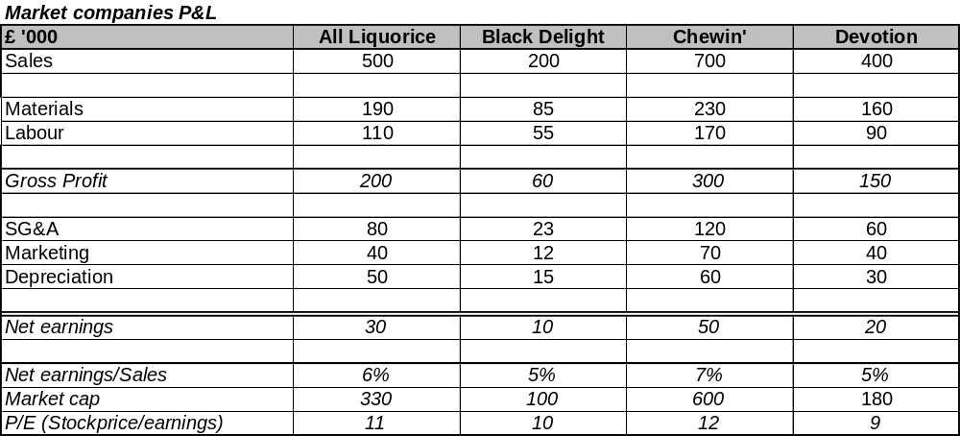

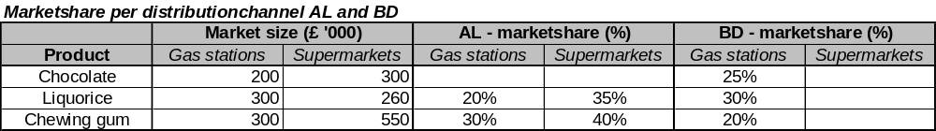

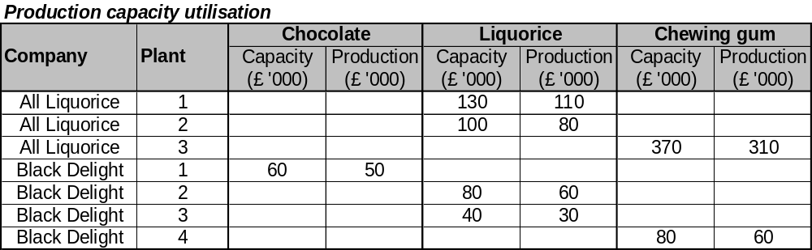

The candidate is urged to really put an effort in quantifying synergies and coming up with a number. This is a real test for the candidate because it shows he or she is number savvy. The right use of the numbers is an absolute requirement. Use of numbers in a wrong way (adding revenue directly to the bottom line is an absolute reason to fail the case).
Excellent candidates see how to use the numbers and get to a valuation without help. Good candidates recognise what the synergies are and have a feel for how to use the numbers but don’t get all the way to the end. Acceptable candidates get to the end with minimum help. Too much help needed will cause the candidate to fail the case.
These numbers allow to do a top down valuation based on the performance of comparable companies in the industry and a bottom up analysis based on 2 synergies.
The valuation based on performance of comparable companies in the same industry is based on the P&L. The P&L information shows the 4 companies in the industry. Upon evaluation of the table the candidate must see that the size, profitability and P/E are different per company. There is a correlation between size and profitability and P/E. Going back to our acquisition, the candidate must then see that a combination of BD and AL will become as big as Chewin, the market leader. Will this allow for the same profitability and P/E? If the candidate assumes that it will and that the profitability and P/E of Chewin are the result of established synergies and economies of scale, Chewin is a good numerical example of how profitable AL/BD will be after the acquisition. The table below shows a valuation of the AL/BD for different profitability and P/E. The current valuation of AL is 330, BD is 100, together 430. For a profitability of 7% and a P/E of 11, AL/BD will be worth 540, or an increase of 110. Thus, being AL, the maximum bid for BD would be 210, but we would, of course, put in a bid that is only so much higher than the current market cap that it will assure AL will win the bid. In other words, if they are willing to sell for 120, we will pay 120 and not a penny more.

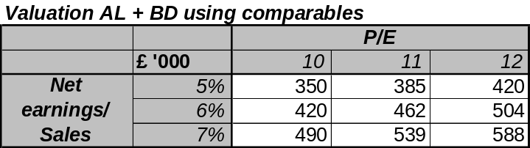

The bottom up valuation is based on the 2 synergies:
- Selling BD chocolate in supermarkets where AL has access
- Closing production facility BD3
The most important opportunity the candidate must derive from the table with the market share information is that there is an opportunity to sell BD’s chocolate through AL’s distribution channel. AL’s supermarket sales force can’t sell this product because they don’t have it. Now they can.
As a proxy for the expected market share the candidate can choose between the existing market share of the product in BD’s distribution channels or the existing market share of AL’s products in their distribution channels. This is an important assumption and tests the candidate for business sense. Think about how it works: supermarkets and gas stations don’t have all brands on their shelves, they make a selection based on brand, prices and sales rep relationship. This allows for a fine discussion about pull and push marketing strategies. I make the simplified assumption that it is push marketing and therefore opt for a comparison with existing AL market shares in the distribution channels.
So, we have expected extra revenues. Great, but at how much should AL value that? To be able to do so, the candidate must recognise that the valuation in the P&L is based on net earnings. Thus, the candidate must assess how much additional earnings will follow from these additional revenues. This needs another assumption, because marginal cost will be less than marginal revenues and the 5% earnings/ sales will be too low. I make the assumption that fixed SG&A cost will not go up and that fixed SG&A cost is about half of total SG&A. This leads to around 15% earnings/ sales for the new found revenue, or 18 increase in earnings.
There also is a synergy in production, i.e. close production facility BD3. From the production capacity utilisation table it follows that the production of liquorice in BD 3 and chewing gum in BD4 can be allocated to other factories. For chewing gum this might not be such a reasonable thing because that would require 100% utilisation of plant AL3. That means no room for emergencies, fluctuations or expansion. This is therefore not an alternative. BD3 liquorice can be closed and production can be allocated to at least 2 other factories without getting close to 100% utilisation.
However, how much is this going to be worth for our valuation? To determine this the candidate must refer back to the P&L and make an estimation per cost item on whether that can be scrapped or not. Materials are still needed, depreciation will continue unless we can sell the plant, property and/or equipment and no marketing, can be saved. Maybe a little bit in SG&A, but that is a wild guess, but, most importantly, the work force in the plant will be made redundant. I assume the savings in labour cost therefore to be the only significant saving. As a proxy, I take an average labour/ revenue ratio and apply that to the revenue in plant BD3 and calculate the result on earnings. See table below.
After application of the P/E multiple, these two synergies lead to a potential market cap of 355, up from 100!
Note: the two methods lead to different numbers. Does that appear to be correct? What would you do about it in practice?

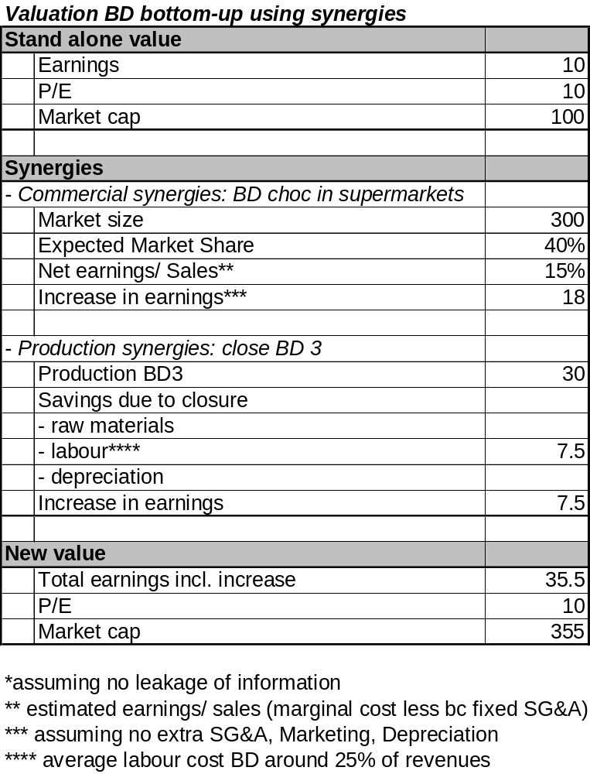
Note: to get to an answer the candidate has to make several assumptions. Don’t be taken aback when perfect information is not available, but use the information to the best and be clear about your assumptions and always test if they are reasonable.
Phase 3: Wrap-up (2 min)
Q4: You are now in the elevator with AL’s CEO. He is going to meet BD management. What should he tell them?
The candidate is required to provide a structured synthesis of the whole case, wrapping together whatever came up in the case and making a recommendation on how much to bid and why. It is important that, even though the candidate might have been a bit lost throughout the case or the candidate has not come to a complete answer, that the candidate shows he or she is capable of (1) keeping track of main question and providing answer to that question and of (2) getting out of dead ends that he or she has encountered with energy.

Case 9 – The Vitamin Store
Context
Our client is a private equity firm who is interested in purchasing “The Vitamin-Store”. The Vitamin-Store is a retailer that sells health & nutrition products such as vitamins, minerals, natural medicines, sports supplements, natural herbs, dietary supplements, and nutrition products (i.e., Slim Fast etc.).
Our private equity client has asked us to value the company and wants to know whether or not they should buy it. What should they consider?
- Valuation of business (i.e., price)
- Capital structure
- Expected return to investors (as PE investors require high IRRs)
Let’s assume that figuring out the capital structure and expected return to investors is something they’re good at, and they want us to review valuation. What are the elements they should consider?
- Market (be sure to explain each of your answers)
  - Size & Growth
    - Drivers of growth could include (why are these growth drivers?):
      - Demographics (i.e., ageing population, education levels, income levels)
      - “Health” trend
      - High level of obesity
      - New formats
      - Level of competition
      - Availability / Number of stores (i.e., expansion into new markets)
    - Price levels of products sold
      - Level of competition
      - Supply-demand economics
- Potential market share
  - Customer segmentation
    - “Health-freaks” / hippies
    - Sports enthusiasts
    - Obese people
    - Mainstream
  - Level of competition:
    - Market players
      - Independents
      - Specialists
      - Online stores
      - Large retailers (i.e., WalMart, Tesco, etc.)
    - Level of fragmentation

Let’s assume that the market looks like the graph at the right. What revenues did the Vitamin-Store have in 2002?  Math calculation: $13 billion * x%  How to get to the x%? Assumptions one can make:  - Historical trend: then 20% * $13bn=$2.6 billion (most simple, most practical)  - Use % change in market share as base  - Interviewee should note that it seems that as a proportion, Vitamin-Store has lost greater market share, and that one would have expected the independents to have lost greater market share to the new players – what does that say about Vitamin-Store customers? | 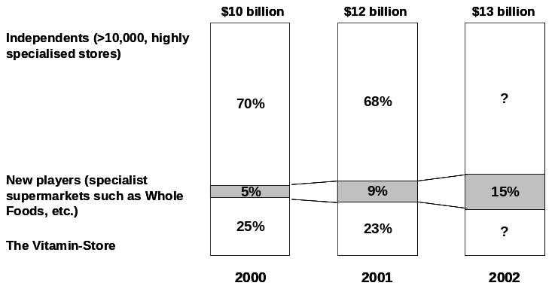

- Cost structure – what would The Vitamin-Store’s major costs be?
  - Per product profitability (profit margins ∼40%)
    - Market share of The Vitamin-Store important if it gives it an advantage over others with regards to negotiating power with suppliers
      - Who supplies these products? I would imagine big pharma for vitamins/minerals and perhaps the Unilevers, P&Gs of the world for dietary products (i.e., SlimFast). So I would imagine that an independent player might have less of an advantage with suppliers than a leading specialist. However, a large Walmart, Tesco, would have larger benefit with Unilevers, P&G, actually with big pharma as well.
      - Why?
      - For example WalMart is one of the world’s largest retailers, if not the largest. WMT deals extensively with the large consumer product companies and already be supplying it huge quantities; furthermore, I also believe that most WMTs have pharmacies, and many big pharmaceutical companies also sell OTC products, so I could assume that WMT also has a good relationship with big pharma; therefore, WMT’s cost structure in this case is better than any other player (most probably)
  - Real estate (real estate / capital leases for retail stores)
    - Are these on prime location? (mostly urban)
    - Are we generating enough sales / square foot and profits / square foot (or per store)? How do we compare to the industry?

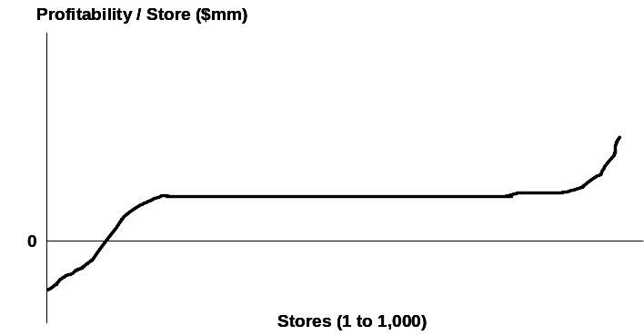 | If the profitability per store is as shown on the left, what you do?  - Improve the worst-performing stores and bring them to the level of the highest performing stores (as shown in the 2nd graph)  - Understand why the bulk of the stores is not performing as the highest performing stores  What would you look into?  - Location? Study traffic levels; area demographics; is this a historical trend, or a one-off?  - High levels of competition driving prices down?  - Product turnover, customer baskets, store layouts: are there specific products that we are not turning over and that we should consider dropping? How to customers make their purchasing decisions? Compare stores  Let’s say that there’s nothing we could about it – what would you do?  - Sell or sub-let the store
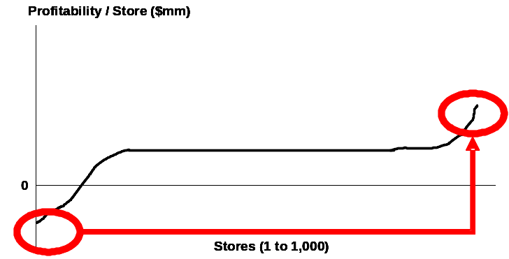

  - Staff
    - Look into sales / employee; employees / store; staffing methods (study traffic patterns in relation to staffing patterns)
    - Look in management and staff compensation (incentive-based compensation vs. high base, for example)
  - Distribution (actually only accounts for 3% of sales – so not major)
    - Do we have a distribution centre? Yes. Are we the best at managing a distribution centre? Can we have our suppliers distribute directly to our stores?
  - Working capital management (doesn’t really affect bottom line, but does affect cash and could be reinvested – it’s invested capital): Manage inventory turnover, accounts receivable and payables, manage cash
The Vitamin-Store is actually not profitable, and the PE firm wants to assess whether it’s actually possible to quickly turnaround the company if they buy it. Furthermore, they have been told that it will be an auction based process. They ask us to prepare a 100-day plan to turnaround the company. Quickly, what are the key items that we should suggest (answer quickly):
These would be parallel activities:
- Product turnover and profitability: drop products that may not be turning over
- Supplier contract negotiations: negotiate better pricing terms with suppliers (big pharma, consumer product companies, etc.)
- Exit non-performing stores (perhaps some real estate that can be sold/sub-let)
- Change management and staff pay packages – based on incentives (even in stores – part of compensation could be linked to store profitability)
- Conduct customer surveys and understand how customers are segmented (this could actually be conducted prior to purchasing the company) – marketing & promotional campaign
  - Let’s look at customer segmentation: what if The Vitamin-Store increased its market share in the 18-35 age category from 30% to 35%. 1 in three men between the age of 18 and 35 spend $10 per month on vitamin supplements and the like. What would be the impact on the bottom line?
    - US population: 300 million
    - Men / Women: 50%/50% = 300 million * 50% = 150 million
    - Let’s assume that average life expectancy = 75 years
    - We could make assumptions as to the population pyramid, but let’s assume that since there are 18 years between 18-35, 15/75 = 20%
    - The 18-35 age category represents 20% *150million = 30 million people
    - Annual expenditures = 30 million * 1/3 = 10 million * $10*12 = $1.2 billion
    - Current market share = 30% * $1.2 billion = $360 million
    - Improved market share = 35%*$1.2 billion = $420 million
    - Profit per year: 40% (as profit margins = 40%) * $360 million = $144 million for the initial year; 40% * $420 million = $168million
    - Net impact on profit = $24 million (without considering any tax issues, etc.)

 | Year 0 | Year 1
Market | $1.2 billion | $1.2 billion
Market share | 30% = $360 million | 35% = $420 million
Profits (40% of revenues) | $144 million | $168 million
Net impact on profitability | $24 million

Let’s assume that WMT is not present in this market for the time being. Two questions:
- Would WMT be interested in entering this market?
- Would they be a threat to The Vitamin-Store?
- Yes – WMT would be interested in entering this market:
  - Growing market
  - Fragmented market (independents account for ∼ 70% of market)
  - High profit margins
  - Relatively small investment from WMT’s perspective → most probably a high return on invested capital
- Would WMT be a threat to The Vitamin-Store?
  - It depends on who The Vitamin-Store is targeting as customers:
    - If they’re targeting the mainstream customer, then WMT could be a threat
    - If they’re targeting a “higher-income” / babyboomer set, then they may be able to effectively cater to a specific segment who may not shop at WMT
  - What should they do?
    - Survey their current customers and understand who they are (that’s not very costly, a couple hundred thousand dollars)
    - Review their current store locations
    - Improve positioning (via campaigns, better store layouts, etc.)
The Elevator-pitch: what would you recommend the private equity principal to do?
Here the interviewee is expected to synthesise the main items reviewed and present a recommendation.
Student should also mention that the capital structure and financing structure may have an impact on the overall return the PE firm can expect to obtain.

Case 10 - AluCo

Introduction
AluCo is one of the world’s largest aluminium producers. It also makes a wide range of alloys, which combine aluminium and other elements and have specific properties. The company has hired you to look at AluCo Closures, a subsidiary that makes two alloys – the 3-series and the 8-series – which are used to make bottle tops (closures). The 3-series is harder and is used in water and carbonated drinks. The 8-series is softer and sold to spirits companies. AluCo historically has maintained the highest product quality in the industry and the company maintains a 65% market share in both markets.

Question 1: Can you tell me if you think this is a good business to be in?

Tip: You have just received a lot of information. Before launching into an answer to what appears a relatively straight-forward question, it is worth taking some time to gather your thoughts and to clarify anything that is unclear. Be aware that the client is AluCo Closures, not AluCo, and that AluCo Closures makes alloys for bottle tops; it does not make the bottle tops themselves. If in doubt, ask.

There are basically two ways to make money in business: be in an attractive industry and/or have an advantaged position in your industry. To understand whether this is an attractive industry I would firstly like to know the size of the market and its growth rate and then I would look at the five forces of pressure within an industry, supplier power, barriers to entry, degree of rivalry in the industry, buyer power and threat of substitutes:

That’s a good start. To answer your first question, I can tell you that the market for both alloys is 40,000 tons a year which sell for about 1,000 euros/ton, and that the market grows at 3% a year.

OK. From the information you’ve given me it seems that the total market is not large. Moving onto an analysis of the key forces of pressure within an industry I think that I can draw the following conclusions from what you’ve told me so far:
- Suppliers are not a threat. You have told me that AluCo Closures buys the aluminium for its alloys from AluCo, its parent company. It is therefore safe to assume that it buys the aluminium at a market transfer price and that AluCo has no incentive to squeeze the margins of its own subsidiary.
- There are barriers to entry. Producing alloys involves combining aluminium with other materials and then rolling them into sheets or coils. Such a process requires significant capital investment. A really good answer will point out that capital investment alone does not act as a barrier to entry, but capex in relation to the size of the market does. ie. high capital requirements to enter a small market will keep most rational entrants out, which is what is happening here.
- Rivalry should not really be a threat since AluCo Closures has such a dominant market position. However, I would like to know how the remaining market share is divided among the rivals, whether the industry is a duopoly or more competitive.
- Substitutes are anything that could be used for closures instead of our aluminium alloy. I would assume from my knowledge of bottles (those I’ve seen in the supermarket) that the main substitutes would be closures made from plastic.
- You haven’t given me any information about the buyers, so I would also like to ask you who the buyers are, how concentrated they are, whether they have significant power in relation to us and whether they are under price pressure from their customers.

Tip: A really good answer would drive through to all of these points since you already have enough information to make these conclusions. Candidates cannot make assumptions about customers/buyers as no information has been given, so they should ensure that they the interviewer for this information.

- AluCo Closure’s customers make bottle tops, which they sell to drinks companies like Diageo and Nestle. The closure industry is fragmented and highly competitive. Companies within the industry face significant price pressure from their own customers.
- You are right about the substitutes. The key substitutes are things like PET plastics. These are a threat because PET is lighter, and easier to handle and transport.

To understand the company’s position within its industry, I’d like to get a better understanding of its sources of competitive advantage. Since aluminium alloys are essentially a commodity product, they are very difficult to differentiate. It is likely therefore that the company has a cost advantage, which will stem from economies of scale. The more volume the company produces, the lower its total average costs. Since the company has such a high market share, it probably has a lower cost position than its rivals, which will act as a source of competitive advantage. Furthermore, its high market share gives AluCo Closures the ability to set prices, something that is further reinforced by its high product quality.
So given the existence of barriers to entry, low threats from suppliers and buyers, a small threat from rivals, the company’s advantaged cost position and ability to charge a premium, I believe that for AluCo Closures this is a really good business.

Question 2: That’s very good, I agree. Now having said all of this, revenue at the company has been falling and the CEO wants you to investigate what is going on. What sort of things would you want to look at to make your recommendations?

I’d want to first examine the price and volume at AluCo Closures to identify the reason for the decline in revenue. If prices are stable then the problem is with volumes, which could be falling because of a decline in market share or a contraction in the overall market. Since we know that the market is growing at 3%, I’d say the problem lies with a decline in market share.

Question 3: That’s a good hypothesis, and you are right. What might cause a decline in market share?

To understand why this is happening I’d want to see if there have been any problems within our client in terms of production quality and delivery reliability. I’d also want to look at the competition; have they done anything recently to try to take customers from our client, an aggressive marketing campaign for example? I’d also want to see if there have been any changes in our customer base, in their needs, or willingness to pay and which might cause them to take their business elsewhere.

Question 4: That’s a good way to start. I can tell you that there have been no production problems at our client. However, it appears that over the past few years, our rivals have spent more on R&D than our client. There has also been some consolidation among our customers. Why might that have happened and what is its significance?

Our customers are in a very competitive industry. They have no pricing power over their customers, which are the large multinational drinks companies. They also have to deal with AluCo Closures, which can use its market power to demand price premiums. Our customers have probably been forced to consolidate to protect their margins. The significance of this consolidation is that it increases our customers’ bargaining power over us. Since we have kept prices constant and our rivals’ higher R&D spending has improved their product quality, these larger customers have probably defected to our rivals. The other point about consolidation is that it divides our customers into two distinct groups: large customers and small customers, and these have different needs; the larger customers are more focused on plant utilization since they want to achieve economies of scale. Smaller customers now need to differentiate their products to compete with their larger rivals. However we have only a single product and service offering and so have probably lost relevance with some of our key accounts.

Question 5: That’s a very good analysis. One option that our client has is to give in to its customers’ demands for a price discount. However our client is concerned about the impact this will have on its profits. If we were to cut prices 5%, how much would we have to increase volumes to maintain the same amount of profits?

Tip: Most Numeracy questions, including this one, require structure more than calculations. In this case the key is to ask for the gross margin, without which you can’t work out the answer. In general, if you find yourself doing large calculations then you are probably on the wrong track. In that case, don’t panic, take a deep breath, retrace your steps and start again.

In this case the gross margin is 20%. So if the original price is 100, then per unit costs are 80 and profits 20. A 5% decline in price makes it 95. Costs remain at 80 and profits are now 15. To make the profits the same, you need to increase volume by one third. So cutting prices to take back market share, requires that it sell 33.3% more product simply to keep profits constant. Given its high market share levels, this is unlikely.

Question 6: What would you recommend to the CEO?

Tip: your recommendations must use the information you have uncovered in the case and address the problems that the company is facing.

I have four recommendations:
- First of all I would recommend increasing R&D spending up to our competitors’ levels and to try and recover our product advantage.
- Secondly I would carry out a study of our customer base to assess the changes going on in the industry and to find out which companies have which needs.
- Thirdly, I would develop a differentiated product and service offering to take into consideration the distinct needs of our different customer groups.
- Fourth, I would recommend reinforcing our sales and marketing capabilities.

Case 11 - Drinking Water Purifier

Introduction
A leading global consumer goods company has come up with a new product for cleaning water to make it fit for drinking. The product is a sachet, which contains a powder. The powder is poured into a bucket of water, and stirred for 20 minutes. At the end of the process, the silt/dirt that was in the water will settle at the bottom of the bucket and the bacteria in the water will have been cleaned/neutralized. On pouring, the recipient gets World Health Organisation certified drinking water.
The company has launched this product with varying rates of success in many developing countries and now they want to enter India. The company already sells other products in India. The CEO wants to know if they should enter the Indian market with this new product and if so, how?

Note: You should recap your understanding of the context with the interviewer, and ask any clarifying questions about the product or the company.

Question 1: How would you go about structuring your analysis of this problem?
This is a typical market entry question and you should follow a structure similar to the one laid out below to analyze it:
- Size the market
  - Define the market
  - Assess size, profitability and growth
  - Identify relevant trends and regulations
  - Identify key success factors
  - Evaluate Risks
- Analyze Customer needs
  - Segmentation (size, profitability, share, growth)
  - Drivers of purchase behavior(product, price, promotion, place)
  - Power in the market
- Understand the competition
  - Key players
  - Competitive situation - concentration and intensity
  - Core competencies (strengths/weaknesses) and capabilities
  - Likely reaction to entry
  - Differentiation
  - Cost structure
- Assess company capabilities and analyze how well company’s strengths match the new market needs
  - Core competencies and resources versus key success factors
  - Potential positioning and pricing
  - Cost structure
  - Profitability returns
- Evaluate barriers to entry
  - Customer related – product differentiation, brand loyalty, switching costs, access to distribution channels
  - Non-customer related – economies of scale, capital requirements, experience curve, regulation
- Evaluate methods of entry
  - Build, acquire, partner
  - Quantify investment cost and risk
- Analyze how the firm entered previous markets, and why were they successful or not.

Question 2: That is a very comprehensive structure. Why don’t we start by estimating the market size for the product? We know that the 1 sachet can be used to clean 10 liters of water.
This is a ‘typical’ estimation question. You should drive the estimation step-by-step, talking the interviewer through each of your steps and asking the interviewer for information where you need it. If you are uncertain about any of the numbers you are estimating, then validate the number and the assumptions you based it on with the interviewer. It is far better to validate a number with them, than use a number that is way out and risk coming up with a nonsensical answer at the end of the estimation as a result. Having said that, you must also demonstrate business judgment and confidence so don’t seek reassurance at every step – only if you need it.
You should acknowledge that, given the product can be used to purify 10 liters of water, it will most likely be purchased by households. A good place to start is by estimating the total population of India, and then determining the total number of households.

Population of India = 1 billion people
Assume an average 5 people in a household (Indian families are generally bigger than Western families)
Total number of households = 200 million

Next you should realize that not all households will have the “need” for such a product. A sensible hypothesis is that -
- The product will probably be used by households which do not already have access to clean drinking water through basic state owned infrastructure. These will most likely be households in non-urban areas.
- The product will be used by households who do not have the disposable income to purchase easier, less time intensive alternative sources of purifying water eg: filters, bottled water etc. These will therefore be the lower income households.

Given India is a developing country it is fair to assume that a larger percentage of the population will be in non-urban areas. You can use your knowledge of UK (a developed country) where the urban/rural split is probably 70/30. Hence, in India it is probably fair to assume that the split is the reverse – Urban/Rural = 30/70.

Based on your hypothesis a), your initial market consists of the rural households = 70% * 200 million = 140 million

Next, based on your second hypothesis, estimate the income division in the rural areas. Given that the Indian rural economy is mostly agriculture based and from your knowledge of the high poverty in India, it is also fair to assume that the split between high/low income in rural India is 30/70.

Based on hypothesis b), the initial market size estimate can be improved to 70% * 140 million = 98 million ~ 100 million.

Hence, you can say that the market for this product will consist of 100 million households in India.

Note: The exceptional candidates will split the regions between urban (major cities), semi-urban (towns and the poorer outskirts of major cities), and rural areas (villages), and make their market size estimations on this basis. You should realize that though there is no proper drinking water infrastructure in villages, water from the wells or rivers is probably cleaner than the stagnant water from the tanks in towns and the outskirts of major cities, and therefore that in rural areas it is probably fair to assume that perhaps a quarter of the households are happy with, and healthy on, their current water source.

The next step is for you to calculate the drinking water consumed per household and hence, the number of sachets used per annum.
Assume that 1 household consumes 10 liters of water per day (1 person consumes 2 liters per day). This is a fair estimation given that in the West we are recommended to drink 1.5 liters of water per day for healthy living, and India is in general a hot country. Given that 1 sachet can clean 10 liters of water, 1 household uses 1 sachet per day.

Note: the creative candidates will notice that the drinking water consumption will vary with age of members in a household and also based on the geographical location of the regions (hot/colder). In general though, it is fair to mention these points but then take average values.

That gives a total of 100 million sachets per day, or 36.5 billion sachets per year.

You should summarize that our target market will consist of people who live in semi-rural and rural areas, and have low income such that they cannot buy the expensive substitutes for the product.

Question 3: Now you have looked at the market and the consumers, let’s try to understand the competitive landscape. What could be the competition for the product?
You may not have knowledge about water purifier substitutes in India, but you should use your own experience to identify competition, and then ask the interviewer for any other competing products that you may have missed. A good way to structure your answer to this question is to think about direct and indirect substitutes. Once you have the full list of competing products, you should do a quick assessment of the value to the consumer of each of these competitors based on basic criteria including price, ease of use, quality, accessibility etc.
Direct substitutes (you may not know about this)
- Chemicals distributed by the government to clean water – free, poor quality of water, easily accessible to poor people

Indirect substitutes
- Boil water – not a perfect substitute as does not get rid of silt/dirt and does not eliminate all bacteria, time consuming, cost attached in terms of electricity, gas or fire wood
- Electronic filters – very expensive, high quality
- Bottled water – relatively expensive, high quality, accessibility may be an issue in rural areas
- Unclean water – probably used most, least expensive and very real danger to health
You should make a hypothesis that given we are targeting the lower income population, the price of the product will need to be lower than that of bottled water and filters. You can make a fair assumption that that ‘lower price’ is a given (i.e., the consumer goods company realize this and intend to pitch the price below that of bottled water and filters)
You should summarize to say that the product doesn’t seem to face strong competition. There are no good quality direct substitutes, and the indirect substitutes are either poor quality or are too expensive for the target segment.

Question 4a: Next, let’s try to understand the revenues and costs associated with the product. From our experience of launching in other developing countries, the average price for the product has been 6.2 US cents. How do you think we should price this product in India?
You should use the information discussed in previous questions to come up with a pricing strategy. Price can be determined on a number of different bases, some of which are better than others:
- Cost plus – cost of the product plus a margin.
- Price of direct/indirect substitutes – you should note that all the direct and indirect substitutes discussed before provide different benefits and therefore a different ‘value proposition’ to the customer. You should assume that the company’s aim is to maximize their profit, but that to obtain sizeable market share they need to be priced below the closest, cheapest substitute, i.e., bottled water.
- Customer’s willingness to pay – this can be determined either by primary market research, or by creative means of estimating the percentage of a typical household’s disposable income spent on bottled water, or even the health bill related to water borne diseases!
The price for the company’s product should therefore be such that it covers the product cost but is less than the price of the closest indirect substitute (i.e. bottled water.) Note that purely using cost-plus pricing will not work as is takes no account of competitors’ pricing or customers’ ability or willingness to pay. However, it is worth mentioning it as an option and any product price does need to pitched above the product cost if the company is going to make a profit.
Given that India is quite representative of other developing countries, we can probably use the average price charged in other countries as long as that meets the criteria we have mentioned above. Hence, it is fair to recommend that the company set a price of 6.2 US cents for their sachet in India.

Question 4b: Now, let’s look at the costs of the product. From experience of launching in other countries, we know that the fixed cost of setting up a new manufacturing plant/machinery is 100 million dollars, the variable manufacturing cost is 3.5 cents per sachet, and the other variable costs are 20% of the variable manufacturing costs. What do you think the other variable costs (i.e., the 20% are), and how many sachets does the company need to produce to breakeven?
You should review the value chain post manufacturing and identify other variable costs. Once the product has been manufactured and packed (assume manufacturing costs includes packaging), then you have to transport the packaged goods from the warehouses to the distribution outlets. In addition to the transportation cost, you will have the sales effort of getting the distributors and the commission paid to the distributors. Hence, to summarize the other variable costs will be:
- Transportation
- Sales
- Commission to distributors

Moving onto the calculation, you should first calculate the total variable costs:
VC = 3.5 + 0.2 * 3.5 = 4.2 cents
FC = 100 million
To break even,
Price * Quantity = FC + VC * Quantity
Quantity = 100 million dollars / (6.2 – 4.2) cents = 5 billion sachets

Hence, the company needs approx 1/7th (5/36.5) of the market to breakeven.

Question 5: What capabilities does the company need to launch successfully in India?
You should note that the financial analysis you conducted in the previous question shows that if the company gets 1/7th of the market, the product will breakeven. You need to assess the company’s capabilities across the value chain and determine their match to the key success factors that are necessary to achieve this (or a greater) share of the market:
- Sourcing and production – you should mention that the raw materials for this product seem to be fairly readily available (as they already sell it in a number of countries) and hence, can be probably purchased easily. Production can either be done in other countries and the finished goods shipped to India (good initial option while building up the market), or can be done in India. In the first case, the distribution costs will be large, and will not reduce significantly with volume. If production is done in India, the company can either use spare capacity in existing plants (for other products) or set up new plants. You should also note that if use existing plants, you will be able to reduce the $100m fixed costs and breakeven at a lower value.
- Sales and Marketing – once production is done, you need to market the product to build awareness and educate the target market about the product. Given this is a health product, it would be sensible to involve the government, NGOs and health clinics in semi-rural and rural areas to develop credibility and educate people to ensure repeat purchase.
- Distribution – you should mention that it is very important to select distribution channels that have accessibility to rural areas. You can recommend using existing channels, or identify new retail channels.
You should summarize that given the company has existing operations in India, it can leverage its existing production and distribution capabilities. The biggest hurdle will be marketing the product and building awareness, where the company should involve the Government, NGOs and health workers. However, because they already sell this product in other developing countries, you can hypothesise that they have experience in marketing this particular product in developing countries.

Question 6: What could be the barriers of entry to this product?
You should note that there are two types of barriers to entry:
- Customer related
  - the company will need to break the consumer habit of drinking unclean water. The marketing efforts need to educate the target market, by demonstrating the product benefits, involving the government, NGOs and health officers, to ensure repeat purchase.
- Non-customer related
  - distribution channels should be able to reach the poor infrastructure, rural areas in India.
  - threat from copy cats who can easily determine the product composition. As a first mover in this market, the company should aim to get the product certified by the government and health agencies to distance its product from future competitors’ offerings.

Question 7: The CEO calls you, and asks you for your final recommendation - should he enter India, and if so, how?
You should recommend that, based on the analysis you have conducted throughout this case, the company should enter India. (This should be the recommendation, unless during the discussion you came up with very valid points that would make the entry unfeasible).
Supporting points:
- Market needed to breakeven is 1/7th of the total size – This seems achievable as there are very few competitors who can meet the needs of the target consumers in semi-rural and rural areas with low income, and the negative health benefits of drinking polluted water are severe (life threatening.)
- The company has an existing presence in India and can use its existing production, distribution and marketing/market knowledge capabilities. This can potentially reduce the fixed costs and mitigate some market entry risks.
- Also because of company’s existing presence in India and its success in other developing countries, it should easily be able to partner with the Government, NGOs and health workers to create promotions to build awareness of the product and educate the people about health issues related to unclean drinking water.
For the implementation, you should recommend using existing production and distribution capabilities, and partnering with the government, NGOs and health workers for marketing the product. You should also be creative and recommend doing a pilot launch in few areas and using the learning when expanding into other areas.

Case 12 - Scottish Bankers

Introduction
In this situation I am playing the role of a CEO, and you are representing a consulting firm. This was a complex problem experienced by a real client in 2002 and it had many possible solutions. We will explore this problem in several stages, and occasionally I will direct you towards a series of responses that reflects what really occurred.
Background:
Your client is a Large Scottish Retail Bank, which has been operating in a stable market for several years, with low competition. The bank has been experiencing declining profitability over the past few years.
You now have the chance to ask some clarifying questions. Good questions to ask are:
- Are their products similar to their competitors?
  - Yes. They have a very similar product set to their competition
- How regulated is the market?
  - Regulation prevents mergers and takeovers
- Do they have much money for investment in new developments/initiatives?
  - No. Funding for future development is limited

Question 1: Your client is understandably very interested in reversing this decline in profitability. How could they go about doing this?

Poor Answer: Anything other than Profit = Revenue – Cost (Information has already been given to rule out competition)
Standard Answer: Profit = Revenue – Cost (common to hear R = P x Q and Cost = FC + VC)

(Note: This answer simply shows that you know the framework)
Good Answer: Profit = Revenue – Cost, Therefore we need to increase revenue or decrease costs, or both
(Note: This shows that you know the framework, and how it needs to be applied)
Excellent Answer: Profit = Revenue – Cost, therefore we need to increase revenue or decrease costs or both, in order to help reverse our declining profitability situation.
(Note: This shows that you know the framework, know how to apply it, and can link it back to overall issue.)

Question 2. What are the top 3 items of income and expenditure?
NOTE 1. Some countries do not have fees as a major component of Revenue (e.g. South American countries, Italy), so if you are from one of these countries interviewing in London or another European country make sure that you clarify whether your understanding of the market (most probably derived from your experience in your home country) is applicable in the UK.

Poor Answer: If the interviewee misses the fees component, or does not structure the problem from the first question, or gives up after only listing a few items.
(Note: Consulting cases do not generally require a lot of industry specific knowledge in order to solve them and this is true of this case. If you are lost on this question, try looking at a problem from a first person perspective, i.e. I don’t really know how this business operates, but when I deal with them/use their service…)
Standard Answer: A list of all of the products that banks sell (e.g. Loans, Credit Cards etc.), as well as most of the major cost items.
(Note: An accurate answer, but can be improved by taking the next step. In a case like this, always consider what the actual source of income is – is it the product itself, or a component of the product?)
Good Answer: A list of all of the products that a bank sells, and then how the revenue is derived from them (e.g. Loans, which generate interest for the bank), as well as most of the major cost items.
Excellent Answer: A list of the major revenue items, and then where they come from (e.g. we earn interest from loans and credit card. Fees from Loans, Credit Cards, and Deposits. Investment Income from the funds deposited with us) as well as most of the major cost items.
Revenues
Key Items | Extra Items
The interest from Borrowing and Lending Money (Margin Spread) or Savings and Loans | Investment Income
Fees* | Ancillary products such as credit cards, insurance etc.

Variable Costs
Key Items | Extra Items
People (staff) | Expenses
Account Fees (transaction costs etc) | Back Office Expenses

Fixed Costs
Key Items | Extra Items
Branches | Call Centres
Infrastructure Development and Maintenance Cost | Marketing
Staff

Additional Information (to be given after the interviewee answers)
- Within the UK most revenue is driven from the Margin Spread and Fees
- It is not possible to cut down on branch or labour costs as most jobs are unionised and protected, and communities protest heavily at branch closures creating a bad image for the bank
- Unfortunately, the margin spread is one of the key competitive differentiators for our industry, and we are unable to change our margin too much without our competitors reacting.
- Therefore, Fees may be worth further investigation

Question 3a. What different types of fee revenues do you think there are?

Poor Answer: Account Fees, Overdraft Fees
(Note: This misses several categories of fees.)
Standard Answer: Annual Fees on Loans, Annual Fees on Debit Cards, Transaction Fees on Debit Accounts, Overdraft fees, late fees etc.
(Note: This is an unstructured laundry list.)
Good Answer: Loans have Annual Fees, and Penalty fees, Debit Accounts have Annual fees, Transaction Fees, and Penalty fees, Credit Cards have annual fees, Transaction fees, Interest Charges and Penalty fees
(Note: This answer is good because it covers all of the fees possible using a structured approach, listing the products first and then the fees associated with these products.)
Excellent Answer: There are broadly three types of Fees: Transaction fees for using a service, Annual fees for the maintenance of an Account, and Penalty fees for Overdrafts, being late with payments etc, There are also interest charges for some types of accounts. Not all of these fees are applicable for all accounts.
(Note: This answer provides a structured, MECE – mutually exclusive, completely exhaustive - approach to answering the question, as well as an accurate summary)

Question 3b. What do you think would be the key drivers of transaction fees?
HINT (to be given if Poor Answer or some sort of example is given) – imagine we are running a regression on a lot of transaction fee revenue data, what might be our independent and dependant variables.

Poor Answer: Fee Amount OR number of Customers
(Note: An answer like this shows that you are not thinking about the problem in a structured way. You need to carry structure through the case – taking the profitability equation (Revenue = Price X Quantity) from question 1 through to this question)
Standard Answer: Fee Amount and number of Customers
(Note: Customers can perform multiple transactions, the solution is not simply about getting more customers.)

Good Answer: Fee Amount and Number of transactions
(Note: This answer shows that you have thought about the structure, and what this means in a business context (i.e. in a bank))
Excellent Answer: Revenue = Price X Quantity, therefore the fee amount, and the number of transactions will be the two main drivers.
Price: It is unlikely that we will be able to increase fees substantially (depending on the elasticity of the good), however we should test this with some sensitivity tests.
Quantity: Anything that can increase the amount of transactions, provided that it is cost effective
(Note: This answer shows that you have thought about the structure, and what this means in a business context, and have taken it to the next step, and tried to consider what this means to our problem, and some methods of solving it.)

Question 4. What might be some methods of increasing fee revenue?

Poor Answer: One or two of the possible answers below (or other sensible answers not listed), usually in an unstructured manner.
(Note: This answer shows a low level of creativity.)
Standard Answer: Four or Five of the possible answers below, usually in an unstructured manner.
(Note: This shows a normal response to the problem for someone who is unfamiliar with the industry. Since this question was designed to test creativity, provided that you have been structured with all of your previous answers, this is a good answer. If you have not been as structured as you could be with previous answers, some good feedback might be to think about the structure of your answers.)
Good Answer: A structured approach to answering the problem, usually with 4-5 of the possible answers. E.g. First lets find out why they are not using our transactions, then think of some possible ways to increase this.
(Note: This demonstrates a normal level of creativity, and that you can communicate new ideas in a logical manner.)
Excellent Answer: A structured approach to answering the problem, usually with 10+ of the possible answers. E.g. First lets segment our customers and find out why they are not using our transactions, then think of some possible ways to increase this. (in categories)
(Note: This demonstrates a high level of creativity, and that you can communicate your new ideas in a logical manner (the record for the number of ideas given is 19))

Possible Answers:
Identification
Call or survey our customers to identify why they are not using the services as much as we would like
Model customer demand and attempt to identify why customers are not using our services as much as we would like.
Segment the customers (by age, wealth etc.) an attempt to see if there is a pattern, or if different customers want different things.
Distribution
Increase the number of ATMs available to people
Increase the number of debit cards in the family linked to the one account
Expand the debit card network into other channels (e.g. taxis, supermarkets, gas stations, etc.)
Increase internet access for people
Provide a toll-free number to call the call centre
Marketing
Advertise to highlight the services offered by the bank
Create incentive campaigns to encourage use of the cards (e.g. Reward points)
Send more flyers into peoples letterboxes.
Establish Campaigns
Service
Create more services that people want to use
Link the different types of accounts more so that people have a greater incentive to want to use the systems

Question 5. I have some further information for you if you are interested.
The bank has 5 million Accounts (Credit Card Customers) with a total deposits (or credit card limits if that is the direction taken earlier) of £10 billion. Normally the Fee Revenue generated from a single Account (Card) in a year is approximately ½ % of the funds deposited (Credit Limit). Of the 5 million Accounts (Cards) there are approximately 1 million dormant accounts. A dormant account is defined one that earns no fee revenue in a year (e.g. It has only used fee free transactions etc. We don’t really have the data to understand why.). Of these the mean account has approximately £2000 in it. Of the 1 million dormant accounts, the bank has 19,000 ‘high net worth’ Accounts (Credit Card customers) who have on average £100,000 in their accounts. / (£100,000 Credit Card limit)
How much extra revenue can be generated by targeting these ‘high net worth’ customers?

Answer:
- The average account has £2000 in it.
- There are 4 million active accounts with £8 billion deposited, the average fee revenue per account is £10, therefore the bank currently earns £40,000,000
- The bank has £2 billion in delinquent accounts, of which £1,900,000,000 is with ‘high net worth customers’
- Therefore the 19000 accounts which hold £1,900,000,000 can earn £9,500,000 for the bank. (£500 per account)

Poor Answer: Getting the question wrong
(Note: This is a relatively easy question, but is uses very large numbers)
Standard Answer: £9,500,000
(Note: You have answered the question correctly, but haven’t solved all that there is to solve by failing to drive to ‘so what does this mean for the business’.)
Good Answer: We are currently earning approximately £40,000,000 in fee revenue, we can earn an additional £9,500,000 from the high Net Worth Customers, which is approximately a 25% increase.
(Note: This is a good answer because it solves the question, and thinks about what that means for the business.)
Excellent Answer: We are currently earning approximately £40,000,000 in fee revenue, we can earn an additional £9,500,000 from the high Net Worth Customers, which is approximately a 25% increase. However this will not all be profit, as there is probably a variable cost component to transactions, although this does provide as an upper bound.
(Note: This answer solves the question, thinks about the implications for the business, and also questions whether the result is really valid.)

Question 6. Okay, I am going to bring this to the board as a proposal, what would be your summary?

Poor Answer: Waffle, poor summary, misses the main points, or forgets about key issues or the £9.5 million
(Note: Good Feedback is to take clear notes (draw a margin on your notes page, and draw out one word from the answer to each question))
Standard Answer: A rehash of the main points of the case. Usually repeated in order (e.g. First we looked at this, then this, etc.)
(Note: Good Feedback – be succinct. (Situation, Complication, Resolution))
Good Answer: A bullet pointed answer delivered in under 30 seconds mentioning the main issue and the result of the findings. Not a complete restatement of every point in the case
(Note: Good Feedback – always think through what the next steps might be)
Excellent Answer: A bullet pointed answer delivered in under 30 seconds mentioning the main issue and the result of the findings. Not a complete restatement of every point in the case. In addition, the interviewee will mention some of the next steps that need to be taken

ACTUAL RESULT

(Generally speaking, interviewers have spent some weeks or months solving the problem they’re giving to you in the case interview. Asking the interviewer what happened demonstrates interest and enthusiasm to the interviewer, as well as showing a results focus and hopefully engaging the interviewer’s interest in you as well.)

This case occurred in 2002 for a Scottish bank. The bank identified this as a problem, and designed a process to call all of these High Net Worth customers. Generally speaking they fell into 3 categories.
- The person was deceased and the account was tied up in the Estate.
- The person was perfectly happy with the money where it was, and did not want to move it. In this case, the bank suggested moving it into a long term savings account that cost the bank less money to maintain.
- The person had ‘forgotten’ about the money, and either withdrew it, utilised it, or the bank was able to sell on some further products to help make use of the money.
Overall the project generated several million in revenue for a cost of about 0.2 million

The only thing that is not really mentioned here is what could be done about the dormant ‘low net worth’ accounts. Should they be struck off the books? Should these customers be encouraged to leave?

Case 13 - Greek Television Channel

Interviewer: Introduction and Framing the Context
Our client is a privately owned free-to-air TV channel in Greece. Its chairman and sole shareholder called us because his team has not been able to turn the business around since he acquired it, three years ago. They are loosing money big time! Their EBIT margin has been around -30% over the last three years…
He is no longer sure he should keep his stake in the channel. He wants us to help him make that decision and has asked us to help him answer some very specific questions:
- Firstly, is it possible to turnaround the business at all?
- Secondly, and if the answer to the first question is positive, what are the guidelines he should follow to turn the business around?
I would like you to see if you can come up with a structure for our approach to solving this client problem. But, before that, please tell me a little bit about the TV industry in general and free-to-air channels in particular.

Note: If you are thinking “what the hell is a free-to-air channel?” you should ask! One of the purposes of this question is to see how comfortable you are with situations that may be new to you…
And if I ask if you know anything about the TV industry, that is the perfect timing to break-the-ice and show how willing you are to learn something new from the interview!

A free-to-air channel broadcasts its TV signal to everyone, without restrictions – whoever has an aerial at home can receive it for free. A free-to-air TV channel would be BBC-one for example. Oppositely, Sky-one is a pay-TV channel – you have to pay a subscription to watch it.

So, what would you say are the main sources of revenue of a free-to-air TV channel?

Note: The interviewer is looking for you to demonstrate business sense and creativity (explore all the hypotheses). In the absence of subscription-based revenue, the first obvious answer is advertising.
But, in order to score high in the question, you should think of other potential revenue streams – not many people do so!

I would say the main sources of revenue of a free-to-air TV channel are:
- Advertising (sell time slots during the channel’s breaks to advertisers)
- Product placement (if legal!) and programme sponsorship (although you can include these in advertising…)
- Content wholesale (sell programmes the channel produces itself to other TV channels)
- TV Shopping (charge sales commissions and air-time fees, etc.)
- Other audience-generated revenues (charge commission on text messages sent by viewers to vote on specific characters of a reality-show, for example)
- Merchandising (you can say that for almost everything, right?)

Interviewer: Provide some more information.
Well, in this case the revenue comes almost exclusively from advertising.
Actually, it seems that our client is not underperforming as far as the other sources of revenue are concerned. So, for the sake of simplicity, we can consider that all its revenue is advertising.
As to the cost structure, we can consider the following breakdown:
- Programming costs: 50%
  - Content produced in-house: 25%.
    - This includes all the costs directly allocable to a certain programme. In the case of a news show, for example, it includes: journalist and cameraman’s salaries, studio rental, etc.)
  - Content purchased / rented from third parties: 25%
- Broadcasting-related equipment and staff costs: 30%
- Overhead costs: 20%

Note: This is not a very quantitative case. I try to explore your analytical skills without necessarily asking you for calculation. That is why the numbers are very rough (and not that important).

Interviewer: push for your imagination
Let us move now to a more creative exercise…
Imagine that there are two countries just like Greece. They look exactly the same: they have the same geography, economy, etc. Even the companies in both countries have the same budget to spend on advertising… Everything you can think of is the same! Except one thing: the number of TV channels. In Greece A you have 4 channels whilst in Greece B you have 8.
Imagine too that you own one of those channels in Greece A and another in Greece B.
I tell you now that you can stick to only one of those. Which one would you chose?
Interviewee: address the obvious, but in a structured way (and remember this question later in the game!)
I would prefer to stay with the channel in Greece A. This is so because of two reasons:
- Greece B provides, in average, half of the revenue per channel of Greece A.
  - This is so because the size of the TV advertising market is the same in both countries (assuming companies will invest the same proportion in TV vis-à-vis other media in both countries), but Greece B has twice the number of channels.
- Costs in Greece B are expected to be lower than in Greece A, but not in the same proportion of revenues. So the profit margin (on a percentage basis) will be lower.
  - This is so because the cost structure seems to be dominated by fixed costs.

Note: Everyone talks about the first point but, despite it being obvious, many miss the second…

Interviewer: asking the big question, letting your mind float free
Well, the project starts tomorrow and I would like to approach the chairman with a structured set of hypothesis we would investigate further during the engagement. Can you help me with that?
By the way, the client has already sent me a quite comprehensive set of data for us to analyse. So, if you need any information, ask me. I might have it …

Note: Theoretically speaking, the interviewer should ask you a sequence of questions that would guide you through the problem. However, in real life, most interviewers conduct their interviews in an open-ended way – that is why we replicate this model in some CaC interviews…
Only after you start following your own approach will the interviewer guide and help you with his/her “magic hand”… This demands even more structure from you!

Interviewee: show structure, structure, structure
)Note: New pieces of information the interviewer is willing to provide during the discussion are here shaded in grey __. )
The first step is to remember what the problem to be addressed is. You can shine by saying that is important to start with a clear (and correct) formulation of the problem and then repeat the two questions the interviewer raised raised right at the beginning of the interview. Moreover, do you remember the easy question about Greece A and B? It was not there by chance but to remind you that the industry context is very important! Make sure you explore it. Only a very small percentage of people address that perspective without the interviewer having to prompt them... Make sure you pay attention to everything discussed during the case: it might be useful later on!

The EBIT margin is tremendously negative…
…Nonetheless, my initial hypothesis is that the situation is exclusively driven by poor internal performance. By this I mean the other players in the market are making money and the industry is “healthy”. In order to confirm this, I would like to know the EBIT margin of the competitors.
The average EBIT margin of the market (excluding the client) is -10%.

Note: It is very important that the interviewer knows exactly why you are asking a piece of information. State your hypothesis upfront – it also helps structuring your reasoning! In addition, ask specific questions. It is not easy to answer to questions like “What has been happening to revenues?” without giving the answer away! Moreover, if you ask for well thought ratios and indicators you show good analytical thinking…

Hum... It seems that the client is indeed underperforming its competitors (-30% vs. -10% EBIT margin), but because all the players in the industry are making a loss, it would suggest that there is something wrong with the industry… I will explore that first.
Have been there any recent changes in the competitive landscape? I mean, have new channels entered the market?
No.
And what about substitute products, such as pay-TV over cable or satellite – are they strong in Greece or have been growing recently?
No. They are neither strong nor growing recently.

Note: You can see Porter walking around these pages, right (i.e., Porters 5 Forces)? (You do not need to calling it by its name, though…) The idea is to go through Porters exploring each strategic force and asking sharp questions to find where the “trigger” might be…

(…after covering other strategic forces)
And what about the level of competitiveness in the market – is it strong in comparison to other countries? How many channels are there?
There are 8 channels, including our client.
8 channels for a country of around 10 million people… that gives us 1.25 million people per channel – it seems quite low! My hypothesis is then that the Greek TV market is too fragmented and that is what has been driving the industry’s profits below zero.
In order to confirm this, I would like to compare the ratio of 1.25 million habitants per channel with what is observed in the average of the European countries. Do you have this information?
I do not have the exact figure with me, but I know it is much higher. Many times that amount.

Note: You could have analysed not only the supply side but also the demand side – asking for the TV ad expenditure per capita in Greece and in the average of the European countries for example.
But at this moment I would say I was happy with the conclusions you had reached so far on this “industry analysis”. I could also ask for some recommendations in that regard. You can see some suggested answers in the last and wrap-up question at the end of the case.
I would then ask you to move on and analyse what other “internal factors” could be influencing the channel’s performance.

Looking now at the internal performance (as I know we are underperforming vis-à-vis the average of the industry)…
…It seems that around 50% of the costs are fixed (infrastructure and overhead) whilst the other 50% (programming) are more of a variable and addressable nature. Even if these programming costs do not vary necessarily with the number of viewers, they will be a function of the channel’s strategic decisions in what concerns the positioning of its programming grid.
I would like then to rearrange the profit equation and ask the following:
Profit equation item | Fixed (and less addressable) costs | Fixed/variable (and more addressable) costs | Revenue
Categories included | Infrastructure and overhead | Programming | Advertising
My hypothesis | Costs are stable and are not the root cause of the problem | Client is spending too much in the hope of recovery | The client is not generating enough
Performance indicator | (infrastructure + overhead costs) / (broadcasting hours) | (programming costs) / (broadcasting hours) | (ad revenues) / (broadcasting hours)
What I would like to ask about that indicator | Channel’s and market’s average: absolute figures and growth rate over the last 3 years

I can tell you the following:
- (infrastructure + overhead costs) / (broadcasting hours) look the same for our client and the average of the market. This figure has grown with inflation across the board.
- (programming costs) / (broadcasting hours) also look the same for our client and the average of the market and this figure has also grown with inflation across the board.
- Our client’s (ad revenue costs) / (broadcasting hours) ratio is about 20% below that of the market. It has been flat over the last 3 years, whilst the market’s revenues have been growing with inflation.

Note: Usually it is helpful to ask information about performance indicators (use ratios that can be easily compared across competitors!!) in the following way:
- What is the client’s absolute figure and the market’s average
- How have those two absolute figures been evolving recently
You can also see that if you make the interviewer’s life easier by stating clearly what your hypotheses are, his/her “invisible hand” will guide you in a quite smooth way…

Ok. I have validated my hypothesis regarding infrastructure and overhead but have ruled out my hypothesis about programming. It seems that this problem is more about revenue…
I can decompose revenue into:
Quantity * Price =
= [# of min of advertising sold * average # of viewers per min] * [price per viewer per min]
So, I would like to know how each of the 3 ratios above look like for the client and for the average of the market, and how have they evolved over the last 3 years.

Everyone in the market sells about 10 minutes of advertising per hour – it is a legal limit. It has been so for the last 3 years, at least.
The same can be said about the average viewership during advertising breaks: it has been the same and quite stable over the last years for the client and the average of the market.
Our client’s average price per viewer per minute is around 20% below that of the market. This gap has been widening over the last years.

Our client’s price is lower… This could be because either the client charges lower prices in absolute terms or, in case there are different “types of product” being sold, the client is selling a poorer product mix. I do not know much about the advertising market – how does it work?

You do have different types of “advertising products” being sold…
Advertisers do not pay purely on a “per second basis” – they pay for the number of viewers they reach during a specific advertising break.
We can consider, for the sake of simplicity, that they will pay the same amounts for the same type of viewers across the different channels.
However, they do not pay the same amount for every type of viewer…

I see: they will probably pay more for high-income middle-age men than for the elder, for example…
So, I would like to learn some more about the segments in the market. More specifically, and for each segment, I would like know what is:
- The size of the segment (as % of total viewership)
- The average price being charged for each minute of advertising
- The share of the segment in our client’s viewership

This is the information we have:
Segment | Size (% of total viewership) | Price (indexed) | Share of client’s viewership
Children and youth | 30% | 100 | 20%
Middle-age people | 50% | 80 | 10%
Elder | 20% | 50 | 70%

Ah! I see… It seems that even if we get the same number of viewers than the average of the market, we are not able to extract the same amount of revenue because our viewers worth less. I say this because our viewership is more skewed towards the elder segment…
This explains the 20% price differential! But we saw before that the client is spending the same in programming as the market does. There is a mismatch here!!
The client will have either to start spending less in programming in order to adjust its cost structure to its less-valuable viewership or rethink completely the segments it is targeting…

Note: You can see now the case is pretty much over… I would now ask you for recommendations on this “internal performance” analysis. Again, you can see some suggested answers in the last and wrap-up question at the end of the case.
Be careful: you should not only think of revenue, but also cost-to-serve, level of competition in each segment, etc…
During the “real case” I would have pushed more for your analytical skills by asking you to explain me how would you potentially come up with certain analyses.
For example, whilst discussing costs, I could have asked you to explain me how could you calculate a proxy of the cost of “1 hour of programming targeted to children” based only on:
- The programming grid, with the cost allocated to each time slot
- Viewership data broken-down per demographic segment, for each time slot
And, of course, the conversation could have led us through very different paths. The questions would have to been adjusted accordingly, as well as the guidance from the “invisible hand”!
But apart from that, this is basically it!

Interviewer: asks for the mandatory elevator speech…
Ok. Imagine now I am the chairman and I am in a rush to leave my office. You have one minute to tell me what your preliminary findings are…

Interviewee: do not forget any important message, but keep it short (do not describe how you got to these conclusions!)
The channel has a performance gap vis-à-vis its peers. But even if that gap is addressed, it might not be possible to turn to profit as the industry is structurally unattractive.
- The industry is structurally unattractive due to a very high level of competitiveness: there are too many channels.
  - It might be necessary to ask for regulatory intervention or foment a wave of consolidation in the industry.
- As to the channel’s performance gap vis-à-vis its peers, it is caused by a skew of viewership towards older and lower-priced segments. The average price is lower than that of the market, but no downward adjustment to the expenditures has been made.
  - It will be required to make an assessment of the atractiveness of the different segments in the market: their size, their average advertising price, the cost-to-serve them and the strength of the competitors currently targeting them.
  - The channel will then have to make a clear targeting choice and adjust the programming grid and cost structure accordingly.

Case 14 - Pharmaceutical Industry

Introduction
Your client is a highly profitable pharmaceutical company that has a world leading position in one therapy area (TA) and is a niche player in a non-related therapy area. The company currently has annual sales growth of 8%, but the CEO has set a target annual growth rate of 12-15% – in other words s/he wants to triple their revenue over next 10 years.
However, their research project pipeline is thin. The research and development organisation is heavily under-spending compared to their budget (they have a budget target of around 16% of revenue, but are not using all the money allocated). Senior management has little insight in how the R&D department operates.

Additional information provided if probed:

A therapy area is a disease area, i.e., oncology, diabetes, respiratory or pain control
- They develop and sell prescription drugs only
- Their growth target is ambitious but not unrealistic (given the money they have for investments and typical industry development)
- Both TAs contribute equal to profit, but the world leading TA generates twice as much revenue as the niche TA

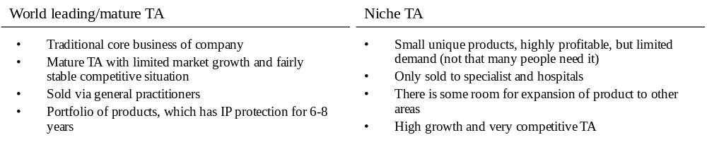
Question 1: What is the client’s key issue/problem?

Note: This is an open-ended question to test if the interviewee has taken in the information given.

The client’s issue is that while they are growing at what sounds like a reasonable rate, they are not meeting the annual revenue growth targets that the CEO has set. They also have a significant problem in their R&D department. As the pharmaceutical industry is very R&D driven (i.e., R&D is necessary to develop new products and there is usually a significant time lag from initial research to product launch) strong R&D is necessary to produce strong revenue growth. The research pipeline is thin and because R&D is under spending it looks like the pipeline will remain thin, unless changes are made in that department. In addition senior management do not have a good understanding of the R&D department, which means that they probably do not understand the underlying drivers of the thin pipeline & the under-spending. I would hypothesise from what you’ve already told me that the problem in R&D (whatever that problem is) is largely responsible for the lower than desired revenue growth.

Note: It is important to realise from the information that revenue is the concern not profit. Prescription drugs are a highly regulated area and that regulation is in place to ensure that successful product launches typically generate the desired profit margins, without exploiting customers.

Question 2: OK, thank you. Now that you’ve summarised the problem, what initial suggestions do you have for improving their revenue growth and failings in the R&D department?

Because it’s a question of revenue, I would like to firstly explore the two levers effecting revenue, which are Price and Quantity. (Revenue = price * quantity)
Price:
You have already told me that the market is highly regulated and therefore I would assume that our client does not that have many options to generate significant growth in terms of price.

Quantity:
There are a number of ways in which our client could potentially increase the quantity of the drugs that they sell:
- Firstly they could look to expand into new geographical regions
- They are currently in all markets of interest
- Ok, so if geographical expansion is not an option, they could look at trying to increase their market share in their current markets:

Existing Customers New Customers
Sell more existing Sell existing products to
products to existing customers new customers

- The client is slowly growing their market share in the world leading TA, but it is unlikely that they can grow significantly more. In the niche area they have unique products with little competition – unless more people need their products it is unlikely to see growth.
- In that case, their remaining option is to try to increase the overall size of the market, i.e., grow the pie, by developing and selling new products to both existing and new customers
- That is correct. New/more products (potentially in new non-related areas) would enable us to grow.

OK, so turning my attention to the failings in the R&D department you said in your introduction that they have two key problems – firstly a thin pipeline and under-spending, and secondly the fact that senior managers do not understand the R&D department, so have probably, historically been unable to identify the underlying drivers of the under-spending and thin pipeline, and to solve them.

There are a number of reasons they could be under spending:
- Not enough good research projects on which to spend
- Lack of R&D talent
- Lack of motivation/incentives to staff
- Budget control problems

There are a couple of reasons why management has a lack of understanding what is going on:
- Unclear organisational structure
- Lack of useful management control procedures/tools

Question 3: OK, so what do you think the R&D process would look like?

Note: Most interviewees will have very little knowledge of the specifics and this question is designed to see if they give a structured response based on the knowledge they might have from other industries and/or experiences as well as to make sure that they have an understanding of the R&D process. The latter is important for subsequent questions.
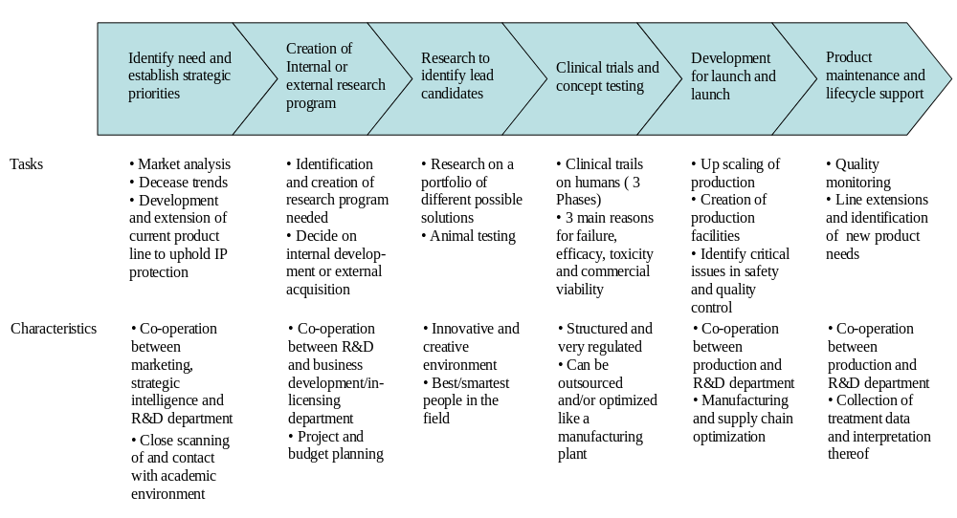
OK, there are different steps involved in the R&D process and
I imagine that each as different characteristics and needs different skill sets:

Question 4: Given the R&D process you have just identified and some of the skills needed in the different steps do you have any suggestions for how senior management can help the R&D department improve productivity?

Note: If you previously identified potential problems in the R&D department then you should take these into account. Creating new incentive structures could for example could help solve a lack of motivation.

The most important issue is however to create a transparent and logical division of responsibility for non-related processes and/or TAs. This will allow:
- Optimisation of non-research related processes in centres of excellence (e.g. clinical trails).
- Senior management control - underperforming units for example become easier to identify.
Given the 2 clearly distinct TAs this is the most logical split of the research department:

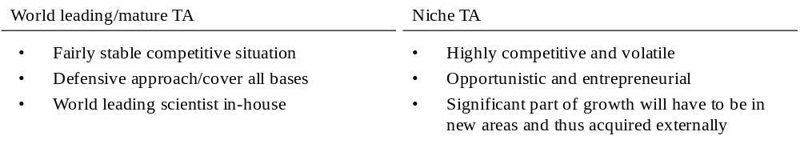
This not only splits two research units, which have very different culture (and few synergies) but also:
- Creates competition between the units, which should lead to better budget utilisation.
- Sets the future growth area (niche TA) free from the shadow of the traditional TA and increases their visibility internally and more importantly externally (makes it easier to find partners and attract in-licensing opportunities)

Note: An excellent candidate will notice that the research process takes 10+ years and that increased productivity needs to be accompanied by external acquisitions/licensing.

Question 5: We would like to understand the state of our current pipeline. In order to fulfill their growth targets, the CFO would like to have 1 product coming through the R&D process every year. Assuming that the process consists of 4 independent phases, how many targets do we need in each of the 4 phases?

In order to calculate the numbers the interviewee needs to ask for the following information:
- Length of phase
- Success/attrition rates
- If the phases are successive or parallel

The phases are successive and the “model” data are as follows (the data are made up to make the calculation fairly easy – there would normally be more phases and the success rates would depend on therapy area)

Phase | A | B | C | D
Success rate | 30% | 67% | 40% | 50%
Attrition rate | 70% | 33% | 60% | 50%
Months in phase | 24 | 18 | 36 | 24
Flow target | 25.0 | 7.5 | 5 | 2
Stock target | 50.0 | 11.25 | 15 | 4

Flow target is the number of projects that needs to flow from one phase to the next phase every year.
Stock target is the number of projects that needs to be in each phase at any given time.

It is easiest to calculate flow and stock starting from the goal of 1 product per year and then work backwards. Example of calculation:

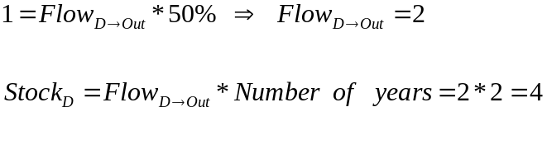
Question 5: You run into the CFO in the elevator and he asks you how the work is progressing and whether you think will be able to help them reach their revenue goal. What will you tell him?

You should summarize the key findings as to where the problem areas are and how they can be solved. In this the candidate should take all aspects of the case into considerations should in particular note some or all of the following:
- High revenue growth can only be obtained by having more products coming out of the R&D process.
- The R&D process consists of different phases, which can individually be optimised based on their core activities.
- The niche high-growth TA can be given higher visibility and credibility if separated out into an independent unit. The culture is moreover likely to be more entrepreneurial and opportunistic than in their traditional strength TA.
- Creating separate units enables internal comparison of productivity and is thus likely to create healthy competition between the units. Especially if they make them compete for funds.
- Creating a clear division of responsibility and reporting structures will enable senior management to better set and follow up on strategic goals as well as allocate funds where needed.
- An important observation that would give extra points is that the R&D process takes 10+ years and that they therefore will not be able to meet their ten year growth goals by growing the R&D pipeline, so will need to in-license product to meet these growth targets.

Case 15 - Happy Healthcare UK

Introduction
The government, through the NHS, pays for healthcare in the UK. This includes GP visits and hospital visits. However, many people choose to take out private health insurance to benefit from shorter waiting times, or to be treated by ‘better’ or more experienced doctors. The NHS dominates healthcare in the UK, with private hospital groups making up about 10% of the market.
Our client is Happy Healthcare, a small private healthcare company based in the UK. They have asked us to advise them on making some of their hospital activities more efficient. Firstly they would like us to conduct a detailed analysis of the industry in which they operate, and then move onto recommending a course of action for them. Finally they would like us to look at the implications of this course of action.
Happy Healthcare own and operate 10 hospitals in the UK (versus over 1000 for the NHS). The hospitals are typically half the size of NHS hospitals and do not include Accident & Emergency (ER). Revenue comes from patients claiming on their own private medical insurance, or paying in cash themselves. In 2005 Happy Healthcare had revenues of £100m (which represents less than 1% share of the hospital market), with an operating profit of £0.5m.

Question 1: What challenges do you think Happy Healthcare face in a market like this?

This is a relatively straightforward question to set the scene and settle you into the case. You will need to structure your answer to this question, as it is an open question and without an appropriate structure you will risk missing the key points. A structure such as Porter’s 5 forces, which is used to analyse industry attractiveness, can help in this analysis:
Degree of rivalry – high (low profit margins, and the NHS is a major competitor and a very dominant player in the industry. There are also a large number of private hospital groups targeting exactly the same market as Happy Healthcare.)
Supplier power – medium-high (Doctors are the key scarce resource in this industry. There are generally several options for other suppliers e.g. medical equipment etc)
Buyer power – high (Patients can easily opt for the NHS for free or, as mentioned previously, there are a number of other private hospital groups)
Threat of substitutes – low (there are no real substitutes for healthcare)
Entry Barriers – medium (it takes a lot of time, investment and expertise to enter this market if starting from a zero base, but entry will not be difficult for international private healthcare companies who already have the necessary capabilities)
Once you’ve laid out this high level structure, you can analyse more deeply each force to highlight specific challenges that Happy Healthcare faces:
Internal rivalry:
- How can HH differentiate itself from direct competitors, i.e., other private healthcare groups (brand, quality of service, location, procedures offered, price etc)
- How can it differentiate itself from the NHS (brand, quality of service, waiting times, location)
- How can it react to moves by the NHS (e.g. what if the NHS reduced waiting times significantly etc)
- How can it increase its currently low profitability?
- How can it grow? (with expanding its target market, e.g., expanding its target demographics, new services, new locations etc)
Supplier power:
- How can Happy Healthcare attract and retain top quality doctors?
Buyer power:
This issue is driven largely by Happy Healthcare’s performance relative to its competitors on the issues identified in Degree of Rivalry:
- How to attract patients (brand, quality of service, waiting times, location, procedures offered, price, deals with individual insurance companies etc)
Threat of substitutes:
- There are no substitutes with the exception of going overseas for procedures, which is difficult and risky as the quality of the procedures in other countries is hard for UK patients to analyse
Entry Barriers:
- Can Happy Healthcare raise entry barriers? E.g. building new hospitals in the next most attractive locations that competitors might choose or offering a standard of service at a price that is very hard to beat.

Question 2: The NHS has long waiting lists for many hospital operations (e.g. often over 1 year for something like a hip-replacement operation). They have decided to contract out these operations in bulk to the private sector to help reduce the waiting times. Happy Healthcare is trying to decide whether they should enter into these new contracts. What factors do they need to consider when making this decision?

This is a slightly tougher question. A good way to structure the answer to this question is to analyse accepting in terms of its advantages and disadvantages to Happy Healthcare:
- Accepting the contract will mean an increase in business:
  - What are the consequences of an increase in business?
    - Do they have enough spare capacity?
    - Should they build more capacity just for these contracts?
      - If so, what if the contracts are not renewed in a few years?
- What would happen if they did not participate?
  - Their competitors would probably take up the remaining work helping them to expand into newer areas, attracting talented doctors etc
  - They may be able to stay more focussed on their core market/customers and focus on increasing profitability
Advantages:
The most obvious advantage is that accepting the contract will increase business volume. The fact that these are bulk contracts means it will be easier to plan for the increase (e.g. scheduling resources etc), than trying to increase business directly from the patients themselves. Furthermore, as more NHS patients see the superior facilities at Happy Healthcare, they may be tempted to take out private insurance for all their healthcare needs increasing the size of the private healthcare market.
Disadvantages:
One key disadvantage is that accepting the NHS contracts could increase waiting times at Happy Healthcare’s private hospitals, thereby reducing their ability to differentiate from the NHS (which is their unique selling point in the first place). Furthermore private patients may not appreciate being treated alongside public patients, which could damage the appeal of private healthcare to existing customers.
Another disadvantage is that Happy Healthcare may not have enough resources to undertake all the operations. You should realise that the NHS will not pay as much for these operations as would private insurance companies, as they are a bulk buyer. Consequently, you also need to ask whether Happy Healthcare will turn a profit on these contracts?

Question 3: Happy Healthcare has decided that it will enter into these NHS contracts. However, it is concerned about capacity. In particular it has asked us to look at its outpatient areas.
Each hospital is generally arranged into 2 major areas:
- ‘Inpatient’ area (for surgery and overnight stays)
- ‘Outpatient’ area (for consultations, simple procedures not requiring an overnight stay, physiotherapy and tests, e.g., X-rays, blood tests etc)
Let’s look at capacity first. Thinking about outpatients in particular, how would you analyse a hospital in terms of capacity?

Given the lead in, you should easily be able to identify that both personnel (doctors, nurses, other clinical personnel like radiographers, physiotherapists etc) and equipment (X-Ray machines, MRI scanners, laboratories for blood tests etc) are key capacity constraints.
However, you should structure the answer logically rather than just giving a list. For example:
- First determine a more complete understanding of what activities take place (e.g. by thinking about capacity in terms of the patient’s journey – see below for more detail)
- Then try to figure out what resources are required for each activity/stage in that journey
- You should then note that it is very important to understand the current utilisation levels of each of these resources
- Consider how easy/difficult it may be to add more capacity at each stage
- Note that simply driving utilisation rates higher will have an impact (i.e. longer waiting times, possibly worse customer service resulting in damage to the brand etc)
- Note that some resources are fixed cost (e.g. equipment and physical space such as car parks, waiting rooms etc) and others are variable (e.g. staff)
- Develop hypotheses identifying potential bottlenecks (e.g. doctors, waiting areas etc). You do not need to come up with the ‘right’ answer here, just show that you can arrive at a logical hypothesis, which could then be tested.

Activities, Resources & Utilisation:
For parts 1, 2 & 3 you could consider the patient journey from when patients enter the hospital to when they leave:
- General enquiries
  - Admin Staff (utilisation very variable and demand driven)
- Appointment booking
  - Admin Staff (utilisation very variable and demand driven)
- Car park
  - Physical space – is there any way of expanding the size of the car park. If yes, what is the cost of land in the target expansion area? (utilisation variable, but must satisfy peak demand)
- Reception
  - Receptionist (utilisation variable, but must always be present)
  - Waiting area – how easy is it to expand the waiting area? (utilisation variable, but must satisfy peak demand)
- Clinical activity:
  - Consultations
    - Receptionist (utilisation variable, but must always be present)
    - Consultant doctors (high utilisation, generally a limited resource)
    - Consultation rooms (utilisation demand driven, but must be enough rooms for peak demand by consultants)
    - Waiting area (utilisation variable, but must satisfy peak demand)
  - Physiotherapy
    - Receptionist (utilisation variable, but must always be present)
    - Physiotherapists (high utilisation, appointments used to smooth peaks and troughs)
    - Physiotherapy rooms (utilisation demand driven, but must be enough rooms for peak demand by Physiotherapists)
    - Waiting area (utilisation variable, but must satisfy peak demand)
  - X-ray dept
    - Receptionist (utilisation variable, but must always be present)
    - Radiologists/Radiographers (high utilisation, appointments used to smooth peaks and troughs)
    - X-ray machines (utilisation demand driven, but must always be present)
    - Space for X-ray machines (fixed utilisation)
  - Other waiting areas (e.g. in X-ray dept, Physiotherapy dept etc)
- Leaving hospital
  - Billing
    - Staff (utilisation variable and demand driven)
    - IT systems (utilisation generally fixed – always on)
  - Debt collection
    - Staff (utilisation variable and demand driven)
    - IT systems (utilisation generally fixed – always on)
  - More general enquiries
    - Staff (utilisation variable and demand driven)

From this analysis it should be clear that the utilisation of almost all resources in the outpatients area is variable. This can lead to peak demand exceeding supply resulting in queues and potentially lower quality service.
You are not expected to list all items in the patient journey. However you should view the hospital as a business – i.e. one that requires admin staff (not just doctors and nurses) and realise that private hospitals must collect money at some stage.

Adding capacity:
Happy Healthcare’s ability to add capacity depends on the cost and the ease of acquiring the extra capacity.
- General staff for reception and admin functions are relatively cheap and easy to acquire. On the other hand specialist clinical staff like doctors are both expensive and difficult to find.
- Equipment is expensive but easy to acquire. While extra physical space (waiting rooms, consulting rooms, car parking spaces etc) could be expensive or cheap depending on the location. Likewise the ease of acquiring extra space could be easy or difficult depending on planning permission, willingness of others to sell land etc.

Bottlenecks:
Note that the client is barely profitable (something that you were told in the introduction to this case), so cost would be a major concern for them when looking to add capacity. Therefore, adding resources/capacity is not a trivial decision. Bottlenecks could include:
- Doctors (or other clinical staff) – critical resource with no substitutes, a scarce resource that is difficult and expensive to acquire, high utilisation.
- Waiting areas (or other physical space) – required resource, but one, which can become over utilised at the expense of some patients standing.
- Admin staff – required resource but one, which can become over utilised at the expense of, increased process times. Possibly be under-resourced relative to other clinical staffing levels.

Question 4: Happy Healthcare believes that they will have problems taking on new business in several areas. As a result the project team has been split into different work groups and you have been asked to look at the billing functions. For private patients, bills have to be prepared for and be completed ready by the time the patient leaves. It is important to prepare the bills as soon as possible (preferably same day) so that the private patients can take the bill home with them to claim against their insurance. If they are not given the bill to take home as they leave, this typically adds 2 weeks to the claim time, even if the bill is posted to them the next day.
Happy Healthcare gives you the following graph. The graph shows patient arrivals per day for a typical week in one of their hospitals, which does a lot of joint replacements. The graph indicates the utilisation of the 2 separate billing departments and their maximum capacity.

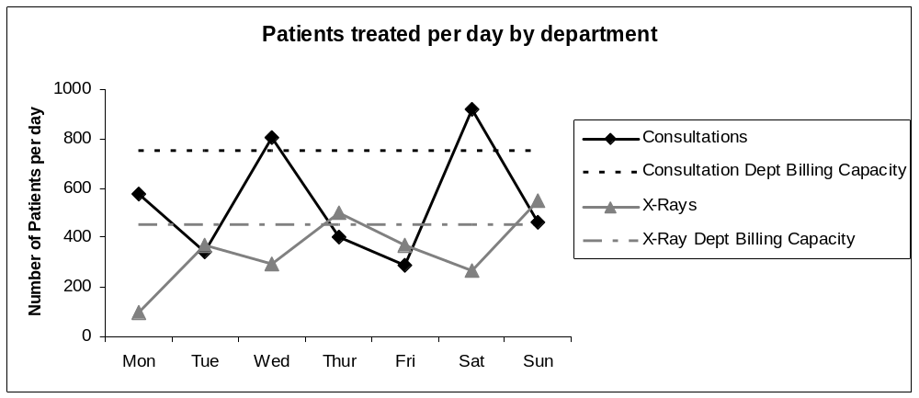

What does this graph tell you?

You should be able to identify the following from looking at this graph:
- Both areas exceed capacity on some days
  - This will lead to delays (which are costly)
- Both areas appear to have inversely proportional patient demand
I.e., a busy day in consultation is a quiet day in X-ray and vice versa
- You may hypothesise a relationship between X-rays and consultations
  - X-ray lag consultations by one day
  - X-rays lead consultations by one/two days

Question 4b: Does it look like X-ray’s cause consultations, or do consultations cause X-rays?

You should notice that X-ray’s consistently lag consultations by one day, but do not lead consistently (sometimes 1 day, sometimes 2). You should also note that there are more patients having consultations than having X-rays. Intuitively one X-ray should not cause more than one consultation the following day, but that a consultation could result in one or more X-rays the following day.

Question 5: Assume that any NHS contracts will mean a significant (~40%) but flat increase in both consultations and X-rays throughout the week. The NHS contract states that bills must be processed within 48 hours of the procedure. How would you minimise late bill processing using the existing level of resources?

You could take several routes here. However, the key elements to realise are:
- NHS bills will have more flexibility than private bills (i.e. 48 hours to complete vs. 24 hours respectively if you are aiming to give private patients they bills when they leave hospital), so you can move NHS bills to ‘quiet periods’ when there are less private bills to process. Busy days are followed by quieter days facilitating this approach
- Billing is a relatively simple function. Consultation bills and X-ray bills are not that different making it easy to consolidate them and use one department which would remove the current overcapacity problem
- Other potential solutions:
  - More IT – automate the bills
    - Currently the bills are manually entered into the billing system from printouts given to them by the consultation and X-ray receptionists
    - Link the receptionists appointment system to the billing system
    - Prepare bills in advance for consultations (cannot do this for X-rays because we only find out the day before that an X-ray appointment has been booked)

Question 6: Well done! Now we need to find out if we can use your idea to meet the new demand levels. After considering your suggestion Happy Healthcare think they can now handle 1,200,000 outpatients.
Every operation typically involves 1 inpatient visit and 6 outpatient visits (including tests and follow up appointments). Happy Healthcare currently has 1,000,0000 patient visits per year (inpatients and outpatients). They think that total operations may increase by as much as 40% in 10 separate NHS contracts.
If operations did increase by 40%, how many outpatient visits will they have?

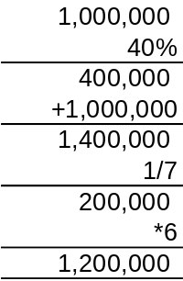

Question 7: How would you recommend Happy Healthcare proceed?

This is the final wrap-up question and you should therefore give your final recommendations, taking into account all the analysis you have conducted and conclusions you have come to during the course of the case. A good answer would be:
If Happy Healthcare took on all this business they would reach capacity very quickly. This would cause them a lot of problems when demand from private patients fluctuates.
You should realise from the earlier graph that demand is variable. Therefore demand will exceed 100% of capacity on a regular basis, causing delays, poorer service, and potentially increasing costs and damage their brand.
Your recommendations should contain 2 or 3 ideas, possibly including:
- Monitor capacity levels closely
- Don’t take on so much business (e.g. only 5 of the 10 NHS contracts) as it is not worth jeopardising your more lucrative private patient business for the NHS contracts
- Add more capacity (noting that this may take time, and the cost may be prohibitive)
- Conduct a more detailed analysis of the revenue/costs of the NHS contracts to determine if they are worth taking on or not.

Case 16 - Russian Tourism Industry

Introduction
Your client is the government of a region in southern Russia. The region includes the country’s leading tourist destinations, primarily ‘sun and beach’ tourism. But the government is unsatisfied with the tourism sector’s revenues. They have hired your consulting company to fix this problem, preferably by the next elections in 2008 (it is now 2005).
Five minutes after flying into the regional capital, you get a call on your mobile phone. The deputy governor wants to meet with you in two hours time to see how you will approach the problem.
You have three graphs (at the end of this case), which you may look at if you need to when answering any question in this case.

Question 1: What will you tell him?

This is clearly a revenue problem and you should use the equation Revenue = price * volume to structure your answer to this first question. A good answer would be something like:

“I have been told by the client that the problem is unsatisfactory revenues in the tourism sector. To solve this case, I would take a good look at the key elements of revenue, which are price and volume (Revenue=price * volume). By volume in this context, I mean both the number of tourists visiting the region throughout the year and also the number of ‘paying’ activities that they engage in while they are there. Therefore, when trying to increase volume, we need to focus our efforts on increasing both of these factors. Price is the amount that a tourist pays for each activity that s/he engages in while visiting the region, e.g. eating at a restaurant, taking the children to a water park, renting a deck chair on the beach. On the aggregate level, this is the average spend per tourist. To increase volume, we can seek to increase the number of tourists and the average number of paid activities per tourist. To increase price, we can either try to get current tourists to pay more for their current activities or try to get them to migrate to higher cost activities.”

Question 2: The meeting is also a chance to gain information from the government. What pieces of information would you ask for?

To answer this question you need to ask yourself what information you feel you need to begin to build an understand of ‘what is going on’ and how to solve the problem. It will be useful to have some historical context and also to try to pinpoint the situation with regard to each ‘aspect’ of revenue:

“To begin with, I want to understand the historical trends related to revenue. You have told me that you are unsatisfied with tourist revenues, but not exactly what makes you unsatisfied with the revenue from tourism. I would ask for historical information on tourism revenue. I would also ask for data on the number of tourists visiting the region, the average number of activities they engage in, plus the average spend per tourist.”

Question 3: Okay, the deputy governor provides you with a report conducted by a local consultancy {See graphs 1 & 2 at the end of the case}. What does this tell you?

The graphs indicate that both the number of tourists (volume) and total revenues from tourism have been increasing over the past three years. As we have identified average spend per tourist – i.e., average revenue per tourist - as our key indicator we will need to determine if volume of tourists is increasing faster than revenue. This seems to be the case. The number of tourists has increased by around one third in two years, while the total revenue has only increased by around one fifth. This indicates that, although more tourists are visiting our region, the average spend is less. There could be a number of reasons for this. For example, the supply of our tourist offering could have increased faster than demand, leading to overcapacity and a reduction in price, or the demographic of our tourists may have changed, leading to us having, for example, more older tourists who do less and therefore spend less or and increase in tourists from a lower income group.

Question 4: Okay, so revenue per tourist is declining. Why do you think that is a problem?

When looking for a structure to answer this question with you should ask yourself what key benefit the region is looking to derive from tourism. This has to be profit (not revenue per se) and therefore thinking about the profit equation is a good way to structure this answer. However, in addition to this, you need to remember that your client is the region’s government, and consider in your answer how exactly they will derive revenue and therefore profit from tourism (given that the hotel, the beach chair etc are owned by individuals, not by the government):

“To begin with, the region is not maximizing revenue and is therefore not maximizing profit (Profit = Revenue – Costs), and will not accrue all of the wealth possible from tourism. This is especially a problem because capacity – hotel rooms, space on the beaches, room in restaurants – is likely to be limited and therefore the region is getting less of a return on its finite resources. For our client specifically, this is a problem because they primarily make money from tourism through taxation as a percentage of consumption – such as VAT on services provided to tourists, payment for communal services used, etc. They are receiving less money, but have a greater number of users, especially for public goods, such as roads, public transport, but also communal services, which pushes up their costs with no associated increase in revenue.

Question 5: What are the different ways that you can measure capacity in this context?

A good way to answer this question is to think about the tourist’s ‘journey’ from arrival to departure in terms of the activities that they will engage in and then identify where the potential bottlenecks are:

“I can think of a number of potential bottlenecks in capacity in the tourism industry. One is in terms of transport. Tourists can arrive in the region by air, land or sea. In terms of air, we will have a fixed capacity in terms of airports’ abilities to handle flights. In terms of sea, we would have the same capacity issues for tourists arriving in ports by cruise ship. In terms of land, we have the capacity of our road and railroad system. We may have capacity issues in terms of accommodation, i.e. the number of hotel rooms. There are probably a number of other capacity issues, such as space on beaches and the capacity of communal infrastructure (sewers, water systems, ability to provide electricity, etc.). Finally, if there is seasonality to our tourism flows, we will need to look at the capacity during peak seasons as the bottlenecks will most probably only occur during the peak season. Personally, I would first look at capacity in accommodation because when adding air, sea and land together, the capacity of ‘transport’ is considerable, so accommodation is a more likely bottleneck. Also, accommodation is not an option – people need somewhere to stay – whereas other activities such as visiting the water park or sitting on a deck chair are ‘options’ and therefore both less likely to be used by everybody and less of a problem if they are full. Do we have figures for hotel occupancy during peak season?”

Question 6: Yes. The average reported hotel occupancy was 85% in 2004. Hotel occupancy in the region was 90% during peak season. What do these figures tell you?

At the end of the day these figures don’t tell you that much unless you have some context to put them in. Therefore a good answer to this question would be to make this clear and then request some more information:
“ 90% sounds fairly high, but on its own doesn’t really tell me much. Do we have similar figures for other regions that we can use to judge whether this figure is high or not?

Yes. The region’s main competitor – Turkey – had only 65% occupancy rate during the peak season, which was considered a good year.

“That’s great. If our client’s main competitors has 60% hotel occupancy during a good year, then that is a good indication that the region’s capacity is getting very stretched. This possibly indicates that our region doesn’t have sufficient slack capacity during the peak season.”

Turning point: Now, let us imagine that you have been working on the project for about one week. You have another meeting with the deputy governor. Can you quickly summarize your conclusions about the tourist industry’s problems and outline possible solutions?

With a question like this, the interviewer is not looking for you just to re-hash everything you have talked about so far, verbatim. He/she is looking for you to summarise, conclude and come up with some sensible recommendations:

“Though overall revenue from tourism is increasing, the increase in the number of tourists means that the average revenue generated from one tourist is decreasing. This may or may not be a problem for the region, but in order to grow revenue they will have to either increase the average revenue generated per tourist or increase capacity, at least in terms of accommodation which we have identified as the key bottleneck, to increasing the volume of tourists. Expanding capacity is likely to be expensive and take time, which we probably don’t have time on any significant scale given that our clients want to see improvement before they face election in 2008. Alternatively, the region can seek to attract tourists at non-peak times to take better advantage of existing capacity and this solution would seem to make a lot of sense as it has major cost advantages.
There are two ways to increase average tourist spend. One is to increase the spend of current tourists – either by charging more for their current activities, increasing the average number of their paid activities or by moving them onto more premium activities– or by attracting tourist segments that on average spend more. Given indications of high capacity utilization, I would expect the price level to be rising anyway (as resources, such as hotel rooms, become scarcer). The fact that the revenue per tourist is decreasing may indicate that the region is not attracting high spend tourist segments, which may be related to quality issues given high capacity utilization.”

CAPACITY PATH:
Question 7: One of the main destinations is the region’s southernmost city, Sochi. The current terminal can process up to 600 arriving passengers per hour. There is a new terminal building that has been started, but abandoned, 90% complete, for bureaucratic reasons. The new building will be able to process 2,000 arriving passengers per hour. Let’s assume that 100% of the airports traffic comes from tourists. Should the city continue with the expense to build the new terminal?

Once you have been given this question you should realise that you need more information from the interviewer to answer it. You should think through carefully the information that you need to ensure that you don’t ask for too much information that you don’t end up using:

“To begin with, I want to look at the capacity utilization of the current airport terminal. I then would determine future growth in demand in terms of growth in traffic and the number of passengers that must be processed. I would then look at alternatives that would allow capacity to be met, including, but not limited to, opening the partially built new terminal, and make a judgment based on a cost-benefit analysis.
I know that the current terminal can handle 600 passengers per hour, so in order to determine maximum capacity, I need to know how many hours per day it is working. Can you give me this information or should I make an assumption?

The airport is open from 08.00 to 22.00, a total of 14 hours. You can assume for maximum capacity reasons that the maximum number of passengers (600) can be brought in every working hour.

Note: You will extra points for realizing that there will be peaks in terms of arrivals during the day.

“Ok, great, 14 hours per day. That means that the terminal can process 8,400 arriving passengers per day.
Now we need to gauge current demand and must keep in mind that the terminal must have enough capacity to handle the peak in the tourist seasons. Can you give me information about the number of tourists per year? How many of them visit during the peak month? How many of these will travel to Sochi? And how many of those arriving in Sochi do so by plane?”

To give you the information you requested:
- There are around 7 million tourist per year. August is the peak with 30% of the tourists.
- Not all of these tourists will go to Sochi. About 40 will go to Sochi, the others will head to three other destinations.
- Not all of the tourists in Sochi will arrive by plane. About 30% will.

“Okay, so that means that currently 252,000 passengers arrive in Sochi via the airport in the peak month of August. That is very close to the airport terminal’s month capacity of 260,400 and if we assume future growth in demand, then it is clear that the current terminal does not have enough capacity to meet demand over the longer term.”

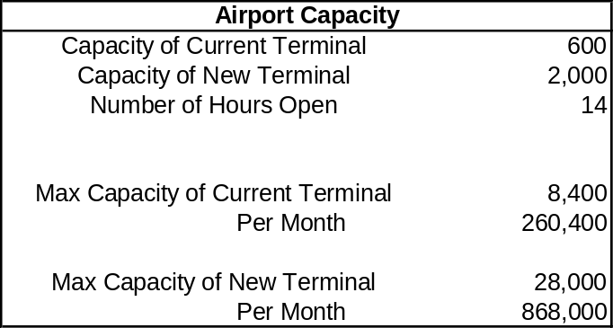

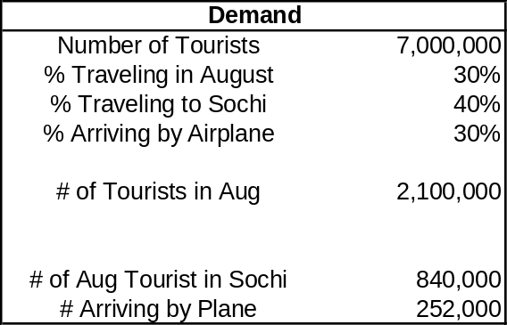

Question 8: Current capacity is dangerously close to current demand at peak. So should they build the new terminal?

“It is not clear at this point if they should finish the new terminal. The fact that they have already built 90% of the new terminal is sunk cost. The new terminal would greatly increase capacity up to 868,000 passengers per month, but it is not clear at this stage if future demand growth will require so much additional capacity. Other options include running the existing terminal for a longer number of hours every day. Perhaps it would be more cost effective to renovate the existing terminal to handle additional passengers. I would also want to check if there are any other bottlenecks at the airport. It doesn’t make sense to increase the capacity to process passengers at the terminal, for example, if the runways cannot allow enough planes to land at one time to economically use the capacity.”

MARKET SEGMENTATION PATH:
Question 9: We have determined that increasing the tourism industry’s capacity will take longer to implement than the politicians are willing to wait, so we have decided instead to focus on segmenting the market. What kind of segments do you think exist in the tourism market? Which ones do you think are most important in this case?

“There are many possibilities for segmenting tourists. Perhaps the first distinction I would make is between domestic and international tourists. Locals and foreigners are likely to have very different perceptions of and information on the region, and may also have different behaviors when it comes to tourism. Perhaps similar to segmenting by domestic/foreign, we could segment tourists by distance from our destination. More distant destinations require a different decision making process than nearer destinations. To continue, we could segment tourists by demographic indicators, such as age, family status, income level, etc. I would suspect that income level may serve as an indication of tourist spend, though this would need to be tested. I would similarly expect tourists in different age groups and different family status to have different behaviors regarding tourism. Behavior is another way to segment tourists. There are different types of tourism. Perhaps there exist, for example, opportunities to develop winter tourism, ecotourism, extreme tourism, or health/spa tourism in the region and attract the interested market segments. Of course, it would great to segment along the lines of tourist spend if possible, but we may have to use multiple segments to target specific customer bases. For example, we may find that there are X number of young, high income, singles that prefer extreme tourism and are on average willing to spend Y amount of money.”



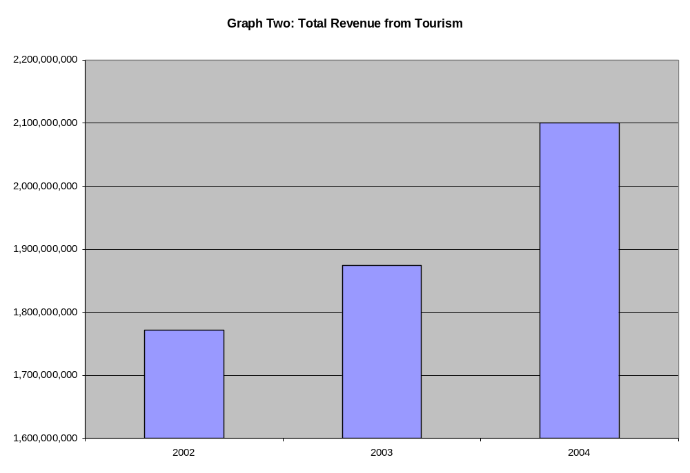

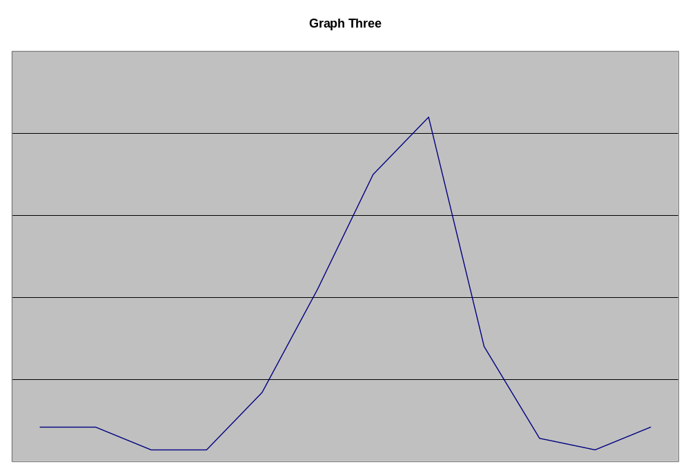

Case 17: Irish Retail Bank
Introduction

Our client is the CEO of an Irish retail bank. He was appointed just 2 months ago. The bank has been suffering a decade of declining profitability. The new CEO has asked us to identify what's been happening to the bank.
Question 1

So that’s our first task – to figure out why the bank has been suffering from declining profitability. How would you figure this out?
Answer
This is clearly a profitability issue: Profit = Revenue – Cost. Driving to an early hypothesis is important, and asking appropriate clarifying questions will help you to do that:
- How have revenues performed over the last 10 years?
  - Revenues have grown in line with GDP
- How have the costs behaved over this period?
  - The costs have grown
- Have they grown faster than GDP, at the same rate or slower?
  - Faster

- Costs have been growing faster than revenues – so the issue appears to be with the costs.

Other good clarifying questions to understand the bank’s situation, and to rule out any issues with the revenue side are:

- What is the bank’s overall market share and how has it changed over the last 10 years?
  - The bank’s market share (revenue and no. of customers) has been constant at 50% over the last decade
- How does this compare to competitors?
  - The nearest competitor’s market share has been roughly 50% too over the last 10 years
- Has the bank’s product portfolio changed over the last decade?
  - Yes – products have become more complex, requiring increased IT capabilities

Before we explore the costs in more detail, what are the revenue sources for a retail bank?
Revenue sources:
- Interest on loans, such as mortgages – more specifically the Net Interest Margin i.e. the difference between the interest payments offered on deposits and the interest earned on lendings
- Interest on credit cards accounts
- Fees on transactions – customer transactions, inter-bank transactions
- Inter-bank transfer fees
- Financial advisory services – small business and personal
- Asset allocation/investment i.e. investment of capital raised through deposits into unit trusts, or other investment facilities other than lending

Ok, so what are the major costs, coming back to your initial thoughts?
Fixed costs:
- IT infrastructure – since it’s been mentioned that retail banking has become very IT intensive, this is a major cost. This cost can be further broken down into development and maintenance
- Staff – staff in the branches, and staff in operations and the back office. A major cost
- Lease costs for buildings – this is usually a major cost, as most retail banks are located on expensive high street locations
- Other infrastructure costs – maintaining ATM network
- Admin costs – HQ staff, management and other admin costs
Variable costs:
- Sales and marketing costs
- Transaction costs
- Delinquency costs – cost of bad loans (this cost is only variable if we minimise the number of loans that we give out – which is difficult as it is core to our business - or improve our mechanisms for determining which clients are going to refuse to pay their loans back. Therefore it is only variable in a very limited sense.)

So, in summary, which are the three major costs from this list of costs you’ve identified?
The candidate should identify that IT, staff and buildings are the three major costs.

I would now like you to analyse each costs in detail. What key questions would you need to ask to enable you to analyse each of them?
The following information is provided when, if asked, when drilling into each cost:
IT
- Have IT costs grown over the last 10 years, and if yes, what has driven this growth?
  - Yes, they have grown significantly, primarily driven by the increased complexity and, therefore, IT-intensity of retail banking products
- How does our IT spending compare to that of our competitors
  - IT spending has been in line with competitors’ spending. Competitor product mix is are similar to the clients
- Have the IT projects that we’ve implemented run over in terms of time and budget, and have any failed?
  - No. All our IT projects have been successful. Very few projects have needed rework.
- Which parts of IT do we keep in-house and which do we outsource?
  - IT development is mainly outsourced, with certain core features kept in-house. IT maintenance is in-house
  - IT spending has been stable for the last 4 years
Staff
- Have staff costs grown over the last 10 years, and if yes, what has driven this growth?
  - Staff costs have grown significantly over the last decade – as products have become more IT-intense, the bank has had hire new IT-conversant staff for both branches and operations
- Do staff stay with the bank for a longer or shorter period on average than they did ten years ago?
  - Average tenure has increased
- Do staff get paid more on average than they did 10 years ago (inflation adjusted?)
  - Average inflation adjusted salary has increased
- Are the staff represented by any unions, and if yes, are these unions strong or weak?
  - The majority of staff are represented by a single union, and the power of that union is strong
- Have we been able to re-train staff to use these more complex IT systems?
  - Their has been resistance amongst non-IT conversant staff to training and job modification
- What are the labour laws like in Ireland?
  - Labour laws in Ireland make it very difficult to fire employees
- Have there been any major redundancies over the last decade?
  - The bank has not made any employees redundant on a large scale over the last decade
Buildings
- Do we own or lease our buildings (head office and high street branches)?
  - In Ireland, our client has owned all its branch locations for over 20 years (it is an old bank), so building cost is low. The market in Ireland is fairly saturated, so we haven’t seen too many new branches open in the last decade
Other
- Are there any other costs that are major and/or that have increased significantly over the past decade?
  - All other costs are minimal, or have remained constant over the last decade

Hint: The candidate needs to figure out that Staff is the issue. The bank has been hiring new employees to meet their changing staff needs (i.e., staff who are able to work with the increasingly complex and sophisticated IT systems), but was not able to fire employees who were surplus to requirements in the new IT-intense environment. The root cause is union power and restrictive labour laws.

Question 2

We go to the CEO with this finding, and the CEO suddenly remembers that Parliament announced yesterday that it would loosen labour laws within 2 months to allow staff redeployment. The CEO proposes we look at two operations departments in a pilot study to take advantage of this law change.

 | Residential mortgages (RM) | Broker mortgages  (BM)
No. of staff | 30 | 30 including 5 salespeople
Average annual salary | €60k | €50k
Total no. of applications processed per annum | 80,000 | 20,000
Other | IT intensive | Fairly manual

Before we get into the calculations, what options are there for generating savings? Once again, it would benefit you if you asked some questions to aid you in your analysis. What questions would you like to ask?
Some clarifying questions are necessary at this stage:
- Are the applications similar for each department?
  - Yes, identical
- Can we ignore other aspects of cost?
  - Yes, we can
- What are the relative revenue/application?
  - Identical in this case
- Are both departments operating at capacity?
  - Yes, they are
- Are the residential and broker markets expected to grow, if so by how much?
  - Let’s assume that they will not grow beyond their current volumes
- Are the 5 salespeople critical – do we really need 5?
  - Yes

Now that you’ve asked these questions, what options for generating savings would you like to propose?
Options:
- Merge RM with BM, new IT process, train all staff, and let go of excess staff
- Move BM revenue to RM, eliminate BM and expand RM
- Look at outsourcing BM and RM
- Increase efficiency of BM by implementing IT and cross-training with RM staff

Question 3

The CEO has reviewed the options that you’ve given him/her and has decided that he/she would like to move the broker application volume to the residential mortgages department. Outsourcing is too sensitive from an industrial relations perspective at this stage, and cross-training has not worked in the past.
How many additional staff will RM require? What will be the total cost savings?

Again, it is necessary to ask some questions to aid in your analysis:
- Can we assume that staffing is application volume dependent?
  - Yes
- Can we assume that the applications are identical, and ignore the costs to modify the RM IT to handle broker applications?
  - Yes
- Can we assume that the staff being transferred from BM will be paiod the new salary?
  - Yes
New staff level:
- The total application volume for RM in the future will be 100,000
- This is a 25% increase over the current volume of 80,000
- Assuming volume dependent staff levels, this implies a 25% increase in back office staff
- Therefore we will need 1.25 * 30 = 37.5, or rounding up, 38 operations staff
- We also need to keep the 5 salespeople
- Therefore, a total of 13 staff will be transferred to RM, and 17 staff will be let go from BM
Cost saving:
- 17 staff @ €50k are being let go => a saving of €850,000
- 13 staff are being given an extra €10k => an extra cost of €130,000
- Therefore, the total saving is €720,000 per year

Question 4

You have to sell this recommendation to the CEO. When you go to present your findings, you discover the CEO is rushing off to a board meeting. You have 30s to communicate your message.

The candidate should provide a concise recommendation, following the pyramid principle. It should be related to the initial issue of profitability, include the saving. Rambling is not good. For example:
We’ve looked at the pilot divisions as you suggested. We recommend eliminating the BM division, and rolling broker applications into the RM division. This move will reduce costs by €720k p.a., helping to ease the staffing pressure that profitability has been facing for the last decade. We will have to let go 17 BM operations staff as part of this move. Our recommended next steps are to begin an implementation plan for this move, and to identify other consolidation opportunities within the bank.

Case 18 - Performance Chemicals

Introduction
- The client is a $250 million Performance Chemicals division of a $7 billion Specialty Chemicals Company.
- The CEO of the parent company has set a “growth agenda”. He believes that his company can become the fastest growing chemical company in the industry and has set a growth target of 10-15%.
- The CEO has asked all division business managers to develop growth strategies to support his agenda.
- Performance Chemicals’ business manager, like many other managers in the company, does not believe that there is significant untapped potential in the markets served by his unit. The business manager has approached “Strategery Partners” for advice.

Question 1: Is the Performance Chemicals’ business manager’s scepticism in the CEO’s growth target warranted?

Hint: Often clients will frame a challenge presented to you based on implicit assumptions that may, or not be correct. Your job as a consultant is to ensure that the challenge is correctly/accurately defined, independent of client-bias, so that your problem solving approach is sound. To do this, you must ask appropriate questions to confirm or challenge your client’s perspective.

Relevant Questions | Answers
What products does your company make? | Asphalt additive, paper pulp bleaching solution and sodium solution
What market to you serve? | North America
How do you define “growth” | Profit growth (note: it is important to recognize that profit growth is the most relevant metric as it is most aligned with shareholder value)
What is your current growth trend | 3-4% per annum
What is the industry trend | 3-4% per annum
Who are your competitors? | Two major competitors with revenues and products similar to the client and many other much smaller
How intense is competitive rivalry (Porter’s 5-Forces) | High customer power. High supplier power (commodity inputs), High market entry barriers (capital costs), Low risk of market substitutes.

Good Conclusions
- The client’s scepticism is warranted. Growth will be tough!
  - CEO’s growth target is between 2.5-5 times current company and industry growth rate
  - Porter’s 5-Forces suggests that market is highly competitive, so taking market share from competitors is unlikely
Extra point conclusions
- Client’s products are fundamentally commodities (limited differentiation due to standard customer requirements), so the market is highly price sensitive and margins are likely to be low. Increasing profits by increasing price is probably not viable.
- The client’s market is fairly consolidated. This means that growth through local market acquisition is likely not practical – there are limited synergies to be gained from scale.

Question 2: Acknowledging that growth is tough, what are the generic ways is which our client could grow? Of the growth strategies identified, which are most viable?

You have said that growth is defined in terms of growing their profits, so firstly I would like to analyse the elements of profit to identify whether we could ‘grow’ profit by improving our performance in any of those areas. Profit = Revenue (price*volume) – Costs (fixed and variable):
  - Increase prices – Could we increase prices on our existing products? However, we could potentially look at whether the products be differentiated to merit higher prices?
  - Increase volumes – Is there untapped market demand, i.e, can we grow the size of the market as a whole? Can we increase our share of the existing market?
  - Reduce fixed costs – How efficient is the client, i.e. capital equipment capacity utilization, management productivity?
  - Reduce variable cots – Can better material prices be negotiated with suppliers? Can labour costs be reduced?

Good Conclusions
  - Based in findings from the first “Question 1”, I know that the customers are highly price sensitive and that they have significant power, so an increase in price is likely to result in drastic sales volume reductions. I also know that the client’s products are fundamentally commodities and customers have standard requirements, so there is little room for product differentiation.
  - Focusing on cost reduction is likely to be unsustainable given the extent of growth target – 15% cost reductions could potentially be achieved on a one off basis, but would be difficult to sustain year after year.
  - I would therefore conclude that focusing on volume growth is the best way to pursue profit growth.

Extra Point Conclusion
  - As the client produces commodities, costs are likely to be competitive. An efficient economy of scale is required to compete in a price sensitive, low margin business.
  - Volume growth can be achieved in four ways:

 | Current Customers | New Customers
Current Products | Sell more current products to current customers | Sell more current products to new customers
New Products | Sell new products to current customers | Sell new products to new customers

Question 3: OK, that’s great. You have rightly identified that the best way for this company to try to deliver year on year profit growth of 10 – 15% is to increase their volumes, and you have identified four ways that they could do that. What strategies could they follow to achieve more sales of existing products to existing and new customers and how could they sell new products to existing and new customers?

Good Answer
  - Product innovation that can leverage current processes or technical knowledge
  - Solution offerings – inventory management, expand product portfolio to become a “one-stop” shop for customers.
  - New market entry (developing economies? Remember, the client currently only serves North America)

Extra Point Conclusion
- Recognized the distinction between strategy and implementation. M&A is not a strategy. It is an approach to implementing a strategy to enter a market or expand a product portfolio. It should be noted that many of the above strategies can be achieved through M&A, partnership, organic investment, etc.

V. Fit Interviewing
a. Overview
In addition to a number of case interviews, you will almost certainly be given one or more fit interviews during the consulting interview process with each firm. These interviews may either be combined with the case interview (hybrid case and fit) or conducted separately, depending on the firm.

b. The Importance of Fit
While students increasingly understand the importance of preparing for and practicing case interviews, it is a common misnomer that fit interviews are less important in the interview process. While it is true that consultancies will spend less time testing fit than case, be under no illusions that a poor performance in the ‘fit’ component will destroy your chances of securing a consulting job. So please remember when you are preparing for your interviews that performing well on both is critical to landing the job.
In a fit interview, the interviewer does not need to believe you’d make a great best friend – that’s not the point. However, they do need to respect you, to want to work with you, to think that you would fit into the company’s culture, believe that you’d be a great representative with clients, and be confident that they’d be happy to spend ten hours on a plane with you. And they do need to feel that you are ‘above the bar’ on the dimensions we discussed at the beginning of this Case Book – Leadership, Personal Impact and Drive/Aspiration.
If the ‘fit’ aspect of an interview is not working and you don’t feel like you’re gelling with the interviewer, it is your responsibility not the interviewers. Some candidates come out of interviews saying ‘it just didn’t work’, as if ‘it’ was something they had no control over. If the interview doesn’t seem to be working, try to analyse on the hop what is not working and change your behaviour. Often the interviewer will give you quite strong hints about why you not ‘gelling’. If they keep asking you to go into more depth in your answers, make sure that the next answer you give and all the others after that are very detailed.
I have been disappointed in the past by students who have been excellent at cases, but who were continually turned down for consulting jobs. When I asked for feedback on their behalf, because I couldn’t understand why they were being turned down, it was because of poor preparation in, and therefore performance on, the fit component of the interview. By their own admission they hadn’t put any effort into preparing for ‘fit’ aspect because they thought it would be easy to ‘wing it’ in the interview, and found out, too late, that that wasn’t the case. Don’t make the same mistake!

c. Criterion Based Questioning
In fit interviews you will be asked about your background, motivations, experiences and capabilities. Many consultancies are reasonably sophisticated in the fit interview, and instead of just ploughing through the biographical aspects of your CV, they will interview you using a technique called criterion based questioning:

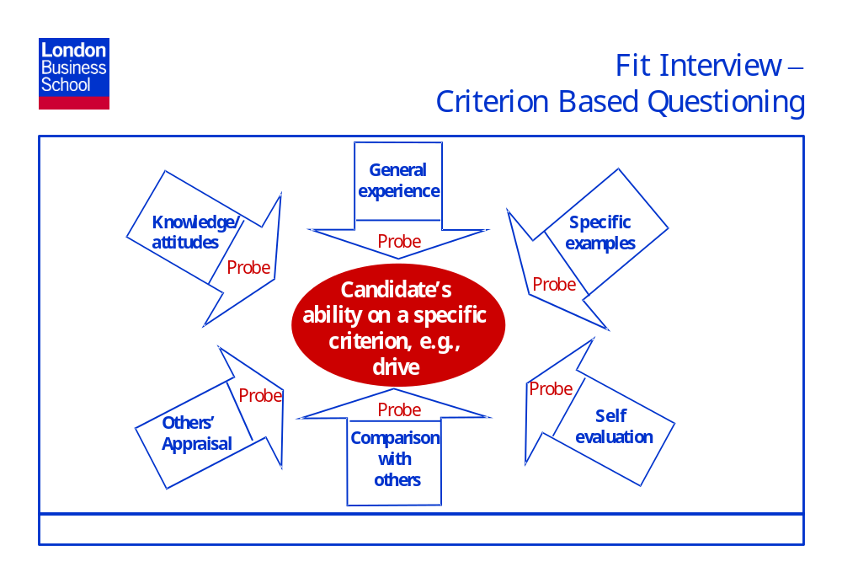
In criterion based questioning, the interviewer will explore in detail the candidate’s experience and ability on a specific criterion, e.g., drive, teamwork, entrepreneurial spirit. The criterion they will explore are those I highlighted as being important right at the beginning of this Case Book – i.e., Problem Solving (criterion will be tested mainly through the case), Personal Impact (criterion - listening/understanding/responding, empathy, influencing, teamwork, confidence vs ego, sense of humour), Leadership (criterion – integrity, maturity, willingness to take personal risks, ability to take initiative) and Drive and Aspiration (criterion – enthusiasm, desire to excel, self-development, energy, perseverance). The interviewer will explore these criterion by probing the interviewee in detail on the six different topics highlighted in the slide above, though of course they will probably not run through all six probing questions for each and every criterion they are testing an interviewee on, because of time constraints. An explanation of the six probing questions is as follows:
General Experience:
- The amount of experience a candidate has had overall in using/developing that criterion.
- Example - Desire to excel: How important has working hard and being driven been in your career to date?
Specific Examples:
- Specific examples where a candidate displayed that criterion
- Example – Desire to Excel: Describe a previous achievement for which you had to strive?
Self-Evaluation:
- How the candidate assessed his/her ability on that criterion
- Example – Desire to Excel: Could you have done more to make sure you achieved your full potential over the past three years?
Comparison with Others:
- How the candidate compares with others on that criterion
- Example – Desire to Excel: How would you compare your level of drive and aspiration to succeed against the top quartile of your peers at…..?
Appraisal:
- What others think of the candidate on that criterion
- Example – Desire to Excel: How did you manager in X role appraise your desire to excel?
Knowledge/Attitudes:
- How well the candidate understands the need for that criterion in consulting. Whether the candidate has a good perspective on the attributes necessary for good performance on that criterion.
- Example – Desire to Excel: In what circumstances do you think it would it be appropriate to give up on an objective?
To prepare for the fit aspect of your interview, you should go through your CV and experience to date (both professional and personal) and come up with at least two examples for each criterion that demonstrate your experience, abilities etc on that criterion. Once you’ve done this, write an answer to each of the six probing questions for each of your two/three/four/five examples. If you can, run your examples and answers by a fellow MBA (preferably someone who has had some consulting experience) and see if your examples and answers are convincing. Once you get into an interview – a situation which is stressful and at which you will be required to give well-developed, relevant answers very quickly – you will be grateful for this level of preparation.

d. Two key ‘Why do you want to....?’ questions
In addition to testing the above criterion, the interviewer will almost certainly ask you two key questions: ‘Why you want to go into consulting’, and ‘Why their particular firm’. Your ‘story’ is very important in answering these questions. You should very succinctly be able to tell the interviewer why you have made the choices that you made to date - e.g., choice of college, choice of post college/pre MBA work experience, choice of London Business School over other MBA colleges, and flowing from all this, why you are now seeking a position in consulting and why, in particular, their firm. This story needs to convey to the interviewer exactly why you are at London Business School and convince him/her that you are serious about a career in consulting and about his/her firm in particular.
Getting the balance right in your answers to these two key questions is important. Remember that most of your interviewers were in your shoes not too long ago, and they will be well aware that most people joining consulting firms from their MBA view it as a reasonably short term, career accelerating move. As such, stating that you have always wanted to be a consultant and that your ultimate aim is to become a Partner in their firm may come across as sycophantic and somewhat less that true. Conversely, saying that you want to work in consulting for two to three years as a career accelerator may be viewed as uncommitted. It is all about balance!
If you do envision yourself being in consulting long term there is nothing wrong with saying that, but you might want a slightly less emphatic approach that the one above. For example: ‘I believe from my past work experience, what I’ve learn on my MBA, and what I’m good at that a career in consulting would suit me very well. If I like it and I’m effective at it, my plan would be to continue in that field and strive for Partnership of a consulting firm. However, as I’ve never worked in consulting, my career interests and therefore goals may evolve from there in the future.’
If you believe that you won’t be in consulting for the long term, be honest about the fact that you may want to look elsewhere after a while. For example: ‘My ultimate goal is to run my own business in the travel industry, and I think that consulting as a medium term post-MBA career will provide me with great experience to do that in the longer term. Having said that, if I really enjoy consulting, I am very open minded about making it my long term career.’
You will also certainly be asked a question about ‘Why their firm in particular?’. You must be able to articulate a few reasons why that firm is the best fit for you. Read the website, go to the company’s presentation, talk to their representatives after the presentation, read the ‘Who are the consultants?’ presentation on portal, come and talk to me. However, do not put yourself under undue stress researching little known facts about the firm or trying to come up with genius questions that no-one else will ever have thought of. The interviewer is only trying to assess that your interest in their firm is genuine and that you have good reasons to back up this interest. Keep that in mind when you’re preparing answers to this question.

e. Do you have any questions for me?
The fit element that is most common in consulting interviews and is often overlooked by candidates as being a fit question, is the ‘Do you have any questions for me?’ question that most interviewers will pose at the end of their interviews. Your questions communicate your level of interest in their case, their firm, the type of work that they do and also demonstrates (or not!) your ability to ask insightful questions. Spend time preparing firm specific questions before each interview. Try to make these high caliber questions, not just questions that can be gleaned from a quick scan of the company’s website. And finally, make sure you listen to and show interest in the response and think about asking a follow-up question to demonstrate that interest.

f. A Two-Way Process
Fit interviews are very much two-way conversations between the interviewer and interviewee. You should feel that you are interviewing the firm as much as they are interviewing you. In addition to having insightful questions about the firm, try to analyse the people that you are speaking with when you’re interviewing with that firm. If you get the job, you will also need to sit on a ten-hour flight with people similar to your interviewers and work very, very long (often stressful) hours with them. Is that really something you want to do? The goal in the Milkround is not just about getting a job (any job). It is about getting the right job – even though it may be hard to remember that at times. The MBA Milkround is like no other process you will go through in your life. You have a whole array of fantastic firms all wanting to hire talented MBAs – all of whom are prepared to come to you and lay out their wares. Make sure that you don’t waste that opportunity by not having the confidence to ensure that the firm you end up working for is the one you really want to work for. Getting the job is not the only goal here. The goal is to be happy and professionally satisfied long after you have left London Business School, whether that is in consulting or in another field altogether.
It is also very important to go to interviews having confidence in yourself and your abilities. As I mentioned earlier, MBAs can be too concerned about being career changers – forgetting that 80% of people who go through the consulting selection process are career changers. At McKinsey, I worked with Doctors, Lawyers, Army Officers, a Fashion Photographer and an ex-New Zealand All Blacks Captain. All of these people left their jobs, went to business school, and joined high a calibre consulting firm afterwards. Do not under any circumstances feel that you have to apologise for your past career choices. However, as mentioned previously do have a good story that illustrates a ‘train of thought’ running through your career decisions. Also think hard about what you have learnt and how this learning applies to a new career in consulting. There are aspects of almost any job that can relate to consulting. Consulting firm as looking to hire the best people, regardless of background, so remember that and have confidence when you interview.

VI. Conclusion
I hope that this second edition of the London Business School Consulting Club Case Book will prove useful to all London students in finding both summer internships and full-time jobs in consulting. I would welcome any feedback about the book and how it can be improved to ensure that each future edition builds on the last. You can either contact me directly (kmedina@london.edu) or speak to Julie Horiuchi an MBA 2006 member of the Consulting Club committee.
As I mentioned in the Introduction, please just consider this as one source towards helping you secure your dream consulting job. The Consulting Club in association with Careers Services work very hard each year to provide a range of stimulating and useful events, which if you are serious about going into consulting, you should definitely attend. These include lectures on ‘What is management consulting?’, ‘Who are the consultants?’, ‘How to get a job in consulting’, training sessions run by consulting companies themselves, group crack-a-case training sessions and very importantly the mock crack-a-case interviews. Please make the most of all these events and, in addition, take any less formal opportunities to practice with friends and course colleagues. I am also available for help and advice when you need it.
Good luck!!

The Pyramid Principle by Barbara Minto

